A Mortality Reflection, Bitcoin’s First Principles, and Firm-Specific AI
Recommended Reading from Tech Founders
2026-07-17

A Mortality Reflection, Bitcoin’s First Principles, and Firm-Specific AI
By Recommended Reading from Tech Founders • July 17, 2026
The strongest recommendation is Tim Ferriss’s mortality-focused blog post, The Tail End. Additional authentic picks span Bitcoin’s foundational paper, a revisionist measurement study of US living standards, firm-specific AI agents, and two Ferriss listening and reading recommendations.

Most compelling: The Tail End
- Content type: Blog post
- Author: Tim Urban / Wait But Why
- Link: The resource URL was not supplied; Ferriss’s recommendation
- Recommended by: Tim Ferriss
- Key takeaway: Ferriss called it the one article to read this month, pointing to its diagrams as a way to grasp how short life is. [1]
- Why it matters: It turns an abstract concern about limited time into a concrete prompt to consider the time remaining with close family.
“It turns out that when I graduated from high school, I had already used up 93% of my in-person parent time. I’m now enjoying the last 5% of that time. We’re in the tail end.” [1]

First principles and long-run measurement

Bitcoin white paper
- Content type: Research paper
- Author: Satoshi Nakamoto
- Link: The white paper URL was not supplied; watch the discussion
- Recommended by: Brian Armstrong
- Key takeaway: Armstrong encouraged readers to work through the paper despite its difficulty, calling it “one of the most important documents written in financial history.” He described Bitcoin’s core problem as enabling peer-to-peer cash without a bank, government, or company in the middle. [2]
- Why it matters: Armstrong’s interpretation connects the paper’s technical premise to reduced intermediary costs and delays, sound money, and economic freedom. [2] 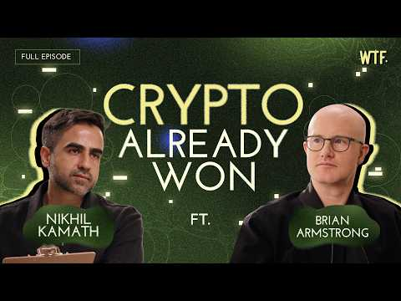 The Crypto Skeptic vs The Coinbase CEO | Brian Armstrong x Nikhil Kamath | People by WTF (42:32)

Working paper on US standard-of-living growth, 1900–1990 (full title not supplied)
- Content type: Working paper
- Authors: @VBPeral and @bhwittenbrink
- Link: Read the announcement thread
- Recommended by: Marc Andreessen
- Key takeaway: The authors use 5.1 million Sears catalog listings to construct a quality-adjusted consumer-goods price index. They report that twentieth-century growth was larger than official statistics imply and peaked before World War II rather than after it. [3]
- Why it matters: The paper offers a data-driven challenge to both the measured scale and timing of US living-standard growth; Andreessen called it “Absolutely fascinating.” [4]

AI implementation: the firm-specific work

Post/thread on encoding firms’ nuances into AI agents (title not supplied)
- Content type: Post/thread
- Creator: @gsivulka
- Link: Read the thread
- Recommended by: Marc Andreessen
- Key takeaway: Andreessen called the post “a very good read” and singled out its central claim: “Encoding each firm’s nuances into agents will become the largest economic task of the decade ahead.” [5]
- Why it matters: The recommendation directs attention to organization-specific knowledge and workflows as the consequential work behind deploying agents, rather than treating generic agent capability as the whole challenge.

Two additional Tim Ferriss picks

The Last Time
- Content type: Audiobook chapter / meditation
- Creator: Sam Harris
- Link: The resource URL was not supplied; Ferriss’s discussion
- Recommended by: Tim Ferriss
- Key takeaway: Ferriss described it as a short meditation on the experiences people do not recognize, in the moment, as their last time. [6]
- Why it matters: It complements The Tail End with a more personal lens on attention, change, and finite experiences.

The Blade Itself series
- Content type: Fantasy novels; audiobooks recommended
- Author: Joe Abercrombie
- Link: The resource URL was not supplied; Ferriss’s discussion
- Recommended by: Tim Ferriss
- Key takeaway: Ferriss called the series “really fun” and highlighted it as a relatively short fantasy read. [6]
- Why it matters: A clear leisure-reading recommendation alongside the day’s more analytical and reflective resources.

Sources
- 𝕏 post by @tferriss
- The Crypto Skeptic vs The Coinbase CEO | Brian Armstrong x Nikhil Kamath | People by WTF
- 𝕏 post by @VBPeral
- 𝕏 post by @pmarca
- 𝕏 post by @mstockton
- The Random Show! Mortality, AI, Supplements, Rock Climbing, & More

