After Automation, Missionary vs. Mercenary, and a Douthat AI Essay
Recommended Reading from Tech Founders
2026-05-24

After Automation, Missionary vs. Mercenary, and a Douthat AI Essay
By Recommended Reading from Tech Founders • May 24, 2026
Aaron Levie’s endorsement of Dan Shipper’s After Automation was the clearest signal in today’s set, paired with John Doerr’s recommendation of The Monk in the Riddle and his standing reading stack. Patrick Collison added a New York Times essay that widens the lens from AI and work to AI and aesthetics.

What stood out
The clearest signal today was an article that offers a crisp frame for thinking about AI and jobs: automating tasks does not necessarily eliminate the job. Around that, John Doerr surfaced a founder-values book and two publications he relies on to stay current, while Patrick Collison pointed readers to a New York Times opinion piece on AI, philanthropy, beauty, and aesthetics [1, 2, 3]

Most compelling recommendation

After Automation
- Content type: Article
- Author/creator: Dan Shipper [4]
- Link/URL: https://every.to/p/after-automation [4]
- Who recommended it: Aaron Levie, who called it a “fantastic post” about why jobs are not going away in the way some predict [1]
- Key takeaway: Automating one or many tasks within a job usually expands the job definition instead of eliminating it. Work shifts toward doing more tasks, doing them at higher quality, or taking on the tasks that have not yet been automated, often for a newly reachable audience [1]
- Why it matters: It is the most actionable framework in today’s set for thinking about AI’s effect on coding, legal work, sales, and marketing without confusing task automation with job elimination [1]
“Don’t fall into the trap of confusing tasks with jobs.” [1]

Founder philosophy pick

The Monk in the Riddle
- Content type: Book
- Author/creator: Randy Komisar [2]
- Who recommended it: John Doerr [2]
- Key takeaway: Doerr recommends it for its distinction between missionaries and mercenaries in entrepreneurship, illustrated through a startup that improved after pivoting from selling caskets toward building community and clarifying its mission and values [2]
- Why it matters: This is the richest founder-framework recommendation in today’s inputs because it ties company performance to mission, values, and the kind of motivation that can align a team [2]
- Source discussion: https://www.youtube.com/watch?v=uZ56og18pf0 [2] 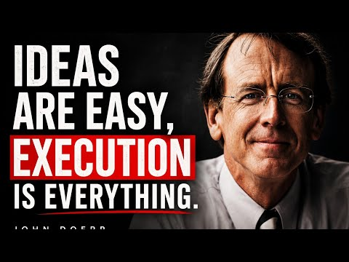 The Brutal Truth About Business and Execution (27:13)

Two broader reading signals

Ross Douthat’s New York Times opinion piece on AI, philanthropy, beauty, and New Aesthetics
- Content type: Opinion article
- Author/creator: Ross Douthat [3]
- Link/URL: https://www.nytimes.com/2026/05/23/opinion/artificial-intelligence-philanthropy-beauty.html [3]
- Who recommended it: Patrick Collison, who called it interesting [3]
- Key takeaway: The source only specifies the piece’s focus: AI, philanthropy, beauty, and, in passing, the call for New Aesthetics [3]
- Why it matters: It broadens the day’s list beyond labor and operating questions into a more cultural line of thinking about AI [3]

MIT Technology Review
- Content type: Magazine
- Author/creator: MIT Technology Review [2]
- Who recommended it: John Doerr [2]
- Key takeaway: Doerr named it as one of his favorite magazines while describing how he stays current by reading heavily across newspapers and magazines [2]
- Why it matters: It stands out as an ongoing publication recommendation for readers who want regular coverage of emerging fields and innovation [2]

The Economist
- Content type: Magazine
- Author/creator: The Economist [2]
- Who recommended it: John Doerr [2]
- Key takeaway: Doerr cited it alongside MIT Technology Review as part of the reading stack he uses to stay current on innovation [2]
- Why it matters: It complements the more startup-specific picks with a broader publication that Doerr treats as part of his regular learning system [2]

Bottom line
If you save only one item, save After Automation. It had the clearest endorsement, the most specific underlying argument, and the most direct relevance to a live founder question: what AI changes about jobs versus tasks [1]

Sources
- 𝕏 post by @levie
- The Brutal Truth About Business and Execution
- 𝕏 post by @patrickc
- 𝕏 post by @danshipper

