After “coding is solved”: plan-first, parallel-agent ops, and sandboxing become the workflow
Coding Agents Alpha Tracker
2026-02-20

After “coding is solved”: plan-first, parallel-agent ops, and sandboxing become the workflow
By Coding Agents Alpha Tracker • February 20, 2026
Boris Cherny’s strongest claim yet: coding (for his work) is “largely solved,” and the real frontier is end-to-end agentic ops—backed by +200% PR productivity and Claude reviewing 100% of PRs. Plus: Cursor’s cross-OS agent sandboxing, Claude Code perf/regression signals, and new lightweight OpenClaw clones worth cloning.

🔥 TOP SIGNAL
Boris Cherny (Head of Claude Code) is blunt: for the kinds of programming he does, “coding is largely solved”, and the frontier is shifting to adjacent, end-to-end agentic work (project management, paying tickets, general ops) rather than better IDE autocomplete [1]. In that world, throughput isn’t hypothetical: he says Anthropic saw +200% productivity per engineer (PRs) [1], and Claude now reviews 100% of pull requests (with human review still in the loop) [1].

🛠️ TOOLS & MODELS
- Claude Code — stability + performance signals
  - v2.1.47: long-running sessions use less memory [2].
  - Team guidance: keep reporting issues and they’ll fix them [2].
  - Practitioner complaint: Theo reports Claude Code has “regressed an absurd amount” with UI/feedback issues (timestamps not updating, missing “thinking,” multi-minute hangs with 0 output) [3] and suggests it “needs to be rewritten from scratch” [4].
- Cursor — agent sandboxing shipped across desktop OSes
  - Cursor says it rolled out agent sandboxing on macOS, Linux, and Windows over the last three months [5].
  - Mechanism: agents run freely inside a sandbox, only requesting approval when they need to step outside it [5].
  - Implementation write-up: http://cursor.com/blog/agent-sandboxing [5].
- OpenAI Codex — pricing/availability + compute pressure
  - @thsottiaux: Codex is included with a ChatGPT subscription (even Plus has “very generous” usage) [6]; they attribute this to gpt-5.3-codex achieving “SoTA at lower cost” [6].
  - Same source: candidates increasingly ask how much dedicated inference compute they’ll have, and usage/user is growing faster than user count → compute could be scarce [7].
- Gemini 3.1 Pro — dev-workflow positioning (ramping up)
  - Google Antigravity: Gemini 3.1 Pro is ramping to Google AI Ultra/Pro users, pitched around “advanced reasoning” and “long horizon planning” for dev workflows [8]. Details: https://antigravity.google/blog/gemini-3-1-pro-in-google-antigravity [9].
- GitHub Copilot → Zed editor (GA)
  - GitHub: Copilot subscription support in Zed is generally available [10]. Changelog: https://github.blog/changelog/2026-02-19-github-copilot-support-in-zed-generally-available/ [10].
- Model choice drift + self-hosting pressure (reported trend)
  - Salvatore Sanfilippo says he’s seeing excellent programmers move off US models (Codex, Claude Code) toward Chinese open-weight models like Kimi 2.5 and GLM5 [11], often via providers or by building in-house Nvidia GPU inference to avoid outages and keep sensitive data internal [11].
  - He frames DeepSeek v4 as a potentially major moment if it lands as SOTA (as rumors suggest), putting pressure on OpenAI/Anthropic business sustainability [11].

💡 WORKFLOWS & TRICKS
- “Plan mode → execute” as a default loop (Claude Code / Boris Cherny)
  - Start the task in plan mode (he says he does this for ~80% of tasks) [1].
  - Iterate on the plan (model goes back-and-forth) [1].
  - Once the plan is good, let it execute; he’ll auto-accept edits after that [1].
  - Implementation detail: plan mode is literally a prompt injection: “please don’t write any code yet” [1].
- Parallel agents, but treat “state” as a first-class problem
  - Cherny: he runs ~5 agents in parallel while working (terminal/desktop/iOS) [1] and highlights you can run many sessions in parallel [1].
  - Kent C. Dodds: similar “utter chaos” workflow—multiple projects, “a couple cloud agents” each, plus a locally guided agent [12].
  - Failure mode (real): Simon Willison describes “parallel agent psychosis”—losing track of where a feature lives across branches/worktrees/instances [13].
  - Recovery trick: after hacking in /tmp and crashing, he recovered the code from ~/.claude/projects/ session logs, and Claude Code could extract and recreate the missing feature [14].
- Turn your feedback firehose into PRs (fast iteration loop)
  - Cherny’s pattern: point Quad/Cowork at an internal Slack feedback thread; it proposes changes and opens PRs quickly, which encourages more feedback because users feel heard [1].
  - Bug-fix loop: “as long as the description is good,” he can fix a bug in minutes by delegating to Claude [1].
- Token policy as a productivity lever (especially early)
  - Cherny recommends giving engineers as many tokens as possible early (even “unlimited tokens” as a perk) so they try ideas that would otherwise feel too expensive; optimize/cost-cut after an idea works [1].
- Avoid over-orchestration: tools + goal > rigid workflows (model-first design principle)
  - Cherny: don’t “box the model in” with strict step-by-step workflows; give it tools + a goal and let it figure it out—he argues heavy scaffolding mattered a year ago but often isn’t necessary now [1].
- “Ephemeral app” mindset + AI-native interfaces (Karpathy)
  - Karpathy built a one-off cardio experiment dashboard with Claude; it had to reverse engineer a treadmill cloud API, process/debug data, and build a web UI; he still had to chase bugs (units, calendar alignment) [15].
  - His takeaway: the app-store model feels outdated for long-tail needs; instead, the industry needs AI-native sensors/actuators with agent-friendly APIs/CLIs so agents don’t have to click HTML UIs or reverse engineer services [15].
- Agent “memory” ops in practice (LangSmith Agent Builder)
  - LangChain’s concrete guidance:
    - Tell your agent to remember what works [16]
    - Use skills to inject specialized context when needed [16]
    - Edit agent instructions directly when it’s faster [16]
  - Entry point: https://blog.langchain.com/how-to-use-memory-in-agent-builder/?utm_medium=social&utm_source=twitter&utm_campaign=q1-2026_ab-philosophy_aw [16].

👤 PEOPLE TO WATCH
- Boris Cherny — production-grade Claude Code habits (plan mode, parallel sessions) + strong claims about where “after coding” goes [1].
- Andrej Karpathy — high-signal framing: ephemeral bespoke apps + “AI-native CLI/API” requirements for tools and hardware vendors [15].
- Simon Willison — the best micro-case study of parallel-agent failure/recovery using session logs as the source of truth [13, 14].
- Steve Ruiz (tldraw) — pragmatic company-building: code gets easier, but alignment/positioning/communication get harder—and he’s automating the overhead away [17].
- Theo — sharp practitioner critique on Claude Code regressions plus continued pressure on “harness vs infra” policy differences across vendors [3, 4].
- François Chollet — frames agentic coding as ML optimization (spec/tests as constraints) and asks what the “Keras of agentic coding” will be [18]; @swyx suggests DSPy as the presumptive community default [19].

🎬 WATCH & LISTEN

1) Boris Cherny — “Plan mode” as the default starter move (~1:09:52–1:10:41)
Hook: a simple, copyable workflow: force planning first (no code), iterate the plan, then execute + auto-accept when the plan is solid [1].
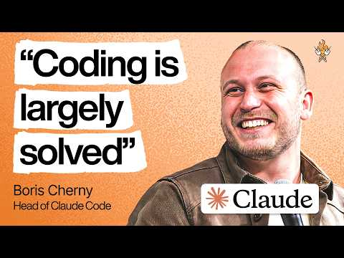 Head of Claude Code: What happens after coding is solved | Boris Cherny (69:51)

2) Boris Cherny — “Coding is largely solved… what’s next?” (~0:18:19–0:19:06)
Hook: his thesis on why the frontier is shifting from IDE coding to adjacent operational tasks and general automation [1].
Head of Claude Code: What happens after coding is solved | Boris Cherny (18:19)

3) Steve Ruiz — daily automated release notes from landed PRs (~0:20:35–0:21:02)
Hook: treat agents like scheduled staff: every day, Claude scans the last 24h PRs and drafts “release notes we’d publish if we shipped main today” [17].
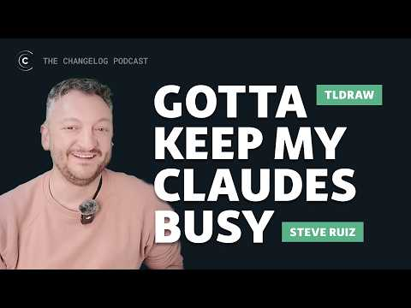 Selling SDKs in the era of many Claudes | Steve Ruiz from @tldraw (20:35)

📊 PROJECTS & REPOS
- NanoClaw — “Clawdbot” in ~500–700 LOC TypeScript using Apple container isolation for sandboxing/security; posted as Show HN [20, 21]. Repo: https://github.com/gavrielc/nanoclaw [20] • HN: https://news.ycombinator.com/item?id=46850205 [20].
- Nullclaw — “fastest, smallest OpenClaw clone”: 678 KB static binary, no runtime/VM/framework overhead [22]. Repo: https://github.com/nullclaw/nullclaw [22].
- tldraw agent starter kit — Cursor-like agent panel next to a canvas; cloneable starter for agent+canvas UX: https://tldraw.dev/starter-kits/agent [17].

Editorial take: As agents make code cheap, the new edge is orchestration discipline: plan-first loops, sandboxing, session-log recoverability, and AI-native interfaces that don’t force your agent to “be the computer.” [1, 5, 14, 15]

Sources
- Head of Claude Code: What happens after coding is solved | Boris Cherny
- 𝕏 post by @jarredsumner
- 𝕏 post by @theo
- 𝕏 post by @theo
- 𝕏 post by @cursor_ai
- 𝕏 post by @thsottiaux
- 𝕏 post by @thsottiaux
- 𝕏 post by @antigravity
- 𝕏 post by @antigravity
- 𝕏 post by @github
- Deepseek v4 potrebbe essere un colpo al cuore alla sostenibilità dell’AI americana
- 𝕏 post by @kentcdodds
- 𝕏 post by @simonw
- 𝕏 post by @simonw
- 𝕏 post by @karpathy
- 𝕏 post by @LangChain
- Selling SDKs in the era of many Claudes | Steve Ruiz from @tldraw
- 𝕏 post by @fchollet
- 𝕏 post by @swyx
- 𝕏 post by @betterhn20
- 𝕏 post by @swyx
- 𝕏 post by @jedisct1

