Agent-First Software Moves Center Stage as Washington Tries for One AI Rulebook
AI News Digest
2026-03-21

Agent-First Software Moves Center Stage as Washington Tries for One AI Rulebook
By AI News Digest • March 21, 2026
The day’s strongest thread was the move toward agent-first software: Andrej Karpathy described a new engineering workflow built around persistent AI loops, and Dreamer launched a consumer-facing agent platform. The White House released a national AI framework, Waymo published stronger safety data, and Percy Liang shared new synthetic-data efficiency gains.

The main thread
Today’s clearest pattern was the shift from AI as a chat surface to AI as a persistent operator. Andrej Karpathy described software work as increasingly about delegating macro actions to agents, while Dreamer launched as a consumer platform built around a personal Sidekick that helps users discover, build, and run agents [1, 2].

Karpathy says the bottleneck has flipped from typing to orchestration
Karpathy said he has effectively stopped typing code since December and now works by delegating larger tasks across multiple agent sessions and repositories, treating the new constraint less as raw model capability than instruction quality, memory tooling, and token throughput [1]. He also said an autonomous AutoResearch loop found hyperparameter interactions in NanoGPT overnight that he had missed after years of manual tuning, as long as the task had clear objective criteria [1].
“I don’t think I’ve typed like a line of code probably since December, basically” [1] 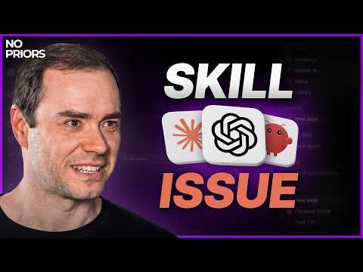 Andrej Karpathy on Code Agents, AutoResearch, and the Loopy Era of AI (1:40)
Why it matters: This is a stronger claim than “AI helps me code.” Karpathy is describing a workflow where humans define goals, metrics, and constraints, while persistent agents keep running outside the interactive loop [1].

Dreamer launches a consumer-facing agent platform
Dreamer emerged from stealth as a consumer-first platform to discover, build, and use AI agents and agentic apps, centered on a personal Sidekick; the company was founded by David Singleton and Hugo Barra [2]. The platform combines a gallery of community agents with SDK and CLI tooling, hosted databases, prompt management, serverless functions, and a tool ecosystem where builders can get paid based on usage [2].
Why it matters: Dreamer is one of the clearest attempts to push agents beyond developer tooling and into a general consumer product, while treating permissions, interoperability, and monetization as core platform features [2].

Policy and deployment signals

Washington releases a national AI framework
The White House released a national AI legislative framework meant to create “One Rulebook” after what it described as a patchwork of 50 state regimes that could stifle innovation and weaken U.S. leadership in AI [3]. The administration said the framework is intended to protect children from online harm, shield communities from higher electric bills, protect First Amendment rights from AI censorship, and ensure Americans benefit from AI, and said it wants Congress to turn the principles into legislation in its White House article [3].
Why it matters: This is a notable federal bid to define AI governance nationally rather than leave the field to state-by-state rulemaking [3].

Waymo publishes a larger safety benchmark
Sundar Pichai said new Waymo data covering more than 170 million autonomous miles through December 2025 shows the Waymo Driver was involved in 13 times fewer serious-injury crashes than human drivers in the same cities [4].
Why it matters: The update puts a major autonomy claim on measured safety outcomes at scale, not just demos or pilot deployments [4].

Research signal

Synthetic data keeps getting more attractive
Percy Liang said earlier work had already delivered a 5x data-efficiency gain through careful tuning, scaling, and ensembles, and that a rephraser model now adds another 1.8x gain for data-constrained pre-training [5]. He added that synthetic data lowers loss on the real data distribution as more tokens are generated, and that treating the resulting generations as one long “megadoc” improves scaling further, with larger gains under more compute [6].
Why it matters: The result points to a future where useful data, not just compute, becomes a tighter constraint in model training [5].

Bottom line
Today’s news was less about a single new frontier model and more about the systems forming around AI: continuous agent workflows, consumer agent platforms, federal rule-setting, and larger-scale deployment metrics [1, 2, 3, 4].

Sources
- Andrej Karpathy on Code Agents, AutoResearch, and the Loopy Era of AI
- Dreamer: the Personal Agent OS — David Singleton
- 𝕏 post by @DavidSacks
- 𝕏 post by @sundarpichai
- 𝕏 post by @percyliang
- 𝕏 post by @konwookim

