AI embeds into core school workflows as safety rules and assessment redesign accelerate
AI in EdTech Weekly
2026-01-26

AI embeds into core school workflows as safety rules and assessment redesign accelerate
By AI in EdTech Weekly • January 26, 2026
This week’s developments show AI shifting from “chatbots in class” to platform-native workflows, new safety and policy constraints, and assessment redesign. We highlight what’s changing in Google Classroom, Microsoft’s new Learning Zone, child-safety guardrails, and where evidence of impact is starting to surface.

The lead: AI is being embedded into the “systems of school” (not just used as a chatbot)
This week’s clearest signal isn’t a new model—it’s where AI shows up.
- Google is pushing AI deeper into the tools teachers already use (Google Classroom + Gemini) with admin controls and privacy commitments [1].
- Microsoft is shipping an on-device lesson builder (Learning Zone) tied to Copilot+ PCs, plus assignment, reporting, and content libraries [2].
- “Non-classroom” applications—like master scheduling optimization—are being positioned as high-leverage AI because they shape student experience without students interacting with AI directly [3].

Theme 1 — Platform-native AI: planning, differentiation, and content generation inside existing workflows

Google Classroom + Gemini: from prompts to pre-built teacher tools
A teacher-facing walkthrough reports 28 pre-prompted AI tools inside Google Classroom’s Gemini dashboard, organized by planning, instructional materials, assessments, student support, and administrative tasks [4]. Examples include outlining lesson plans, releveling text, generating quizzes, drafting newsletters, and creating PD plans [4].
Two features that stood out in coverage:
- Classroom context inside Gemini: educators can connect Google Classroom to the Gemini app so Gemini can reference class roster, assignments, and grades when helping adjust lessons [1].
- Audio lessons: Google described a Classroom feature that turns content into a student–teacher dialogue audio lesson designed to go deeper into misconceptions (distinct from podcast-style audio) [1].
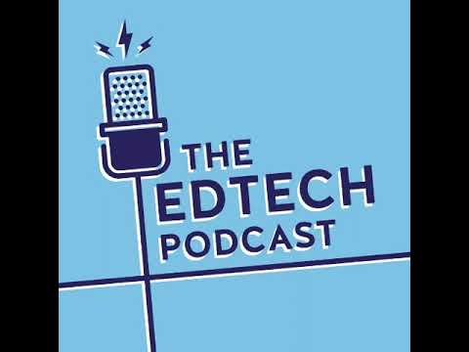 #306 Google at BETT: Gemini 3.0 Transforms Education (7:36)
Google also described Gemini for Education as free access to its “highest-end reasoning model” for Google for Education customers, with a data-protection claim that student data isn’t used for training [1].
A separate pilot example cited up to 10 hours/week of time savings for educators in Northern Ireland after rolling out Gemini [1].
Limitations to keep in mind: a teacher blog explicitly frames outputs as drafts—useful for skipping the blank page, but still requiring review and editing [4].

Microsoft Learning Zone: on-device lesson generation + classroom analytics
Microsoft introduced Learning Zone, an AI-powered app for Copilot+ PCs that uses a local small language model to generate interactive lessons in minutes [2].
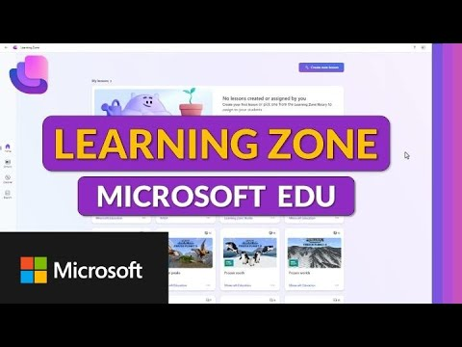 How to Use Microsoft Learning Zone (0:00)
Key workflow pieces from the demo:
- Grounding with sources: teachers can upload Word/PDF files, attach OneDrive files, or use vetted resources such as OpenStax [2].
- Editability: lessons generate as a mix of content and practice “slides,” but teachers can edit slides, add question types, generate distractors, and simplify language [2].
- Assignment + LMS hooks: share via join code/link/QR and share into Teams assignments or Google Classroom; Microsoft also said Learning Zone lesson attachment in Teams/LTI is being worked on for spring 2026 [2].
- Reports: per-lesson and per-student performance insights (e.g., % correct, time), drill-down by exercise type, and identification of students needing support [2].

Theme 2 — Safety, privacy, and regulation: guardrails are becoming product requirements

Two policy “fronts” reshaping AI + edtech
Edtech Insiders highlighted two broad vectors:
- California AI + minors: OpenAI and Common Sense Media announced plans for the “Parents & Kids Safe AI Act,” including age assurance, a ban on targeted advertising to minors, limits on sharing children’s data without parental consent, and content safeguards against harmful AI content. The piece notes these rules would also apply to AI-powered educational tools [5]. Enforcement would flow through the Attorney General and financial penalties (moving away from a private right of action) [5].
- Screentime scrutiny spilling into edtech: an NTIA inquiry is questioning whether federal subsidies are pushing schools toward more screens without evidence of learning benefit [5]. The same article links a broader political trend (e.g., Kids Off Social Media Act proposals) to increasing regulation of what happens on school-issued devices [5].

“Red lines” in product design: LEGO Education’s stance on generative AI
LEGO Education described “red lines” for bringing AI into classrooms:
- Generative AI tools may be made safer, but they “cannot be guaranteed to be safe,” so LEGO Education will not bring them into classrooms until that gap can be closed [6].
- They avoid anthropomorphizing AI (no faces/names; not describing AI as creative) [6].
- They emphasize local processing and keeping child data from leaving the classroom or being transmitted over the internet [6].
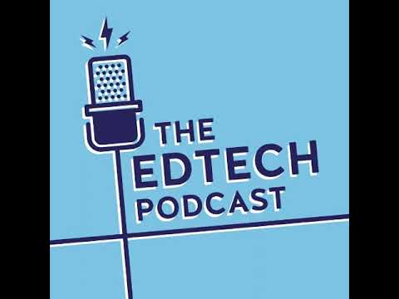 #308 LEGO at Bett UK: Safe AI for Classrooms (7:22)

Procurement reality: compliance-first vs “public” tools
A SchoolAI community manager emphasized COPPA/FERPA compliance, stating SchoolAI does not use student data to train models or sell data [7]. The same comment warns that using public-facing tools with student identifying information (e.g., student names for a seating chart) can break federal law [7].

Theme 3 — Assessment is being rethought for an AI era (and vendors are rushing in)

BETT: assessment shifts from “pattern recognition” toward what’s harder to test
At BETT, one discussion argued that the most valuable things are becoming harder to assess, while the least valuable are increasingly easy for AI (pattern recognition). The takeaway was the need to “measure what we treasure” [8].
In the same coverage, Vicki Merrick described pilots using machine learning-enabled comparative judgment (holistic pairwise comparisons by teacher judges) for more reliable assessment of subjective Key Stage 3 work. In one pilot: 40 judges assessed 2,000 Year 7 art items across 14 academies in less than an hour and achieved a 0.89 reliability score [8]. Teachers reported greater confidence because their judgments were one of many [9].

AI tooling for assessment creation + feedback loops
- Kahoot AI Generator: creates quizzes from prompts, slides, or PDFs, with “over 13” question types and modes like Accuracy Mode (points for correctness rather than speed) [10]. Kahoot also cited “almost 200 independent research studies” and claimed grade increases by a letter grade on an average test [10].
- Red Pen AI: a formative assessment workflow that starts with uploading photos of handwritten student work, identifies urgent curriculum gaps, generates editable feedback, and tracks class progress on a dashboard—aiming to reduce teacher workload without requiring 1:1 devices [10].
- Teacher feedback prompts: Monica Burns shared copy-and-paste prompts to draft student-friendly feedback faster, emphasizing drafting + revising with professional judgment [11].

Theme 4 — AI literacy is shifting toward fundamentals, agency, and durable human skills

From “how to use AI” to “how to understand and judge it”
- LEGO Education’s new Computer Science and AI product line aims to teach AI/CS/robotics fundamentals from kindergarten, including probability, statistics, machine representation, and algorithmic bias—explicitly pushing away from “throwing conversational chat bots in front of children” [6].
- The National Literacy Trust launched a “National Year of Reading” campaign after reporting that only 1 in 3 children said they like reading and 1 in 5 read every day in a survey of 17,000 children [12]. In the same coverage, an expert argued literacy becomes more important in an AI-driven world because students must write accurate prompts and evaluate whether AI output is accurate and truthful [10].

Evidence emerging on what teachers actually build with AI
A SchoolAI study analyzing 23,000 teacher-created AI learning experiences reports that over 75% were anchored in core curriculum and designed to prompt students to reason, evaluate, and make decisions—not just recall information [5].

“Human skills” framing is hardening into leadership language
A Tech & Learning piece proposed the C.A.R.E.S. framework (cultural competence, adaptability, relationships, ethical judgment, scholarly discernment) as the “irreplaceable” human core as AI drafts lessons, analyzes student work, and generates feedback [13].

Theme 5 — Upskilling is scaling: educators, engineers, and whole workforces
- Anthropic + Teach For All: a partnership to bring AI training to educators in 63 countries, enabling teachers serving over 1.5 million students to use Claude for curriculum planning, customized assignments, and tool-building, and to provide feedback to shape Claude’s evolution [14].
- Gauntlet AI: positions itself as free immersive training for engineers (travel to Austin plus covered housing/food) with employer matching for $200k+ roles; it states participants never pay under any circumstances [15, 16].
- Gemini CLI training: Andrew Ng promoted a DeepLearning.AI short course on Gemini CLI (an open-source agent) focused on multi-step workflows from the terminal, including orchestrating tools via MCP and automating coding tasks [17].

What This Means
- For K–12 and district leaders: AI adoption is accelerating where it can be governed—inside platforms with admin controls, protected data terms, and teacher-facing “draft” workflows (e.g., Classroom+Gemini, Learning Zone). Expect procurement to increasingly center on privacy posture and control surfaces, not feature lists [1, 2, 7].
- For assessment and curriculum teams: “AI in assessment” is splitting into two lanes: (a) automating creation and feedback loops (quizzes, formative feedback), and (b) redesigning what’s assessed (contextual, non-deterministic work) using methods like comparative judgment [10, 8].
- For edtech builders and investors: The regulatory environment is converging on child-focused requirements (age assurance, data sharing constraints, content safeguards) that will apply to AI edtech, not just social platforms [5]. Products with explicit safety “red lines” and local processing claims (or on-device models) may gain advantage in K–12 contexts [6, 2].
- For learners and L&D professionals: The “AI capability” gap is widening—multiple sources frame value as judgment, curation, and the ability to evaluate output quality (not just generating text quickly) [10, 13, 5].

Watch This Space
- Age assurance + AI edtech compliance: whether California’s proposed standards become a de facto requirement for AI products used by minors [5].
- On-device education AI: tools that rely on local models (e.g., Copilot+ PC workflows) as a response to privacy, cost, and offline constraints [2].
- Assessment redesign at scale: comparative judgment pilots and other methods that claim reliable evaluation of subjective work without over-indexing on what AI can do best [8].
- AI literacy as fundamentals + agency: product lines and curricula that emphasize how systems work (and how to judge them) rather than putting chatbots “in front of children” [6, 10].
- Training models for the AI workforce: partnerships and “free training + job outcomes” models expanding across educators and engineers [14, 15, 17].

Sources
- #306 Google at BETT: Gemini 3.0 Transforms Education
- How to Use Microsoft Learning Zone
- The Impact of AI Optimization on the Use of Time, Space, and Resources in Schools
- AI Tools in Google Classroom You Don’t Want to Miss!
- The Two Fronts Reshaping EdTech Policy in 2026: Screentime Scrutiny and California’s AI Bridge
- #308 LEGO at Bett UK: Safe AI for Classrooms
- r/edtech comment by u/The_Nerdy_Teacher
- #309 Bett UK 2026: Bringing Joy to Digital Assessment
- #309 Bett UK 2026: Bringing Joy to Digital Assessment
- #310 From Reading to Robotics: Transforming Assessment at Bett
- 𝕏 post by @ClassTechTips
- #310 From Reading to Robotics: Transforming Assessment at Bett
- Amplifying Human Skills in the Age of AI: Using The C.A.R.E.S. Framework
- 𝕏 post by @AnthropicAI
- 𝕏 post by @Austen
- 𝕏 post by @Austen
- 𝕏 post by @AndrewYNg

