AI in Education Is Moving from Answering to Coaching—and Into the Assessment Reckoning
AI in EdTech Weekly
2026-08-17

AI in Education Is Moving from Answering to Coaching—and Into the Assessment Reckoning
By AI in EdTech Weekly • August 17, 2026
Microsoft’s learning-mode tools, new AI-tutor benchmarks, and a 274-study synthesis all sharpen the same question: can AI improve learning while preserving productive struggle, durable skill, and visible student reasoning? The brief also examines student-authored policy and responsive AI training for the frontline workforce.
AI in education is being forced to answer a harder question: not whether a model can produce a better answer, but whether the learner is still doing the thinking and can perform without it. Microsoft’s learning-mode rollout, a new synthesis of 274 studies, and emerging tutoring benchmarks all point in the same direction: the next product and procurement test is effort, transfer, and visible reasoning. [1, 2, 3]

The product race is becoming a race over productive struggle
Microsoft says its Study and Learn Agent is available in Microsoft 365 Copilot for education licenses at no additional cost. Its stated design is deliberately different from a generic chatbot: it helps students understand, practise, study, and check their understanding using their own material, while preserving effort and productive struggle rather than doing the work for them. For K–12 students aged 13–17, an administrator must enable Copilot Chat; Microsoft says it plans to preselect Study and Learn for those tenants so Copilot Chat defaults to learning mode rather than answer-giving mode around the end of August. [1]
The demonstration shows what that design means in practice. When a student is stuck on an equation, the agent asks what they have tried, simplifies the explanation, rebuilds toward the general method, and then gives another problem to test transfer. In writing, it asks what the student has already done and coaches the thesis process instead of drafting the thesis. It can also turn attached Word, PowerPoint, Excel, PDF, text, or OneNote material into activities such as flashcards. [1] 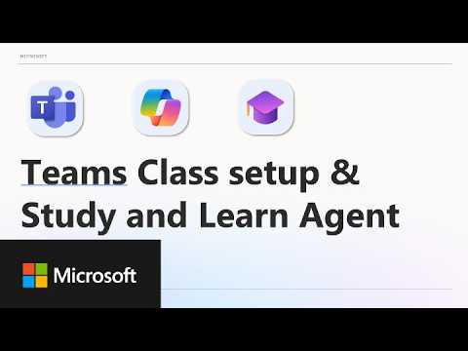 What’s New in Microsoft EDU - Product Updates (August 2026) (24:51)
Microsoft is also putting AI policy into the assignment interface. Teachers can set expectations per assignment—or as a default—with four suggested modes: no AI, brainstorming, editing only, or full AI, with editable text. That is a small but important shift from a general school policy to a task-level contract about what learning the assignment is meant to produce. [1]
Renaissance is making a complementary, teacher-centered bet. Its Renaissance Intelligence product connects assessment data to core instructional materials and recommends adjustments for teachers; the company says about 400 districts were piloting or starting in July. It has deliberately deferred a student-facing AI model, arguing that AI tends to reach an answer too quickly and can undercut curiosity and productive struggle. [4] The emerging split is clear: Microsoft is trying to make the student interaction more pedagogically disciplined, while Renaissance is using AI to help the teacher differentiate inside the shared classroom rather than sending students to isolated software. [4]

The evidence is moving from “can it answer?” to “does learning survive?”
A podcast discussion of a new University of Sydney/Barker Institute synthesis reviewed 274 peer-reviewed studies published from 2022 through June on generative AI and school students. It reported a consistent distinction: AI can improve immediate performance in writing, mathematics, science, and coding, while producing better work with AI is not the same as learning better. In one highlighted mathematics study, 1,000 students with unrestricted AI access improved during practice but performed worse after AI was removed than students who had never used it. The review’s more useful question is therefore what thinking remains with the student: AI can help when it supports reasoning, explanation, and practice, but not when it simply supplies the answer. [2] 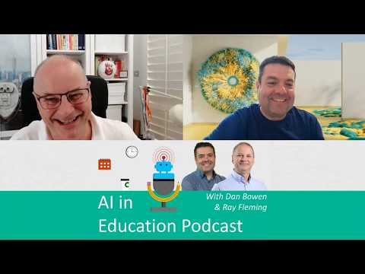 Is AI Helping Students Perform, or Actually Learn? (27:04)
The tutoring market’s own benchmarks point to the same constraint. EduClaw-Bench evaluated model-and-agent configurations over a 30-day learning horizon with simulated learners based on real knowledge-tracing data; almost none of the combinations tested, including GPT5.5 and Alibaba’s Qwen models, maintained strong tutoring performance over time. ELBench tested nine models across general capability, safety, basic education, and higher-order educational development, and the two education-specialized models in the study did not lead on the education-specific modules. The field still lacks a universally accepted definition of a good AI tutor. [3]
That does not mean AI cannot perform difficult educational tasks. Ethan Mollick shared a field-study finding that an agentic loop using the now-obsolete o3-mini produced exam questions with psychometric properties on par with questions used on high-stakes standardized tests. The implication is not that AI-generated assessment is automatically trustworthy; it is that item-generation quality and student learning are separate evaluation problems. [5]
The practical response is to make the learning process observable rather than rely on detection. A current assessment guide recommends collecting an initial question, claim, draft, peer-feedback reflection, revisions, and a final explanation; requiring students to explain choices; and using short conferences, audio reflections, debates, or gallery walks. It also recommends task-specific AI rules—such as allowing brainstorming but not drafting—and a short disclosure of how AI was used. [6] The goal is not to make assignments artificially difficult, but to assess how students think as well as what they produce. [6]

Students are becoming policy authors, not just policy subjects
At the America’s Youth AI Festival in Boston, student leaders from across the United States debated and passed the STUDENTS First Act, a proposed national K–12 framework that will be presented to AASA’s 10,000 member districts as a starting point for discussion—not as finished legislation. Their concerns included cheating, compromised critical thinking, privacy, security, mental health, and deepfakes, alongside equitable access and the benefits of self-directed learning. [7]
The proposed boundaries are more nuanced than either blanket access or a blanket ban: no independent AI use before ninth grade; AI literacy beginning in grades K–5; no AI-generated written or artistic assignments; and older students allowed to use AI for brainstorming, studying, or editing with teacher permission and disclosure. The students also called for human review and an appeals process rather than sole reliance on AI-detection software. [7] Their framework closely matches the direction of the strongest classroom guidance this week: define the purpose of the task first, then specify what AI use supports—or replaces—that purpose.

Workforce learning is becoming responsive to work itself
In frontline training, Opus describes a more operational form of personalization. The platform can ingest Google and Yelp reviews, analyze patterns by location, franchise, or individual, and automatically generate or retrain courses around the resulting performance gaps. Its Ask Opus agent answers from a company knowledge base and links the relevant training resource; in one large customer, 58% of responses had no resource attached, exposing missing knowledge—in that case, recipe data—and giving the company a way to identify what training to build next. [8]
The experience is designed for varied frontline learners: Opus supports 130 languages and audio or reading modes, with 30% of users preferring audio-only training. A manager view creates a practical coaching checklist for employees who need support, coaching, or certification. The company’s CEO explicitly rejects engagement as the main measure, instead emphasizing knowledge retention and behavior change; claims such as reducing order-accuracy issues by 70% in 30 days are provider-reported and should be independently tested. [8]
Andrew Ng’s new AI Engineering Skills Map points to the corresponding shift in what professional learning must teach. Based on more than 10,000 job postings plus expert interviews and surveys, it prioritizes building and deploying AI applications, software-engineering fundamentals, coding-agent fluency, and “shaping the build.” The map treats evaluation, error analysis, context management, tradeoffs, product judgment, and continuous learning as core skills—not optional technical polish. [9]

What This Means
- For K–12 leaders: Make AI permissions task-specific and visible. A district should be able to say when students are expected to work unaided, when AI may support brainstorming or feedback, and what the teacher will see. Microsoft’s assignment controls and the student-authored framework show that “AI allowed” is too crude a policy. [1, 7]
- For assessment leaders: Require evidence of process, explanation, revision, and transfer—and preserve some opportunities for unaided performance. Immediate gains, polished outputs, and strong generated test items do not establish durable capability. [2, 6]
- For edtech buyers and investors: Treat an AI tutor as an intervention that needs longitudinal evidence, not as a chatbot with a friendly interface. Ask how it models learner progress, spaces practice, handles misconceptions, and measures what remains after the tool is removed. [3]
- For L&D teams: Connect adaptive training to operational evidence, but measure retention and behavior rather than clicks. Multilingual and audio delivery can widen access; the unanswered-question log may be just as valuable as the generated lesson because it reveals where the organization’s knowledge base is weak. [8]

Watch This Space
- Tutor quality standards: EduClaw-Bench and ELBench are early attempts to measure sustained tutoring, safety, and higher-order learning. Watch whether public evaluators and buyers converge on tests of retention, transfer, and learner modeling rather than one-turn helpfulness. [3]
- From AI detection to provenance: The EU’s transparency rules now require labeling AI-generated images, audio, video, and certain public-interest writing; the accompanying discussion describes invisible text signals that can persist through copying and editing, while the generating company retains the decoding key. How schools handle provenance, false positives, and appeals will matter more than another detector leaderboard. [2]
- Student-authored governance: The STUDENTS First Act is headed for discussion among AASA districts. Its uptake will test whether student voice can shape practical rules that protect authentic learning without treating all AI use as misconduct. [7]

Sources
- What’s New in Microsoft EDU - Product Updates (August 2026)
- Is AI Helping Students Perform, or Actually Learn?
- EdTech Isn’t One Industry. It’s Nine.
- Keeping the Teacher at the Center of Classroom AI
- 𝕏 post by @emollick
- Assessment After AI: Designing Student Work to Show Real Thinking
- On AI Policy, Students Have Plenty to Say
- Intelligent Training Built for the Frontline
- 𝕏 article by @AndrewYNg

