AI Leverage Ladders, Edge-First Design, and Stronger AI PM Signals
PM Daily Digest
2026-07-01

AI Leverage Ladders, Edge-First Design, and Stronger AI PM Signals
By PM Daily Digest • July 1, 2026
This brief covers a practical ladder for AI-native PM leverage, edge-first design and research habits, and sharper tactics for AI PM job searches and interviews. It also highlights a case where validated user research was ignored until it became a defining product feature.

Big Ideas
- AI leverage is now a ladder, not a single skill. Colin Matthews frames it as personal, product, and systems leverage. On the personal side, PMs move from AI-written text to AI-generated artifacts to delegating full tasks through MCP-connected tools; on the product side, they move from disposable web prototypes to code-based prototypes in the real codebase to AI-generated PRs for small production changes [1]. A matching signal from Lenny: the coordination-heavy PM role is fading in favor of prototyping with real code, querying data conversationally, and running coding agents [2]. Why it matters: leverage now depends on choosing the right rung for the job. How to apply: pick one recurring task and move it up one rung this week; when delegating analysis, require source citations in the output [1].
- Inclusive design starts at the edge, not the happy path. The inclusive design pyramid argues for starting with people who struggle most; if the product works for them, benefits cascade outward [3]. The same talk pairs this with eat your greens: design for user needs over time, not just immediate wants [3]. Why it matters: it reduces blind spots in accessibility and long-term outcomes. How to apply: start the next discovery cycle with edge-case users and ask what the user will need in two to five years, not just today.
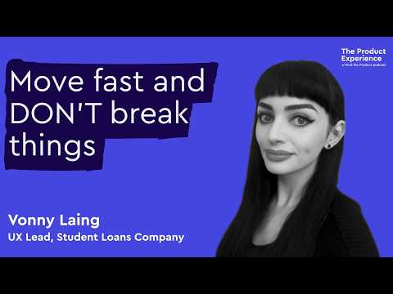 Why the Student Loans Company designs for its hardest users first — Vonny Laing (6:27)

Tactical Playbook
- Replace stale dashboards with on-demand analysis. Ryan Hoover’s workflow: make sure the relevant data is in the database, have an agent write a skill to gather it, then ask the agent to analyze it and generate a temporary HTML dashboard [4]. He argues dashboards decay in usage, while AI produces better insights when it has context and a clear goal rather than overly prescriptive instructions [4, 5]. Apply it: frame the question like an analyst brief, not a rigid spec; for example, ask whether users of a feature have higher 30-day retention and require cited sources in the output [1].
- Run research short, sharp, and continuous. The Student Loans Company talk recommends quick sniff tests, frequent intercept sessions, and mining complaint logs, chat logs, and call listening for signals [3]. Then package insights as stories with verbatims, audio, or photos using a situation → complication → result → recommendation flow [3].
Stories are the things we remember. [3]
Why it matters: faster signal collection only helps if stakeholders absorb it. How to apply: pair every important finding with one direct user quote and one recommended decision.

Case Studies & Lessons
- A research-backed comparison feature was dismissed, then became a defining feature five months later. In one product design project, comparison was documented as central to user decision-making, dismissed, and later turned into one of the product’s defining features [6]. The deeper lesson was governance: the person who named a direction early kept authority, while the person with evidence had to keep re-justifying settled questions [6]. How to apply: log major product decisions with the supporting evidence, the decision owner, and the condition that would justify reopening the call.
- Synthetic users are not a substitute for real users. The speaker argues synthetic users are shaped by biases in the underlying data and can mimic a person without capturing lived complexity or the hidden issues that surface only through rapport with real users [3]. How to apply: use synthetic users only for rough exploration, then validate critical decisions with real people in context.

Career Corner
- AI PM hiring is rewarding evidence, not posturing. Aakash Gupta’s playbook: audit your resume for honest ML-in-the-loop work, learn fundamentals like evals, agents, and context, ship one real project, show it publicly, and target incumbents adding AI [7]. Resume bullets should emphasize outcomes and numbers, not task lists [7, 8]. How to apply: one shipped project with a write-up of evals and failure modes is stronger than multiple tutorial clones [7].
One shipped thing beats five tutorial clones. [7]
- Tighten your tell-me-about-yourself answer. Hiring managers want to hear why your background fits this role, not a full biography [9]. A strong two-minute version opens with your current role and a measurable outcome, tells one relevant before/after story, and ends with why this role specifically [10]. How to apply: build one version per target role and let the deep dive happen in follow-up.

Tools & Resources
- Worth saving: Lenny’s guest post, How top PMs increase their leverage, plus the related course Become an AI-Native Builder. The course focuses on skills and MCPs for discovery, prototyping in the real codebase, shipping GitHub changes, and setting up evals [11]. Colin Matthews has taught AI and technical skills to PMs at companies including OpenAI, Google, Stripe, Figma, and Microsoft [11].
- Prompt templates to reuse: a PostHog retention-analysis prompt that asks for cited sources and HTML cohort output, and a repo-generation prompt that creates a local mock-data prototype without backend dependencies [1].

Sources
- How top PMs increase their leverage with AI
- 𝕏 post by @lennysan
- Why the Student Loans Company designs for its hardest users first — Vonny Laing
- 𝕏 post by @ryancarson
- 𝕏 post by @rrhoover
- r/ProductManagement post by u/KKANGKKA_Chu
- substack
- r/prodmgmt comment by u/my_peen_is_clean
- r/ProductManagementJobs comment by u/heavybeans5897
- r/ProductManagementJobs comment by u/West-Refrigerator664
- 𝕏 post by @lennysan

