AI Moves From Assistance to Autonomous Operations Across Software and Industry
VC Tech Radar
2026-07-23

AI Moves From Assistance to Autonomous Operations Across Software and Industry
By VC Tech Radar • July 23, 2026
New rounds for Meticulous, Splash Robotics, and Atoms lead this investor update. The broader pattern is a shift from AI tools that assist work toward systems that operate software, infrastructure, and physical-world workflows—with routing, memory, evaluation, and orchestration becoming key control layers.

1. Funding & Deals

Meticulous raises $15M Series A for AI-driven software testing
Meticulous.ai raised a $15M Series A after growing ARR 5x over the past year; named customers include Notion, ElevenLabs, Dropbox, and Wiz. Its system analyzes a codebase and simulates user flows before and after each change, aiming to reduce review and testing cycles from hours to minutes as AI-generated code increases review load. [1]

Atoms emerges from eight years in stealth
a16z is backing Atoms, with Ben Horowitz joining the board; Bain Capital Ventures has also publicly said it is backing founder Travis Kalanick and the team. Atoms is focused on digitizing physical-world industries through specialized robotics, beginning with food, mining, and transport. [2, 3]
The company is now publicly recruiting after operating in stealth, with Kalanick characterizing talent as central to taking on three industries simultaneously. [4]

Splash Robotics raises $4.2M for autonomous maritime logistics
Splash Robotics raised $4.2M to build autonomous drone boats for contested logistics and maritime surveillance. Its Typhoon vessel starts at $30,000 and takes eight hours to assemble, compared with cited competing-vessel prices of $300,000–$600,000; the company completed unmanned resupply missions to the USS Essex and USS Theodore Roosevelt at RIMPAC. [5]

2. Emerging Teams

PostHog is betting its analytics data can operate the software itself
PostHog, originally an open-source product analytics company, has repositioned around “self-driving software.” It combines product behavior, support tickets, logs, session recordings, and internal context to identify product problems and generate pull requests for simpler engineering fixes. Its AI systems are already generating a portion of the company’s own pull requests. [6, 7]
A meaningful product wedge is its recently launched support agent, now used by about 1,100 companies. The company is also developing an “intent harness” designed to capture product context—not only technical requirements—so agents can understand why a product should be built a certain way. [6]

QualiLoop targets AI-agent QA and release gating
Founder-built QualiLoop generates reliability, red-team, and bias test programs from an agent’s prompt and configuration; it runs simulated conversations, schedules regressions, and can block releases when critical flows degrade. The founder estimates the setup can be completed in roughly 30 minutes and claims the approach can reduce QA costs by about 90%, with on-premises deployment available for sensitive use cases. [8]

Coasty tackles automation where APIs do not exist
Coasty is building a computer-use agent for workflows inside legacy ERPs, desktop applications, and portals. The agent operates through the screen, mouse, and keyboard, with a recovery mechanism intended to read changed screen states and correct its course rather than continue blindly. [9]

Termi Protocol shows early paid demand in a developer niche
Termi Protocol, a desktop application that visualizes AI coding agents in a 3D workspace, reports 2,292 unique visitors, 145 registrations, and 70 purchases after a Product Hunt launch that reached #5 Product of the Day. [10]

3. AI & Tech Breakthroughs

Agents are becoming primary database users
Supabase says coding agents now launch a measurable 60% of its databases, which it suggests may be closer to 90%, totaling millions per month. The company responded with Supabase for Platforms, designed for companies that need to launch and manage millions of databases; it says more than 50 companies build on the product. [11]
This shifts the infrastructure question from application creation to operation. Supabase’s CEO identifies self-driving databases—handling downtime, security, and patches without operator intervention—as a harder and less crowded “operate” stage opportunity than build-stage tooling. [11]

Routing is becoming a core inference optimization layer
Cursor introduced Cursor Router, which selects a model for each task and is claimed to deliver frontier-quality results at 60% lower cost. Martin Casado described the problem as technically difficult because model capabilities are increasingly uneven, but saw significant room for optimization. [12, 13]
A separate early project, Echo, uses a coordinated pool of open-weight models rather than routing each request to a single model. Its founder reports that the system outperformed the best individual model in its pool on an internal task mix and reached Fable-level results at roughly one-third the inference cost, while acknowledging inconsistent benchmark performance. [14]

Memory and recovery emerge as practical agent architecture choices
Gumroad’s Gumclaw runs recurring support, engineering, finance, and social-monitoring tasks on a dedicated Mac using cron-triggered Fable 5 sessions. Rather than relying on persistent model memory, it stores policies, logs, ledgers, and repositories in a filesystem; corrections are converted into dated policy rules for future sessions. [15]
Its support-to-engineering workflow can verify a ticket, reproduce a product bug, write and test a fix, open a pull request, and record a customer follow-up. Routine work runs autonomously, while broadcast actions require approval and high-stakes decisions are escalated. [15]

4. Market Signals

Physical-world AI is moving from a theme to multiple operating wedges
YC is explicitly calling for startups that rebuild education, healthcare, defense, finance, infrastructure, and work through AI. Its specific thesis for physical work is a new operating-system layer coordinating humans, robots, and AI agents—potentially managing labor itself, not merely software workflows. [16, 17]
The Atoms launch and Splash Robotics round provide concrete examples at opposite ends of this spectrum: industrial robotics in food, mining, and transport, and low-cost autonomous maritime logistics. [2, 5]

Investors are concentrating on AI developer infrastructure, evaluation, and data
a16z Speedrun added Seeam Shahid Noor as an investing partner for early-stage investments up to $1M. His stated focus—AI developer tools, agent RL and evals, data, and infrastructure—is a useful representation of the categories receiving dedicated early-stage attention. [18, 19]

Early-stage formation activity is rising, by one fund’s indicators
Weekend Fund announced a $25M fund and cited a 3x increase in founders launching on Product Hunt, a 41% year-over-year rise in Delaware C-corp formation in the second half of 2025, and a 25% increase in GitHub commits during 2025, nearing one billion. These are fund-reported market indicators rather than independently verified ecosystem totals. [20]

Agent sprawl points to an orchestration and shared-context gap
An operator post describes companies accumulating coding, support, and marketing agents that do not share business context or memory. The proposed next layer is a shared workspace in which existing agents can communicate and collaborate—an emerging need alongside better standalone models. [21]

5. Worth Your Time
- Why Ambitious Startup Ideas Are Actually Easier To Sell — PostHog CEO James Hawkins on shifting from analytics to software that finds product issues and ships engineering fixes. [6] 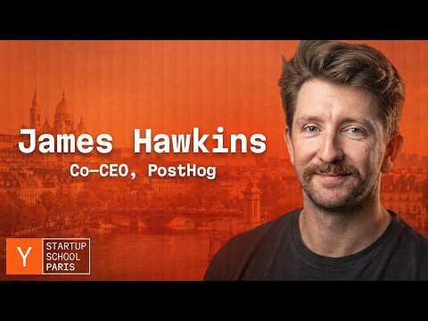 Why Ambitious Startup Ideas Are Actually Easier To Sell (0:53)
- How Supabase Became One Of The Fastest Growing DevTool Companies In The World — a useful discussion of agents as database users, platform-scale database management, and the move toward self-driving operations. [11] 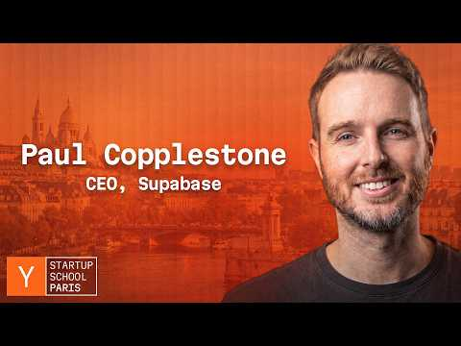 How Supabase Became One Of The Fastest Growing DevTool Companies In The World (16:09)
- Inside the Model Factory — Eiso Kant, Poolside AI — a detailed account of Poolside’s model-building system: immutable data, experiments-as-code, streamed training data, and the operational infrastructure behind rapid experiment velocity. [22]

Sources
- 𝕏 post by @ycombinator
- 𝕏 post by @a16z
- 𝕏 post by @ajay_bcv
- 𝕏 post by @a16z
- 𝕏 post by @ycombinator
- Why Ambitious Startup Ideas Are Actually Easier To Sell
- 𝕏 post by @ycombinator
- r/SaaS post by u/galacticacap
- r/SideProject post by u/Independent-Laugh701
- r/SaaS post by u/FreshnessAi
- How Supabase Became One Of The Fastest Growing DevTool Companies In The World
- 𝕏 post by @cursor_ai
- 𝕏 post by @martin_casado
- r/SideProject post by u/Adr-740
- 𝕏 post by @scotty529
- 𝕏 post by @ycombinator
- 𝕏 post by @ycombinator
- 𝕏 post by @seeamshahidnoor
- 𝕏 post by @andrewchen
- 𝕏 post by @rrhoover
- r/SaaS post by u/Forward-Actuator1165
- Inside the Model Factory — Eiso Kant, Poolside AI

