AI Superpowers Leads Today’s Picks on China, Category Design, and Creator Craft
Recommended Reading from Tech Founders
2026-04-08

AI Superpowers Leads Today’s Picks on China, Category Design, and Creator Craft
By Recommended Reading from Tech Founders • April 8, 2026
Balaji Srinivasan’s recommendation of AI Superpowers stands out because he gives a specific reason to read it: understanding the history of the Chinese tech ecosystem. Tim Ferriss’s picks cluster around category creation and the kind of focused long-form media work he thinks is hard to replicate.

What stood out
Today’s organic recommendations split into two useful groups: one book recommendation with a very clear use case, and a set of Tim Ferriss references centered on category creation and hard-to-copy media craft [1, 2].
Exact URLs to the recommended resources were not included in the source material, so the links below point to the conversations where the recommendations were made.

Most compelling recommendation

AI Superpowers
- Content type: Book
- Author/creator: Kai-Fu Lee
- Link/URL: Not provided in source material
- Who recommended it: Balaji Srinivasan
- Key takeaway: Balaji recommends the book for its history of the Chinese tech ecosystem and says that ecosystem can be understood as a kind of “Galapagos Islands,” where similar kinds of products evolved in different forms [1]
- Why it matters: This is the strongest pick today because it comes with a specific reading job, not just praise: use it to build historical context for how a major tech ecosystem developed outside the US [1]
- Source conversation: The a16z Show
“But read Kai Fu Lee’s book AI Superpowers…” [1] 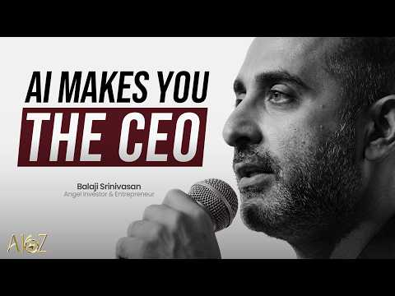 AI Won’t Take Your Job—It Will Make You the CEO | The a16z Show (7:11)

Tim Ferriss’s strongest strategy and media picks
Source conversation: Daredevil Michelle Khare — How to Become a YouTube Superstar

Blue Ocean Strategy
- Content type: Book
- Author/creator: Not specified in the source material
- Link/URL: Not provided in source material
- Who recommended it: Tim Ferriss
- Key takeaway: Ferriss ties it to the importance of owning or creating a “category of one” and calls it a good exploration of that idea [2]
- Why it matters: It is the clearest strategy recommendation in today’s set because Ferriss connects it directly to positioning and category creation [2]

Super Size Me
- Content type: Not specified in the source material; referenced as a category-redefining experiment
- Author/creator: Morgan Spurlock
- Link/URL: Not provided in source material
- Who recommended it: Tim Ferriss
- Key takeaway: Ferriss describes it as a genre-breaking, category-redefining experiment [2]
- Why it matters: It appears here as a model of work that creates its own lane, which is the same broader theme Ferriss highlights with category ownership [2]

Colin and Samir
- Content type: Interview media
- Author/creator: Colin and Samir
- Link/URL: Not provided in source material
- Who recommended it: Tim Ferriss
- Key takeaway: Ferriss says they are among the best interviewers, especially on the creator economy and the practical details of making things in the current era [2]
- Why it matters: This is the most directly useful media recommendation today for readers who want creator-economy insight plus execution detail, not just general commentary [2]
“Colin and Samir [are] the best interviewers out there, in my opinion, especially when it comes to creator economy and the nuts and bolts of making things in this modern era.” [2]

Acquired
- Content type: Long-form media
- Author/creator: Not specified in the source material
- Link/URL: Not provided in source material
- Who recommended it: Tim Ferriss
- Key takeaway: Ferriss cites Acquired as an example of excellent, highly focused long-form work [2]
- Why it matters: It stands out as a benchmark for depth and concentration rather than breadth or novelty alone [2]

David Senra / Founders
- Content type: Long-form media
- Author/creator: David Senra
- Link/URL: Not provided in source material
- Who recommended it: Tim Ferriss
- Key takeaway: Ferriss points to David Senra’s work as highly focused long-form content that is hard to replicate because of the amount of work involved [2]
- Why it matters: This is a strong signal for readers who want examples of sustained research depth and disciplined format execution [2]

Lower-context but still notable

The Year of Living Biblically
- Content type: Book
- Author/creator: AJ Jacobs
- Link/URL: Not provided in source material
- Who recommended it: Tim Ferriss
- Key takeaway: Ferriss calls it an “amazing book” and uses AJ Jacobs as a standout example [2]
- Why it matters: The rationale is thinner than the other picks, but it is still a direct, named recommendation from Ferriss rather than a generic mention [2]

Bottom line
The strongest signal today is specificity. Balaji gives a concrete reason to read AI Superpowers, while Ferriss’s recommendations cluster around two recurring ideas: create your own category, and study the people who execute focused long-form work at a very high level [1, 2].

Sources
- AI Won’t Take Your Job—It Will Make You the CEO | The a16z Show
- Daredevil Michelle Khare — How to Become a YouTube Superstar

