An AI Essay That Changed Garry Tan’s Thinking, and a Useful World-Models Taxonomy
Recommended Reading from Tech Founders
2026-03-15

An AI Essay That Changed Garry Tan’s Thinking, and a Useful World-Models Taxonomy
By Recommended Reading from Tech Founders • March 15, 2026
Garry Tan provides today’s strongest signal, saying a Sam Altman essay changed how he thinks about what builders should do next in AI. The rest of the set includes his shorter book recommendation, Scott Belsky’s endorsed world-models taxonomy, and one repeat-view cultural pick from Paul Graham.

Strongest signal: the Sam Altman essay Garry Tan says “opened my eyes”
Among today’s items, this is the clearest recommendation tied to a change in thinking. Tan says a Sam Altman essay he refers to as Age of Intelligence “really opened my eyes” to what he thinks builders should do next [1].
“His essay of Age of Intelligence was what really opened my eyes to what I think we should do from here, which is I think it’s time for us to boil the oceans.” [1] 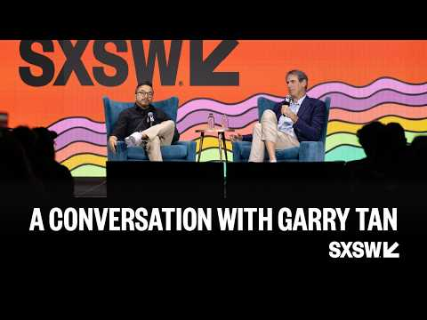 A Conversation with Garry Tan (21:56)
- Title: Age of Intelligence (as Garry Tan names it) [1]
- Content type: Essay [1]
- Author/creator: Sam Altman [1]
- Who recommended it: Garry Tan [1]
- Key takeaway: Tan says it changed how he thinks about what to do from here and pairs that with criticism of what he sees as too much doomerism from some frontier labs [1]
- Why it matters: This is the strongest signal in the batch because the endorsement is explicitly about changed thinking, not generic praise [1]

Same recommender, much shorter format
Tan also reaches for a very different kind of resource: a compact book he describes as simple but foundational [1].
- Title: Who Moved My Cheese [1]
- Content type: Book [1]
- Author/creator: Not specified in the provided material
- Who recommended it: Garry Tan [1]
- Key takeaway: He calls it “a short, very simple book” and also “the defining” one [1]
- Why it matters: The strength of the endorsement stands out given how compact he says the book is [1]

Best map for a crowded AI topic
Scott Belsky’s most useful recommendation today is an explanatory X thread by @zhuokaiz that he calls “good posts on blurring lines of varied approaches to so-called world models…” [2]
“good posts on blurring lines of varied approaches to so-called world models…” [2]
- Title: Five categories of world models [3]
- Content type: X thread [2]
- Author/creator: @zhuokaiz [2]
- Link/URL: https://x.com/zhuokaiz/status/2032201769053212682 [2]
- Who recommended it: Scott Belsky [2]
- Key takeaway: The thread is useful because it does not flatten “world models” into one idea; it organizes the space into JEPA, spatial intelligence, learned simulation, NVIDIA Cosmos, and active inference [3]
- Why it matters: For readers trying to get oriented quickly, a five-part taxonomy is more actionable than treating the whole field as a single bucket [3]
A few concrete anchors from the thread:
- JEPA / V-JEPA 2: latent-space prediction instead of pixel reconstruction; after large-scale video pretraining, just 62 hours of robot data is described as enough for zero-shot planning [3]
- Spatial intelligence / Marble: persistent 3D environments that can be generated from images, text, video, or 3D layouts [3]
- Learned simulation: the thread argues generative video models and RL world models are converging around the same need—simulating how actions change environments over longer horizons [3]
- NVIDIA Cosmos: positioned as a platform play spanning data curation, tokenization, training, and deployment rather than one world model alone [3]
- Active inference / AXIOM: an object-centric, Bayesian alternative to monolithic neural world models, with robotics examples built around hierarchical agents and online inference [3]

One offbeat repeat-view pick
This is the outlier in today’s set, but it is still a clear organic recommendation because Graham emphasizes repeat viewing, not novelty [4].
- Title: The Larry Sanders Show [4]
- Content type: Show / series [4]
- Author/creator: Not specified in the provided material
- Who recommended it: Paul Graham [4]
- Key takeaway: He says the show is “so amazing,” says he is watching it again “for about the fourth time,” and calls it “brilliant people skewering a world they know all too well” [4]
- Why it matters: The repeat-viewing detail makes this feel more durable than a one-off mention [4]

What stands out
The most useful recommendations today do one of two things: they either clearly change a leader’s posture or they make a crowded area legible. Garry Tan’s Sam Altman essay recommendation is strong because he explicitly says it reframed what to do next, while Scott Belsky’s thread recommendation is useful because it gives readers a compact map of competing world-model approaches [1, 2, 3].

Sources
- A Conversation with Garry Tan
- 𝕏 post by @scottbelsky
- 𝕏 post by @zhuokaiz
- 𝕏 post by @paulg

