Archil Raises, Noetik Lands GSK, and AI Control Layers Move Center Stage
VC Tech Radar
2026-04-21

Archil Raises, Noetik Lands GSK, and AI Control Layers Move Center Stage
By VC Tech Radar • April 21, 2026
Archil’s $11M Series A and Noetik’s GSK platform deal were the clearest financing signals, while emerging teams clustered around enterprise knowledge, deterministic workflows, and AI governance. Memory, security, and enterprise budget shifts continue to define where durable AI moats may form.

1) Funding & Deals
- Archil — $11M Series A. Archil raised an $11M Series A led by Standard_Cap to build the layer connecting AI to its data [1]. The product thesis is that next-generation agentic applications are inherently stateful, and Archil gives agents an infinite, high-performance file system they can use to run bash and Linux programs directly [1]. Dalton Caldwell said founder Hunter Leath is the deepest filesystem expert he has met and argued filesystems are the best storage primitive for agents [2].
- Noetik — GSK commercial validation. Latent Space profiled Noetik, an early-stage AI biotech founded by Ron Alfa and Daniel Bear, after GSK signed a deal with $50M upfront plus undisclosed long-term licensing for its technology, including models like TARIO-2 [3]. The write-up frames this as a platform bet on improving tumor-treatment matching in a domain where 95% of cancer treatments fail clinical trials, not a standard drug-asset deal [3]. TARIO-2 is described as an autoregressive transformer trained on one of the largest tumor spatial transcriptomics datasets and able to predict an ~19,000-gene spatial map from standard H&E slides [3].

2) Emerging Teams
- Regulated enterprise AI compliance founder signal. An unnamed solo founder says an AI-native compliance stack combining a data layer, AI agents, and SaaS has been live about six months, generated under $50K from paid Fortune 100 pilots, and has 15+ active deals in negotiation [4]. The founder says the MVP was built largely with Cursor, Claude, and contractor help after years in leadership roles in the target regulated market [4]. In the discussion, lack of a broader team—especially a technical cofounder—was cited as a likely fundraising objection [4, 5].
- Ontora. Y Combinator highlighted Ontora, founded by @dav1dk0rn, @LeonIwanowitsch, and @maxonary, as a system that interviews every employee in large companies to find bottlenecks and make that tacit knowledge available to AI tools [6].
- interfaze_ai. Y Combinator also highlighted interfaze_ai from @yoeven and @khurdula as a model for deterministic tasks such as OCR, object detection, web scraping, speech-to-text, and classification, with the explicit positioning that general LLMs still fail on these workloads [7].
- ResilAI. ResilAI launched a public beta for AI-security incident readiness, using what the founder calls a deterministic governance factory that integrates telemetry from Splunk and Panther to move GRC from checkbox surveys toward a verified system of record [8]. The stack is FastAPI/Python, React/Vite, Gemini Flash for narrative only, and Cloud Run/Firebase [8].

3) AI & Tech Breakthroughs
- Automated alignment research is starting to look practical. Import AI says Anthropic’s Claude-based automated alignment researchers recovered 97% of the weak-to-strong supervision performance gap versus 23% for humans, at about $18,000 over 800 agent-hours [9]. The write-up frames this as an early signal that outcome-gradable AI research can already be automated [9].
- Memory is moving from feature to moat. OpenAI released a research preview of Chronicle in Codex so the system can build memories from day-to-day computer work, and expanded the experiment with recent screen context so users do not need to restate what they are working on [10, 11].
“memory will be the great lock in” [12]
- Agent-security stacks are getting more context-aware. GStack Browser v0.15 added defense-in-depth against website prompt injections and improved BrowseSafe-Bench detection from 15.3% to 67.3%; false positives are non-blocking, and the project is open source [13, 14, 15, 16]. Separately, a solo founder’s Arc Gate proxy claims session-level detection of multi-turn manipulation via trajectory tracking, 192/192 blocked prompts on Garak, and model-version drift detection between GPT-3.5-turbo and GPT-4 [17].
- China’s AI stack is improving on both efficiency and capability. Import AI says Huawei’s HiFloat4 4-bit format beats MXFP4 on Ascend NPUs and gets within about 1% relative loss of BF16 across multiple LLMs, which it ties to export-control-driven pressure to squeeze more out of domestic hardware [9]. The same issue says Kimi K2.5 looks close to GPT 5.2 and Claude Opus 4.5 on dual-use capability evaluations but diverges more on refusals and alignment [9].

4) Market Signals
- Enterprise AI budgets are moving out of IT and into OPEX. Aaron Levie argues token budgets will increasingly be treated as operating expense rather than software-license spend, letting AI budgets compete with broader line-of-business spending [18, 19]. In the same discussion, he says that shift could materially expand the size of enterprise tech budgets [19].
- The bottleneck is workflow redesign and governance, not model access. Levie says real-world implementation remains multi-year and predicts 500K-1M “Agent Operators” to redesign processes, manage prompts and skills, and wire agents into regulated functions [18, 20, 19]. Foundation Capital’s enterprise AI panel points to the same need for control layers, permissions, governance, and production testing beyond pristine pilots [21].
- Procurement is adapting to category volatility. SaaStr says sub-1-year contracts rose from 4% of new-logo deals in 2023 to 13% in 2026, three-year deals fell from 28% to 23%, average sales cycles shortened from 25 weeks to 19 weeks, and 48% of companies use hybrid pricing as their primary model [22]. The stated reason is that buyers do not want long commitments while AI products, pricing, and category leaders are changing this quickly [22].
- Frontier insiders expect more junior-level work to come into scope for automation, but adoption still lags. Exponential View says nearly a third of surveyed Anthropic staff believe Mythos Preview could replace junior engineers and researchers within three months [23]. The same piece says inference costs are approaching 10% of engineering headcount, one company nearly halved the cost of each code change and doubled weekly deployments over five months, and usage limits plus a 98.32% Claude API uptime figure show that infrastructure friction is still real [23].
- Investor appetite is strongest at the frontier, even as public-market proof remains messy. Levie says he would still be “loading up” on frontier rounds because the end-market is larger than most people think [18, 19]. Harry Stebbings notes that even Box—at $1B+ ARR—is valued at $3.3B and being punished by Wall Street [18].

5) Worth Your Time
- 20VC / Aaron Levie on the agentic enterprise. Best for the case that token budgets shift into OPEX, “agent operators” emerge as a real job category, and evals/observability become core infrastructure [19]. Watch the episode
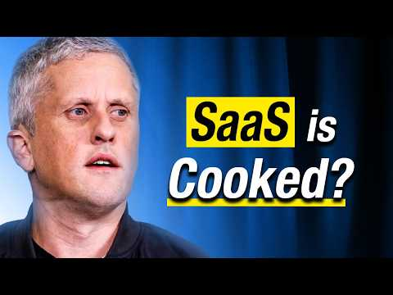 Are SaaS Companies Cooked: Which Thrive & Which Die | Aaron Levie (52:12)
- Foundation Capital — enterprise AI from pilots to production. Useful for the clearest operator view on control planes, governance, permissions, and the gap between pilot demos and production reality [21]. Watch the panel
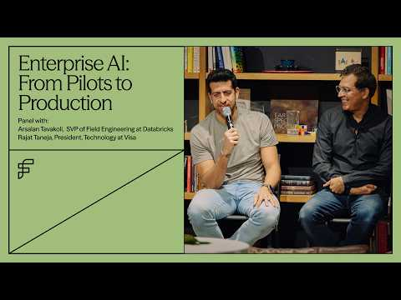 Enterprise AI: From Pilots to Production (0:58)
- Latent Space on Noetik. Good background on why the GSK deal matters, the 95% cancer-trial failure framing, and Noetik’s multimodal tumor-data moat [3]. Read the profile
- Import AI 454. Best single piece here for automated alignment research, Huawei’s HiFloat4 efficiency gains, and the capability/alignment split showing up in Chinese open models [9]. Read the issue
- GStack Browser thread + repo. Useful if you want a concrete browser-agent security implementation with defense-in-depth against website prompt injection, a BrowseSafe-Bench lift from 15.3% to 67.3%, and an open-source install path through Claude Code [13, 15, 16]. Open the repo

Sources
- 𝕏 post by @archildata
- 𝕏 post by @daltonc
- 🔬 Training Transformers to solve 95% failure rate of Cancer Trials — Ron Alfa & Daniel Bear, Noetik
- r/SaaS post by u/Economy_Key486
- r/SaaS comment by u/AdVegetable1234
- 𝕏 post by @ycombinator
- 𝕏 post by @ycombinator
- r/SaaS post by u/ProfessionalBridge89
- Import AI 454: Automating alignment research; safety study of a Chinese model; HiFloat4
- 𝕏 post by @thsottiaux
- 𝕏 post by @OpenAIDevs
- 𝕏 post by @hwchase17
- 𝕏 post by @garrytan
- 𝕏 post by @garrytan
- 𝕏 post by @garrytan
- 𝕏 post by @garrytan
- r/deeplearning post by u/Turbulent-Tap6723
- 𝕏 post by @HarryStebbings
- Are SaaS Companies Cooked: Which Thrive & Which Die | Aaron Levie
- 𝕏 post by @HarryStebbings
- Enterprise AI: From Pilots to Production
- It’s Not Just You. Customers Are Asking for Shorter and Shorter Contracts in the Age of AI
- 📈 Data to start your week: Inside the AI boom – jobs, jargon & jittery uptime

