Asimov's Robot Stories Lead Today's Picks, With The Beginning of Infinity and a Crime-Tech Essay Also Surfacing
Recommended Reading from Tech Founders
2026-04-07

Asimov’s Robot Stories Lead Today’s Picks, With The Beginning of Infinity and a Crime-Tech Essay Also Surfacing
By Recommended Reading from Tech Founders • April 7, 2026
The strongest signal today is Isaac Asimov: in the Sam Altman–Francois Chollet AGI conversation, his Robot stories and Foundation series surfaced twice as formative reading. Andrew Chen also shared a practical article on crime, tech, and how to make things better.

What stood out
Only a small number of recommendations cleared the authenticity bar today, but one stood out because it surfaced twice in a serious AGI conversation and was framed as formative rather than casually interesting.

Most compelling recommendation

Isaac Asimov’s Robot stories and Foundation series
- Content type: Books / science fiction series
- Author/creator: Isaac Asimov
- Link/URL: None provided in the source material
- Who recommended it: Both speakers in AGI: Francois Chollet + Sam Altman [1]
- Key takeaway: One speaker said Asimov’s Robot stories were a major influence behind wanting to build human-level AI since age 16, while the other said Asimov may have had more impact when younger than The Beginning of Infinity [1]
- Why it matters: This is the strongest pick today because it appears twice, unprompted, in a conversation about AGI and is tied to long-run intellectual formation rather than a passing endorsement [1]
“I’ve wanted to build human level AI since I was like 16. And I think one of the big influences on me at the time was Asimov’s Robot Stories.” [1] 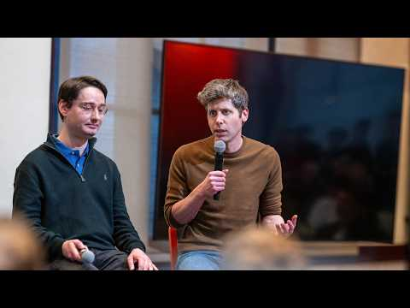 AGI: Francois Chollet + Sam Altman (27:07)

Also worth saving

The Beginning of Infinity
- Content type: Book
- Author/creator: Not specified in the source material
- Link/URL: None provided in the source material
- Who recommended it: A speaker in AGI: Francois Chollet + Sam Altman said it was the book they were going to choose as most impactful [1]
- Key takeaway: It surfaced as the first answer in a discussion of the most impactful book, before that speaker added that Asimov may have had more impact earlier in life [1]
- Why it matters: Even with limited context, it was positioned at the top of a very short list of personally important books in the same AGI discussion [1]

Crime-and-tech writeup (title not provided)
- Content type: Article
- Author/creator: Not specified in the source material
- Link/URL: http://x.com/i/article/2041160953094639617 [2]
- Who recommended it: Andrew Chen [3]
- Key takeaway: After describing personal experiences with car break-ins, a garage break-in, and stolen bikes in San Francisco, Chen called it a “great writeup about crime and tech and how to make it all better” [3]
- Why it matters: This is the most practical recommendation in today’s set: it is framed as a resource on a concrete problem and possible improvements, not just commentary on the problem itself [3]
Across today’s picks, the split is clear: the books are presented as deep formative influences, while the article is recommended for its applied thinking on a live civic issue [1, 3].

Sources
- AGI: Francois Chollet + Sam Altman
- 𝕏 post by @davidu
- 𝕏 post by @andrewchen

