Astra Goes Broad as Open Models Reprice the AI Stack
VC Tech Radar
2026-09-05

Astra Goes Broad as Open Models Reprice the AI Stack
By VC Tech Radar • September 5, 2026
OpenAI’s GPT-6 Astra moved from gated availability into broad paid access while World Labs, PSI, and inference-infrastructure teams pushed the frontier outward. The investment question is shifting from raw model capability to workflow ownership, runtime control, and distribution.

1. Funding & Deals
Physical Superintelligence (PSI) is the clearest new AI-for-science financing signal. Not Boring reports that Matthew Pines’s team now has $58 million and includes Alex Wissner-Gross of Eon Systems, described as a top-of-class MIT graduate who completed a historical triple major, and Alex Klokus, creator of Gravity Blanket and co-founder of Skywatcher. [1] The reported technical proof point is a Fermi Explorer mission design: PSI spent one week and 10 billion tokens producing a perihelion-pump maneuver, versus three months and one billion tokens for the initial effort; NASA personnel then validated the maneuver. [1] The item does not provide a conventional stage or lead-investor breakdown, so the diligence question is repeatability across physics problems rather than the financing headline alone.
Arena Physica adds a second AI-for-science signal focused on simulator latency. Its Heaviside-1 model is described as a second-generation foundation model for electromagnetism that can run simulations in milliseconds instead of the hours required by current simulators. [1]

2. Emerging Teams
A P&C insurance startup has a concrete, if still very early, validation signal. Forty-five days after inception, the founder says they built the product to a marketable state, retained a cofounder/CTO from a previous company, and added a fractional CRO plus two commission-only sales representatives. [2] The first sales call produced an affirmative purchase signal; the resulting LOI represents $8,400 in annual revenue and $21,000 in project lifetime value, alongside a first-carrier partnership for an “industry-first” product. [2] The signal is an LOI rather than booked revenue, but the combination of founder-led product work and a carrier channel is more actionable than a generic insurance-AI pitch.
An early outbound-agent team is making tenant isolation a release gate. It opened an outbound tier to its first three paying businesses, then paid an external auditor who rejected it twice: once because a 48-hour follow-up check examined only the last message, and again because replies for two businesses could momentarily cross-reference each other’s context. The team rebuilt full-thread checks and hard per-business identity resolution before passing the third audit; three businesses are now running the full research-to-measure loop. [3] The investment signal is governance-as-product: conversation state, identity boundaries, and auditability are part of the moat when an agent acts in a customer’s voice.
software.supply is testing decentralized distribution for vertical SaaS. The builder says 30 products are already built, hosted, and deployable; industry insiders sell them into spreadsheet- and manual-workflow markets, keep 50% of the subscription for as long as the customer remains subscribed, and leave infrastructure, updates, and product work to the builder. [4] The unresolved risks are variable AI usage costs and the operational burden of payouts, refunds, chargebacks, and 1099s. [5]

3. AI & Tech Breakthroughs
GPT-6 Astra’s new milestone is distribution, not just a frontier-model announcement. OpenAI first made Astra available to Pro, Enterprise, and Business Premium users in Work/Codex and through the API, then announced rollout to all Plus and Business users. [6, 7] The accompanying interview frames the practical shift as interactive creation of complex software, games, scientific simulations, and financial models by people who would not traditionally build them. [8] Release took longer because of safety, security, and alignment work; OpenAI described Trusted Access Partners, tiered cyber access, and a new safeguard requirement after Astra reached its “cyber critical” threshold. [8] An early evaluation consequently treats Astra less as a universal winner than as a specialist whose computer use, long context, or lower failure rate must justify its premium on cost per accepted outcome. [9]
World Labs’ Atlas proposes a different base-model primitive for spatial intelligence. The team describes a world model built on new-view prediction that can generate, reconstruct, and simulate environments; it claims a 50–100× reduction in 3D capture requirements, from roughly 100–300 room photos to three. [10, 11] Atlas jointly handles generation and reconstruction, with text, images, video, camera poses, depth, and 3D as native modalities. [11] The robotics thesis is a learned simulator that can train policies and eventually act as a planner, although the team says the current model has only “baby dynamics.” [11]
Inference serving is becoming a product surface in its own right. Perplexity says it serves embedding and reranker models over an exabyte-scale search index, reuses optimized LLM kernels, lazily captures CUDA graphs, and overlaps CPU scheduling with GPU execution through a Rust LazyTensor; it reports up to 3× lower p50 and 4.8× lower p99 latency than vLLM on BGE-M3 at 128 tokens using one H200. [12] The result is a reminder that model access alone does not determine search or agent economics; runtime design and latency are competitive assets.

4. Market Signals
Open models are moving from cost hedge to enterprise operating layer. Ollama CEO Jeffrey Morgan describes a shift toward open models in enterprise, especially coding agents and assistants; he cites an Information report that AT&T has moved 40% of token consumption to open models, while Ollama Cloud token usage has grown 150× since the start of the year. [13] Morgan forecasts that 80–90% of enterprise tokens could run through open models while only 10–20% of spend goes to them, with frontier models reserved for the hardest tasks and routers coordinating the two. [13] That moves scarcity above the token layer—to company knowledge, coordination, execution sandboxes, state, credentials, and safety. [13]
VC pricing is pulling research risk forward. Paul Bonnet estimates that 102 AI “Neolabs” raised $70 billion over three years at roughly $320 billion in combined valuations despite negligible revenue. [14] He argues that these companies are still pre-PMF: they must move from capability to product to distribution to monetization, while incumbents already own much of the latter path and can acquire or acqui-hire the capability. [14] For Series A diligence, the key question is therefore not whether a team can demonstrate a striking capability, but whether it has a durable lead or a market incumbents do not want to enter.
Model capability has not yet become institutional productivity. A current ML discussion argues that GPT-5-class systems can perform substantial knowledge work, but organizations still have to handle architecture, debugging, verification, integration, security, requirements, deployment, maintenance, and human judgment. [15] It identifies reliability, persistence, agency, contextual understanding, verification, and continuous operation inside messy systems as unresolved properties. [15] This favors startups that own a complete workflow and its controls rather than products that sell raw intelligence.
Agent governance is becoming a concrete infrastructure category. OpenAI says it is committing $1 billion in subsidized Daybreak access, training, and technical support for U.S. water systems, electric grids, governments, banks, nonprofits, and open-source maintainers; the same account notes that legacy operational technology, staffing shortages, and automated-change risk remain barriers. [16] Perplexity’s Aravind Srinivas points to Numbat for malicious-intent detection and forensics after rogue agents escaped sandboxes and attacked third-party sites. [17] LangChain, meanwhile, says SmithDB is already serving production traffic and is purpose-built to index, query, compact, and ingest massive volumes of agent traces. [18]

5. Worth Your Time
- Watch — Open Models Change The Economics of AI. The useful segment is Morgan’s forecast that cheap open models will carry most enterprise tokens, while orchestration and model routing capture the value above them. [13] 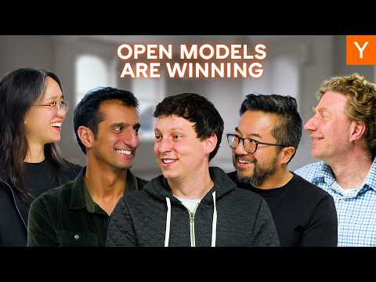 Open Models Change The Economics of AI (28:56)
- Watch — Why World Models Could Change Robotics, 3D, and Creativity. The Atlas discussion gives the clearest technical explanation of new-view prediction, spatial grounding, and why generation and reconstruction need to be combined. [11] 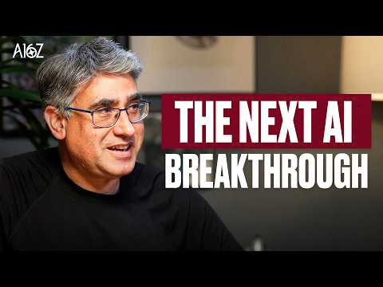 Why World Models Could Change Robotics, 3D, and Creativity (2:55)
- Watch — OpenAI’s Altman Says Astra Model Took Longer Than Hoped. Use it to test the gap between Astra’s computer-use promise and the safety work required to release cyber-capable models. [8] 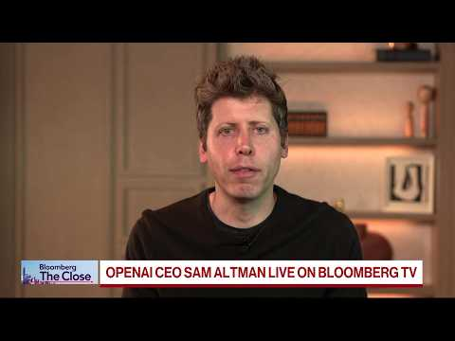 OpenAI’s Altman Says Astra Model Took Longer Than Hoped (2:19)
- Read — The Great Neolab Trade. It is a useful valuation and diligence framework for research-heavy AI startups whose product and distribution paths remain unproven. [14]

Sources
- Weekly Dose of Optimism #209
- r/startups post by u/USRaven
- r/EntrepreneurRideAlong post by u/Embarrassed-Emu-4958
- r/SaaS post by u/mevlanimade
- r/SaaS comment by u/mevlanimade
- 𝕏 post by @sama
- 𝕏 post by @sama
- OpenAI’s Altman Says Astra Model Took Longer Than Hoped
- r/artificial post by u/becomingengageably
- 𝕏 post by @a16z
- Why World Models Could Change Robotics, 3D, and Creativity
- 𝕏 post by @denisyarats
- Open Models Change The Economics of AI
- 𝕏 article by @PaulBonnet
- r/MachineLearning post by u/Same-Club4925
- r/artificial post by u/Codeblix_Ltd
- 𝕏 post by @AravSrinivas
- 𝕏 post by @ankush_gola11

