Ben Thompson’s systems view of AI gets a double endorsement
Recommended Reading from Tech Founders
2026-08-22

Ben Thompson’s systems view of AI gets a double endorsement
By Recommended Reading from Tech Founders • August 22, 2026
An evidence-first reading list led by two separate endorsements of Ben Thompson, with a bounded Nature Human Behaviour study and Tim Ferriss’s personal book recommendation as complementary picks.
Two separate recommendations make Ben Thompson the clearest signal in this set: Bill Gurley calls a Thompson conversation “very good,” while Not Boring calls his AI-router breakdown “characteristically good.” [1, 2]

Standout: My conversation with Ben Thompson
- Content type / creator: Video conversation hosted by Patrick O’Shaughnessy with Ben Thompson, who has written Stratechery for more than a decade and is described by O’Shaughnessy as one of his favorite business thinkers. Watch the conversation. [3]
- Recommended by: Bill Gurley, who calls it “very good” and says Thompson brings a career of thinking to current events. Gurley’s favorite part is the opening argument that there is no reasonable path for the United States to achieve AI dominance over the rest of the world. [1]
- Key takeaway: The conversation connects that geopolitical claim to questions about AI funding, model capabilities, compute and chip suppliers, advertising, Nvidia’s competitive position, and the major platform companies. [3]
- Why it matters: It is the strongest single resource here for pressure-testing AI “race” narratives against the underlying economics of funding, infrastructure, distribution, and business models.

Companion AI-infrastructure read: Stripe Acquiring OpenRouter, Aggregating AI?, Flipping the Business Model
- Content type / creator: Stratechery analysis by Ben Thompson. Packy’s link points to Stratechery generally; the current Stratechery listing identifies the relevant OpenRouter analysis by this title and supplies the direct link. [2, 4]
- Recommended by: Packy McCormick, who calls Thompson’s breakdown “characteristically good” in a discussion of AI model routers. [2]
- Key takeaway: Routers send each task to the model that fits its needs: frontier capability when it is worth paying for, or a cheaper and faster model when it is sufficient. Packy ties that choice to “Return on Tokens”; Stratechery’s accessible teaser frames Stripe’s reported OpenRouter acquisition as a bet on a future market of models and aggregation. [2, 5]
- Why it matters: The useful lens is operational rather than tribal: model choice becomes a routing problem governed by capability, speed, and cost. The direct article page exposed only a teaser in the source capture, so this recommendation is best treated as a pointer to that thesis rather than a full article summary. [5]

Research pick: Voluntary attention regulates acute immune responses in humans
- Content type / creators: Research paper by Nofar Mizrachi, Menachem Rottem, and Liron Rozenkrantz in Nature Human Behaviour. Read the paper. [2]
- Recommended by: Packy McCormick in Weekly Dose of Optimism, who connects the result to his argument that deliberate attention creates meaning and concludes, “Attention really is all you need.” [2]
- Key takeaway: Across three pre-registered within-subject experiments, directing attention toward bodily sensations rather than distraction produced roughly 1.5-fold smaller acute inflammatory responses, with the effect appearing in about 90% of participants across two cohorts. [6]
- Why it matters: This is a concrete, checkable finding—not a general claim that attention treats disease. The authors stress that the model involved localized, acute, histamine-induced inflammation in healthy participants, and that its relevance to infectious, chronic, or autoimmune conditions remains unclear. [6]

Personal practice: Radical Acceptance: Embracing Your Life with the Heart of a Buddha
- Content type / creator: Book by Tara Brach, Ph.D. The post text does not name the book; the attached cover identifies the title and author. Ferriss’s recommendation post. [7, 8]
- Recommended by: Tim Ferriss, who calls it a “godsend” for people who beat themselves up and says it was recommended to him by a neuroscience PhD and then a cynical friend, both of whom said it changed their lives. [7]
- Key takeaway: Ferriss describes it as one of the most useful books he has read, says it is easy to digest, and recommends one short chapter before bed each night. [7]
- Why it matters: The recommendation comes with a clear, low-friction way to test the book rather than a generic endorsement.
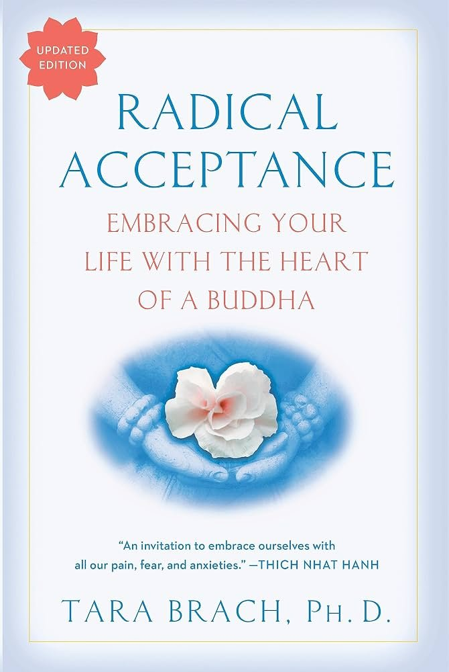
Attached cover image
Cover image from Tim Ferriss’s post.

Sources
- 𝕏 post by @bgurley
- Weekly Dose of Optimism #207
- 𝕏 post by @patrick_oshag
- Stratechery by Ben Thompson
- Stripe Acquiring OpenRouter, Aggregating AI?, Flipping the Business Model
- Voluntary attention regulates acute immune responses in humans - Nature Human Behaviour
- 𝕏 post by @tferriss
- 𝕏 post by @tferriss

