Bootstrapping, Agentic Bug-Finding, and Data Center Water Use
Recommended Reading from Tech Founders
2026-06-23

Bootstrapping, Agentic Bug-Finding, and Data Center Water Use
By Recommended Reading from Tech Founders • June 23, 2026
Satya Nadella’s reread of Bootstrapping was the strongest organic recommendation today, offering a clear historical frame for AI copilots. Marc Andreessen and Aravind Srinivas added practical resources on agentic debugging at Mozilla scale and how to think about water consumption in liquid-cooled data centers.

What stood out
The common thread in today’s strongest recommendations is specificity. Each came with a concrete lesson rather than a simple title drop: a historical frame for AI copilots, a practical pattern for agentic debugging, and a narrower way to think about data-center water use [1, 2, 3].

Most compelling recommendation

Bootstrapping
- Content type: Book
- Author/creator: Thierry Bardini [1]
- Link/URL: Not provided in the source notes
- Who recommended it: Satya Nadella [1]
- Key takeaway: Nadella said he recently reread the book for its account of Douglas Engelbart’s work on the mouse, keyboard, GUI, and human-computer symbiosis aimed at augmenting human capability; he sees AI copilots as taking that vision a step further [1]
- Why it matters: This was the day’s strongest recommendation because it combined a reread, a specific intellectual lineage from personal computing to AI, and a broader human lesson about choosing important work in response to urgent problems [1]
“essentially now this new generation of AI is really helping us take that vision to the next step.” [1] 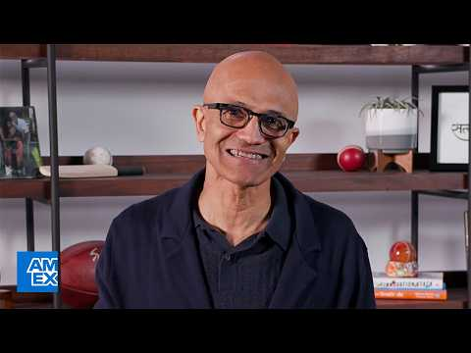 In Partnership With Satya Nadella, Microsoft CEO | American Express (0:45)

Two more worth saving

How to fix all the bugs
- Content type: Video
- Author/creator: Not specified in the source notes; the episode features Brian Grinstead of Mozilla walking through the harness [2]
- Link/URL: https://youtu.be/Idjt53tTv2U [2]
- Who recommended it: Marc Andreessen [4]
- Key takeaway: The video covers how Mozilla tested Claude Mythos against Firefox’s 10M-line codebase, producing more than 400 security bug fixes, with emphasis on goal/loop patterns, verifiers, and false-positive handling [2]
- Why it matters: The value here is operational. The source stresses that the outcome was “50% mythos / 50% setup,” making this a useful resource for readers interested in how agentic systems are actually configured on large codebases [2]

NVIDIA on data center water use
- Content type: X post/thread
- Author/creator: NVIDIA [3]
- Link/URL: https://x.com/nvidia/status/2069147938098483586 [3]
- Who recommended it: Aravind Srinivas [3]
- Key takeaway: Srinivas highlighted NVIDIA’s claim that the marginal water consumption of a properly implemented data center for liquid cooling is almost zero, and that people often conflate water used by power plants with water used to cool the data center itself [3]
- Why it matters: For readers following AI infrastructure debates, this recommendation is useful because it sharpens one specific accounting distinction rather than making a broad claim about all data-center water use [3]

If you only save one
Save Bootstrapping. It had the clearest combination of conviction and explanation: Nadella did not just recommend the book; he explained why he rereads it, what historical vision it helps recover, and how that vision informs his view of AI copilots today [1].

Sources
- In Partnership With Satya Nadella, Microsoft CEO | American Express
- 𝕏 post by @clairevo
- 𝕏 post by @AravSrinivas
- 𝕏 post by @pmarca

