Brian Chesky’s Bill Walsh Playbook, Elena Verna on AI Freemium, and Bill Gurley’s Innovation Pick
Recommended Reading from Tech Founders
2026-05-06

Brian Chesky’s Bill Walsh Playbook, Elena Verna on AI Freemium, and Bill Gurley’s Innovation Pick
By Recommended Reading from Tech Founders • May 6, 2026
Today’s highest-signal recommendations came with clear operating logic: perfect inputs instead of chasing outcomes, give AI users enough free magic to hit the aha moment fast, and look to David Epstein’s new book for company-level innovation.

What stood out
The strongest recommendations today were the ones that came with a reusable operating lesson, not just a title drop. Brian Chesky tied one book to Airbnb’s shift from chasing the scorecard to perfecting inputs, Vikas Kansal highlighted a concrete AI freemium framework, and Bill Gurley made an unusually direct case for a new book on company-level innovation [1, 2, 3].

Most compelling recommendation

The Score Takes Care of Itself
- Content type: Book
- Author/creator: Bill Walsh
- Link/URL: No direct book URL was provided in the notes; source context: How Brian Chesky Is Redesigning Airbnb for the AI Era
- Who recommended it: Brian Chesky [1]
- Key takeaway: Chesky uses Walsh’s principle to shift attention away from the scorecard and toward perfecting the inputs: simplicity, craft, and rigorous attention to small details [1]
- Why it matters: This was the clearest recommendation in the set because Chesky connected it to a concrete operating change: Airbnb still cared about growth, but stopped centering growth and started centering perfection [1]
“Basically, don’t focus on winning. Focus on getting all the inputs perfect.” [1] 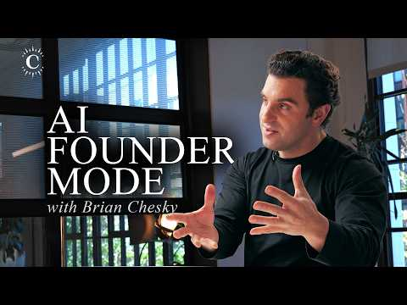 How Brian Chesky Is Redesigning Airbnb for the AI Era (34:46)

Other high-signal recommendations

Why AI doesn’t mean the end of freemium
- Content type: Article
- Author/creator: Elena Verna
- Link/URL: https://www.elenaverna.com/p/why-ai-doesnt-mean-the-end-of-freemium
- Who recommended it: Vikas Kansal [2]
- Key takeaway: AI products should not follow the standard SaaS freemium playbook of giving away the basics and gating the best features. Users need a large amount of free “magic” to reach the aha moment, and time-to-value needs to feel immediate [2]
- Why it matters: This is a specific framework for AI product design and monetization, not a generic growth opinion. It reframes freemium around delivering enough product experience before asking for commitment [2]
“You have to give away a massive amount of ‘magic’ for users to get to the aha moment.” [2]

Inside the Box
- Content type: Book
- Author/creator: David Epstein
- Link/URL: No direct book URL was provided in the notes; source context: Bill Gurley’s post
- Who recommended it: Bill Gurley [3]
- Key takeaway: Gurley framed the book as an answer to the question of how to drive innovation, especially at the company level [3]
- Why it matters: The endorsement was brief but unusually strong: Gurley called it a must-read and positioned it as directly useful for operators thinking about innovation inside organizations [3]
“Many wonder what the secret is to driving innovation, especially at the company level. The answers are in here! Must read.” [3]

Rick Rubin book (exact title not specified in the extracted notes)
- Content type: Book
- Author/creator: Rick Rubin
- Link/URL: No direct book URL was provided in the notes; source context: How Brian Chesky Is Redesigning Airbnb for the AI Era
- Who recommended it: Brian Chesky [1]
- Key takeaway: Chesky singled out Rubin’s idea that an artist makes work for themselves rather than trying to make something successful [1]
- Why it matters: He tied the idea to his own reset: stop trying to be successful, return to the basics, and do the work because you love it [1]

Bottom line
If you save one thing today, save The Score Takes Care of Itself. It had the strongest evidence of real impact because Chesky linked it to how he thinks about product quality, organizational rigor, and the choice to perfect inputs instead of obsessing over outcomes [1].

Sources
- How Brian Chesky Is Redesigning Airbnb for the AI Era
- Why SaaS freemium playbooks don’t work in AI, and what to do instead
- 𝕏 post by @bgurley

