Caitlyn Kalinowski’s Classics List and Tobi Lütke’s Death’s End Endorsement
Recommended Reading from Tech Founders
2026-05-18

Caitlyn Kalinowski’s Classics List and Tobi Lütke’s Death’s End Endorsement
By Recommended Reading from Tech Founders • May 18, 2026
Today’s authentic recommendations were all books: Caitlyn Kalinowski named three titles from a classics-heavy reading list, and Tobi Lütke gave a concise endorsement of the trilogy discussed through Death’s End. The clearest single pick was Herodotus’s Histories, because it came with the strongest explanation of why it matters.

What stood out
Today’s authentic recommendations were all books. Caitlyn Kalinowski surfaced a classics-heavy reading list in conversation, while Tobi Lütke gave a terse but direct endorsement of the trilogy being praised in a post about finishing Death’s End [1, 2, 3].
The strongest single recommendation was Histories because Kalinowski explained exactly why she values it: as the first history book, built from firsthand and secondhand accounts, and as a window into a very different era [1].

Most compelling recommendation

Histories
- Content type: Book
- Author/creator: Herodotus
- Link/URL: Not provided in the source material
- Who recommended it: Caitlyn Kalinowski
- Key takeaway: Kalinowski called it “pretty incredible” and highlighted it as the first history book, noting that it often relies on firsthand or secondhand accounts and lets readers look into a completely different era [1]
- Why it matters: This was the richest recommendation in today’s set because it came with a clear explanation of both the book’s method and its enduring value [1]
“Herodotus histories is pretty incredible… it’s the first history book… It’s a way to look into the world at a completely different era than it is now.” [1] 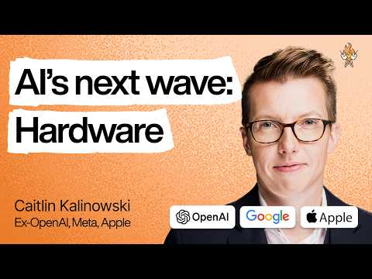 Why we’re at the beginning of the AI hardware boom | Caitlin Kalinowski (ex–OpenAI, Meta, Apple) (92:46)

Also worth reading

Mrs. Dalloway
- Content type: Book
- Author/creator: Virginia Woolf
- Link/URL: Not provided in the source material
- Who recommended it: Caitlyn Kalinowski
- Key takeaway: She described it as “a very interesting book about transitions” and noted its post-war context [1]
- Why it matters: The recommendation is specific about what the reader gets from it: a literary treatment of transition rather than a generic classic-novel endorsement [1]

Book of the New Sun
- Content type: Book (fiction)
- Author/creator: Not specified in the source material
- Link/URL: Not provided in the source material
- Who recommended it: Caitlyn Kalinowski
- Key takeaway: Kalinowski called it “a great fiction book” that she really recommends [1]
- Why it matters: It is the clearest fiction-forward pick in her list and stands on a direct, unqualified endorsement [1]

Death’s End trilogy
- Content type: Book series / trilogy
- Author/creator: Not specified in the source material
- Link/URL: Not provided in the source material
- Who recommended it: Tobi Lütke
- Key takeaway: Lütke replied “incredible series” to a post that said, “Just finished Death’s End. My god, what a trilogy” [2, 3]
- Why it matters: The signal is brief but clean: it is an explicit founder endorsement of a specific trilogy, not a vague comment about reading in general [2, 3]
“incredible series” [2]

Bottom line
If you only pick one item from today’s set, start with Histories for the clearest articulated reason to read it [1]. More broadly, the day’s organic signals were entirely book-focused: Kalinowski’s classics-heavy list on one side, and Lütke’s direct trilogy endorsement on the other [1, 2, 3].

Sources
- Why we’re at the beginning of the AI hardware boom | Caitlin Kalinowski (ex–OpenAI, Meta, Apple)
- 𝕏 post by @tobi
- 𝕏 post by @boycereads

