Claude Code Auto Mode Is Not a Security Boundary
Coding Agents Alpha Tracker
2026-08-28

Claude Code Auto Mode Is Not a Security Boundary
By Coding Agents Alpha Tracker • August 28, 2026
A targeted prompt-injection report punctures unattended-agent assumptions; the practical response is tighter sandboxing, leaner context, cheaper behavioral routing, and staged verification.

🔥 TOP SIGNAL
Claude Code Opus 5 Auto Mode should be treated as approval UX, not containment. Johann Rehberger’s targeted test, summarized by Simon Willison, used a ZIP archive’s local struct.py to shadow Python’s standard library; variants succeeded in 3/5 or 4/5 runs, but the author explicitly calls those small samples rather than a universal attack-success rate. [1, 2] In some runs Claude recognized the compromise but Auto Mode denied cleanup; the report records Anthropic’s position that Auto Mode is a best-effort classifier and that OS isolation plus network-egress control are the real boundary. [2] For unattended coding, use a container, VM, or OS sandbox, restrict egress, monitor the agent, withhold home directories and credentials, and never treat an Auto Mode approval as evidence that code is safe. [2]

⚡ TRY THIS
- Audit the harness, not just the prompt. Run /doctor inside a Claude Code session every few weeks—claude doctor in a shell is only installation diagnostics—and inspect /memory separately. Addy Osmani’s audit covers unused skills, MCP servers and plugins relative to context cost, oversized CLAUDE.md files, slow hooks, and cruft. [3] Then retry a representative task with local skills disabled and archive anything that does not earn its place; keep CLAUDE.md/AGENTS.md focused on checks, expensive commands, generated files, boundaries, and unusual conventions, while moving rules that must always hold into tests, hooks, or permissions. [3]
- Use a behavioral model as a PR queue worker. Start with Theo’s prompt—“Take a look at all the pull requests I currently have open in this repo. Help me prioritize them based on ease of merge and the value that they provide to our users.”—then steer in place: exclude Codex PRs, keep the Fable/Cloud Code set, and request an HTML report for phone review. [4] In the broader run, six subagents assessed overlap, fixed issues, merge risk, confidence, and closure; three hit provider/API failures, but the agent recovered by reading GitHub metadata, diffs, reviews, CI comments, and local source context, auditing hundreds of PRs in about 20 minutes and surfacing eight easy merges. [4] Theo’s selection rule is useful: prioritize staying on task, accepting mid-run steering, and self-unblocking over raw intelligence; he later corrected the cost of a 1,000-plus-PR audit from roughly 50 cents to 12 cents. [4]
- Turn rewrites into phased, self-checking migrations. Start with easy or frequently updated files, add a retry loop, then build a more capable pipeline for the hard remainder: Airbnb moved 75% of 3,500 Enzyme test files in four hours, reached 97% after four days, and left the final 3% to engineers. [5] For a product-scale conversion, feed the agent production runtime types, segmented tests, and an incremental boundary; Mike Krieger describes a dynamic workflow that ported and repeatedly verified a couple hundred thousand lines of Python to TypeScript over a weekend. [6] Treat ROI headlines carefully: Asana’s roughly $6 million pre-AI baseline was a back-of-the-envelope estimate, not observed spend. [5]
- Separate personal context from write access. Peter Steinberger’s setup uses Telegram/OpenClaw for brainstorming and personal context, Codex for coding, and a context call from Codex to Claw only when needed. Start the execution agent read-only or restrict it to trusted folders; useful delegation does not require production access. [7]

📡 WHAT SHIPPED
- Anthropic’s Model Hardware Standard entered research preview. MHS is a model-agnostic specification for programmable lab and manufacturing equipment: standardized read/write primitives and device discovery replace bespoke translators, while natural-language hardware tags generate reference files containing capabilities and enforced safety limits. Agents can operate devices through MCP, the CLI, or code files, then chain learned sequences into deterministic scripts for long-running work. [8] This is still a preview rather than an open-source release; hardware needs a programming interface, and Anthropic says Claude Code’s physical reasoning still requires expert oversight. [8]
- LangChain tightened the deploy loop. Managed Deep Agents can bake an environment once at deploy time from setup.sh or a Dockerfile, so new threads start without cloning or reinstalling. LangChain also says agents built in natural language can deploy to Slack in one click through its “Add to Slack” partnership. [9, 10]
- GLM 5.3 Flash is the Ox Alpha model Theo actually kept using. His field report describes a multimodal, one-million-token, open-weight model with hybrid attention and roughly $0.09 per task versus about $0.05 for Luna; the trade-off is token efficiency—about 47,000 tokens per task versus 20,000 for Luna Max and 17,000 for Soul. [4] Theo’s conclusion is task-specific: keep Fable/Soul for hard problems, but use GLM for cheap, persistent, vision-capable agent work; during the free testing window he says it became the top model on OpenRouter and OpenCode. [4]
- OpenClaw is pushing toward code-native tool use. The project is fully open-source TypeScript, model-agnostic, and exposes a plugin interface for other model companies and harnesses. Its maintainers are experimenting on a branch with “code mode,” where the agent writes JavaScript for tool calls rather than issuing only regular calls—a proposed way to reduce loops and unify MCP invocation, not a finished feature. [7]
- T3 Code crossed 20,000 GitHub stars, while its instruction layer got better. Theo attributes a substantial PR-quality improvement to tuning agentsmd/claudemd; he says the clearest gain was that PR names and descriptions became “100% easier to understand,” while pushing for simple, concise changes also improved the code. [11, 12, 13]

🎬 GO DEEPER
- Theo — “Ox Alpha is INSANE”: Watch the PR-audit fallback and model-behavior sections. The useful lesson is not the leaderboard claim; it is the agent recovering from failed subagents, filtering a large PR portfolio, and producing merge candidates while Theo explains why obedience and persistence can beat raw intelligence for cheap agentic work. [4] 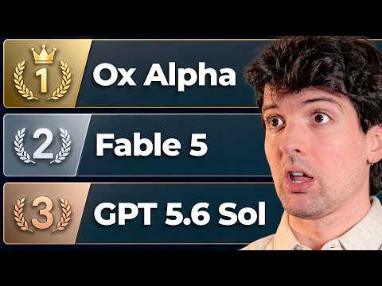 Ox Alpha is INSANE (6:42)
- Mike Krieger — “How Anthropic Builds: Lessons from Labs”: Use the end-state-delegation and migration segments, then the discussion of async agents that own a slice of a codebase, monitor feedback, and remain human-driven at review time. [6] 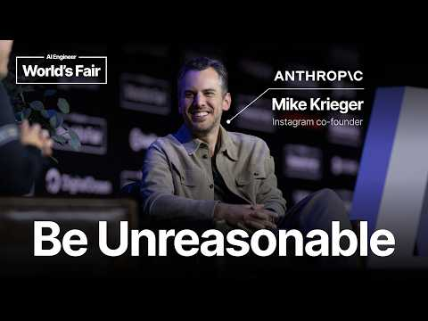 How Anthropic Builds: Lessons from Labs — Mike Krieger, Anthropic (1:02)
- OpenClaw maintainers — “OpenClaw Went Viral. Meet the Maintainers Building and Securing It.”: The practical section is the Codex↔Claw context bridge and the least-privilege rollout; the later discussion shows how the project replaces telemetry with agent-assisted crawling of Discord, Twitter, GitHub issues, and PRs to group problems and prioritize fixes. [7] 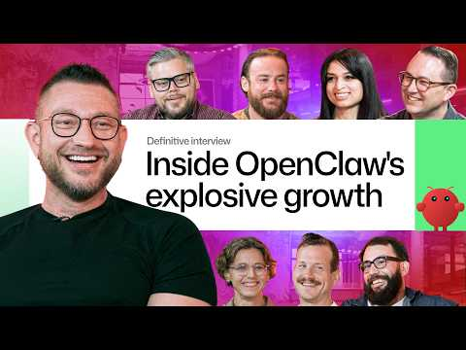 OpenClaw Went Viral. Meet the Maintainers Building and Securing It. (18:38)
Editorial take: The winning agent stack is becoming less trusting and more structured: sandbox execution, lean configuration, behavioral model routing, staged verification, and code-native tool calls matter more than another generic “best model” ranking. [2, 3, 5, 7, 4]

Sources
- Breaking Claude Code Opus 5 Auto Mode
- Breaking Claude Code Opus 5 Auto Mode
- Audit your Agent files
- Ox Alpha is INSANE
- The Pulse: We need to talk about migrations with AI
- How Anthropic Builds: Lessons from Labs — Mike Krieger, Anthropic
- OpenClaw Went Viral. Meet the Maintainers Building and Securing It.
- Previewing the Model Hardware Standard
- 𝕏 post by @bromann
- 𝕏 post by @LangChain
- 𝕏 post by @theo
- 𝕏 post by @theo
- 𝕏 post by @theo

