Claude Code Makes Orchestration a Feature
Coding Agents Alpha Tracker
2026-05-29

Claude Code Makes Orchestration a Feature
By Coding Agents Alpha Tracker • May 29, 2026
Anthropic’s dynamic workflows dominated today’s discussion, but the sharper lesson came from practitioners building and using coding agents for real work: orchestration, environment setup, and verification matter more than swarm hype. This brief pulls the strongest workflows, launches, and clips into one practical scan.

🔥 TOP SIGNAL
- Claude Code’s new dynamic workflows make orchestration itself a first-class feature: Claude writes a plan, fans work across 100s of subagents, verifies the results, and returns one answer [1, 2]. That matches what background-agent builders are actually saying works today: Walden Yan describes practical multi-agent coding as a manager/subagent pattern with isolated boxes, not chaotic swarms, and Addy Osmani’s warning is that verification, not generation, is the scarce skill now [3, 4].
- The real proof points were practical, not theoretical: Cat used workflows to audit hundreds of A/B flags in parallel in under 10 minutes, and Anthropic pointed to Jarred Sumner using them on Bun’s Zig→Rust port at ~750k lines, 99.8% tests passing, in 11 days from first commit to merge [5, 6].

⚡ TRY THIS
- Use dynamic workflows only when the task is too wide for one pass. In Claude Code, turn on auto mode, then either mention workflow in the prompt or enable Ultra Code from the effort menu so Claude can decide when to fan work out. A good copyable use case from Cat: ask it to catalogue all feature flags and identify the ones stuck at 0% or 100% rollout; Boris Cherny says save workflows for token-heavy jobs like migrations, refactors, perf work, and batch bug fixes [1, 7, 5, 8].
- If you’re building your own background agent, split control plane from sandbox on day 1. Walden Yan’s pattern is to keep the brain outside the machine, scope secrets to the sandbox, and reuse existing dev boxes; Cole Murray’s OpenInspect adds setup.sh hooks, pre-snapshots, and restore hooks so the agent starts from a ready environment. Use Docker Compose for infra parity, but expect full VMs when you need real app execution, nested virtualization, screenshots, or video-based testing [3, 9].
- Make the agent prove it before you believe it. Walden Yan says testing is an orchestration problem: the hard part is running the right services, flags, and sessions, not clicking pixels [3]. Addy Osmani’s rule is to codify good with tests, user journeys, and visual regression, because generation is easy now and verification is not [4]. Mitchell Hashimoto’s renderer story is the right cautionary baseline: the agent improved frame time from 88ms to 1.5ms, but a hand-written version still hit ~20µs with zero allocations, so don’t merge just because the number got better [10].
“Generation is now easy. Verification is a big thing…” [4]
- Route effort like you route models. Alex Albert’s practical split: use /fast for interactive back-and-forth, normal mode for async work, and push to xhigh only for the longest or hardest jobs. That matters more now that Fast mode is roughly 2.5x faster and 3x cheaper, while Opus 4.8 defaults to high effort with about the same token spend as 4.7’s default [11, 12, 13, 14].

📡 WHAT SHIPPED
- Claude Opus 4.8 — Boris Cherny calls it Anthropic’s strongest coding model yet: SWE-Bench Pro moved from 64.3 → 69.2 at the same price, and Cat says it’s now the recommended daily model for Claude Code [15, 16]. Simon Willison highlighted three agent-relevant changes: mid-conversation role: "system" messages, a lower prompt-cache minimum of 1,024 tokens, and Anthropic’s own claim that 4.8 is about 4x less likely than 4.7 to let flawed code pass unremarked [17].
- Claude Code dynamic workflows (research preview) — available across Claude Code CLI/Desktop/VS Code plus Anthropic API, Bedrock, Vertex AI, and Foundry; best in auto mode / Ultra Code [7]. Real usage examples today were strong: Cat’s stale-flag cleanup in <10 minutes, plus the Bun Zig→Rust port case study [5, 6].
- Cursor + Opus 4.8 — shipped same day [18]. Cursor says 4.8 is more efficient and more persistent on harder tasks, while Theo says the updated CursorBench shows slightly worse raw performance than 4.7 but still within margin of error; Jediah Katz’s live take is that it has “very good judgment” [18, 19, 20].
- OpenInspect — Cole Murray open-sourced a cloud/background-agent foundation with Slack/GitHub triggers, screenshots/video, setup.sh + snapshot restore, an optional GitHub reviewer, and pluggable sandboxes. Repo: https://github.com/ColeMurray/background-agents [3, 9].
- LangChain Deep Agents — Managed Deep Agents can run without a custom agent server, and Deep Agents v0.6 adds ContextHubBackend for versioned files that shape agent behavior from one run to the next [21, 22, 23].
- OpenClaw — a nice open-source harness cleanup: cold turns 2.9x faster, warm turns 2.5x faster, tarball 59% smaller, deps down 42%. Blog: https://openclaw.ai/blog/lighter-core-sharper-claws/ [24].

🎬 GO DEEPER
- 20:55-22:23 — Walden Yan on why testing beats computer use. Best short clip today if you’re still thinking coding agents fail because they can’t click well enough. His point: real testing means orchestrating frontend, backend, services, flags, and session state correctly [3].
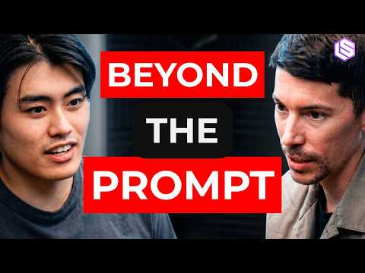 Devin’s 80% Moment: Background Agents, 7x PRs, & End of Hand-Held Coding — Walden Yan & Cole Murray (20:55)
- 13:39-14:55 — Walden Yan on separating the brain from the machine. Watch this before you decide between in-box and out-of-box agent architecture. It’s the cleanest explanation in today’s set for scoped secrets, permission boundaries, and why this design lets you reuse existing dev boxes [3].
Devin’s 80% Moment: Background Agents, 7x PRs, & End of Hand-Held Coding — Walden Yan & Cole Murray (13:38)
- 14:34-15:52 — Matthew Berman walking through dynamic workflows. Good quick explainer on the Anthropic pattern: one main agent plans, parallel subagents attack the problem from independent angles, and adversarial checks try to break the answer before it comes back [7, 25].
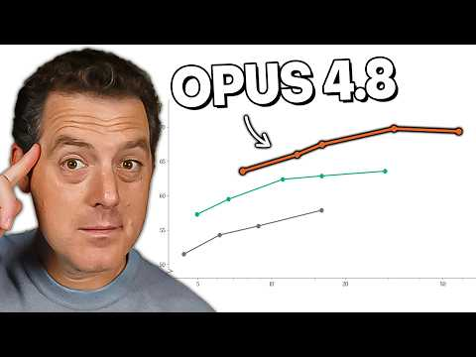 Anthropic just dropped Opus 4.8… (WOAH) (14:34)
- 12:37-13:40 — Addy Osmani on cognitive debt. Worth watching as the day’s best anti-hype check: over-relying on agents can erode muscle memory, and blind acceptance turns convenience into cognitive surrender [4].
 Don’t Lose Your Engineering Identity Working With AI Agents (12:37)
- Repo to study — OpenInspect / Background Agents. One of the clearest open-source references for a Slack-triggered background-agent stack with snapshots, reviewers, screenshots/video, and pluggable sandbox providers. Repo: https://github.com/ColeMurray/background-agents [3, 9].
- Worth reading — Anthropic’s dynamic workflows case study. If you want the official framing plus the Bun migration example, start here: http://claude.com/blog/introducing-dynamic-workflows-in-claude-code [6, 26].
Editorial take: the useful frontier is not “more agents” by itself — it’s better orchestration, better environments, and much stricter verification. [1, 3, 4]

Sources
- 𝕏 post by @_catwu
- 𝕏 post by @_catwu
- Devin’s 80% Moment: Background Agents, 7x PRs, & End of Hand-Held Coding — Walden Yan & Cole Murray
- Don’t Lose Your Engineering Identity Working With AI Agents
- 𝕏 post by @_catwu
- 𝕏 post by @_catwu
- Anthropic just dropped Opus 4.8… (WOAH)
- 𝕏 post by @bcherny
- The Age of Async Agents — Cognition’s Walden Yan & OpenInspect’s Cole Murray
- 𝕏 post by @mitchellh
- 𝕏 post by @alexalbert__
- 𝕏 post by @claudeai
- 𝕏 post by @bcherny
- 𝕏 post by @_catwu
- 𝕏 post by @bcherny
- 𝕏 post by @_catwu
- I think Anthropic and OpenAI have found product-market fit
- 𝕏 post by @cursor_ai
- 𝕏 post by @theo
- 𝕏 post by @jediahkatz
- 𝕏 post by @LangChain
- 𝕏 post by @LangChain
- 𝕏 post by @LangChain
- 𝕏 post by @openclaw
- OPUS 4.8!!! (also maybe GPT5.6??)
- 𝕏 post by @bcherny

