Claude Code’s Leak Turns Into a Blueprint for Better Coding Agents
Coding Agents Alpha Tracker
2026-04-01

Claude Code’s Leak Turns Into a Blueprint for Better Coding Agents
By Coding Agents Alpha Tracker • April 1, 2026
The strongest signal today is convergence: the best coding-agent systems keep rediscovering the same primitives—filesystem-backed memory, parallel subagents, compaction, permissions, and artifact-based review. Also inside: concrete workflows from Redis, DeepAgents, Antigravity, and AI-native OSS maintenance at scale.

🔥 TOP SIGNAL
The Claude Code leak mattered because it turned a black-box harness into a public design manual. Across Matthew Berman’s teardown and Theo’s local build, the same primitives keep showing up: .claude.md injected every turn, parallel subagents sharing prompt cache, aggressive compaction, preconfigured permissions, hooks, and resumable sessions [1].
More interesting: LangChain’s DeepAgents and Google DeepMind’s Antigravity are independently converging on the same architecture—files as the core primitive, context-isolated subagents, artifact-based monitoring, and UI surfaces for parallel agent control rather than only a command line or conversation stream [2, 3].
That convergence is the real takeaway for builders [1, 2, 3].

🛠️ TOOLS & MODELS
- Claude Code, now inspectable. The leak exposed roughly 2,300 files and nearly half a million lines; a Python port is already running locally, with Berman noting the harness still pairs best with the Claude family of models [1].
- What the leak actually taught. Claude Code uses CLAUDE.md as a per-turn instruction layer, 66 built-in tools split into concurrent read-only vs serialized mutating ops, three subagent execution models, five compaction strategies, permission modes including auto, hooks, and resumable or forkable sessions [1].
- DeepAgents + Arcade = open agent harness stack. DeepAgents packages file tools, planning, context-isolated subagents, skills, pluggable file backends, and auto-compaction; Arcade layers delegated per-user auth, secrets, RBAC, enterprise SSO, an MCP gateway, and 8,000+ tools on top [2]. Agent Builder exposes this as a no-code chat UI, and Harrison Chase says he now checks his email assistant instead of email directly [2].
- Antigravity’s product bet. Kevin Hou and Varun Mohan describe Google DeepMind’s Antigravity as an agent-first editor where full codebase migrations without human intervention are now within reach, Agent Manager orchestrates many agents in parallel, and users inspect artifacts/documents instead of staring at chat logs [3].
- New releases worth a glance. Claw beta v2026.3.31-beta.1 ships reliability and security improvements plus a new task system for more reliable subagents and crons [4]. CodexBar beta v0.20.0-beta.1 adds experimental multi-account support for Codex [5]. claude.ai/code now supports /web-setup to reuse local GitHub credentials on the web [6, 7].
- Codex is widening its surface area. OpenAI’s new Codex Plugins put Alchemy inside Codex for one-prompt crypto dashboards and related onchain apps [8, 9]. Separately, Niels Rogge says coding agents crossed a threshold in Dec 2025 where they began succeeding at porting entire models, and his Codex writeup covers porting VidEoMT into Transformers plus best practices for async architecture work [10, 11].

💡 WORKFLOWS & TRICKS
- Claude Code operating recipe
  - Put architecture, standards, hotspots, and team taste in .claude.md; it is loaded on every turn [1].
  - Configure permissions up front in settings.json; Berman recommends auto over bypass / dangerously-skip so the model handles routine safe actions but still stops on risky ones [1].
  - Use /compact before the tool does it for you. Compaction is lossy, large tool outputs already spill to disk, and session memory extracts key state to files [1].
  - Resume sessions instead of starting fresh, and split read-heavy work across subagents or worktrees that share prompt cache [1].
- Design the harness around files, not chat
  - Give agents real file ops plus a persistent workspace; Harrison Chase and Sam Partee argue this is why coding agents are the foundation for general-purpose agents [2].
  - Treat agent definitions as files like agent.md, skills, and mcp.json, and keep large tool outputs in files instead of bloating context [2].
  - Prefer simple primitives like text and files over bespoke workflow tools when possible [3].
  - Default writes to human-in-the-loop; DeepAgents and Arcade both frame write actions, verifiers, and step-up auth as harness-layer responsibilities [2].
- Make your codebase agent-legible
  - Add tests and invariants so the agent knows what must remain true after a change [3].
  - Break work into atomic chunks or PR-sized tasks instead of 3,000-line asks [3].
  - If the agent cannot debug or extend the code without hand-holding, treat that as a codebase warning sign, not just a model failure [3].
  - Review agent-produced artifacts and documents, not just token streams [3].
- High-assurance coding loop for serious systems
  - Start with a real spec; Salvatore Sanfilippo spent a month writing an MD spec before generating code for a new Redis data type [12].
  - Generate and review in small sections, then refactor with alternating human and LLM passes [12].
  - Expect strength on complex local functions, but watch for whole-system conceptual errors when the full codebase is not in context [12].
  - Feed failures back into a trace loop: enrich traces with evals and human feedback, turn recurring failures into test cases, validate fixes, repeat. LangChain’s guide is the cleanest short version of this pattern [13].
- AI-native maintenance and security
  - Auto-patrol easy wins on a schedule; Yegge handles docs, small fixes, bot upgrades, and other easy PRs every 2 hours [14].
  - For promising-but-broken PRs, prefer fix-merge over endless request-changes; his workflow includes merge, merge-fix, fix-merge, cherry-pick, split-merge, reimplement, retire, and reject [14].
  - Keep a generalist review bot running on top of specialized scanners. Devin Review caught the axios npm attack for customers within about an hour / 45 minutes after publish, while Socket says it detected the same issue in ~6 minutes [15, 16, 17, 18].
- Use agents for bounded search problems
  - Predrag Gruevski’s Codex prompt was simple: get a JPEG from ~400KB to under 200KB without resizing or visible quality loss [19].
  - Codex responded by setting up perceptual quality assessment, trying a few hundred flag combinations, and returning a 199KB file that looked substantially identical [19, 20].
  - Good template: if success can be scored, let the agent brute-force the search space [19].

👤 PEOPLE TO WATCH
- Harrison Chase + Sam Partee — one of the best current architecture talks on turning coding-agent primitives into general-purpose agents, from builders actively shipping LangChain and Arcade into real enterprise environments [2].
- Steve Yegge — one of the few people publishing hard ops numbers for AI-native OSS maintenance: ~50 AI-generated PRs/day, median 15-hour resolution, ~88% merge rate, and 15–20 hours/week of maintainer effort [14].
“help contributors get to the finish line” [14]
- Salvatore Sanfilippo — Redis creator, using LLMs on production Redis code with a much stricter process than vibe coding. His key caveat: frontier models beat most humans on code quality, but still lag super-experts and can miss system-level issues [12].
- Niels Rogge — a firsthand, production-level Codex account from a Transformers contributor porting VidEoMT into the library. Blog: huggingface.co/blog/nielsr/contributing-to-transformers-with-codex [10].
- Kent C. Dodds — useful counterweight to tool obsession. His point: AI makes spikes and experiments cheaper, so the scarcer skill is still user empathy and problem clarity [21, 22, 23, 24].

🎬 WATCH & LISTEN
- 9:20–11:30 — Claude Code compaction modes. Best short breakdown of micro compaction, context collapse, session memory, and why to call /compact proactively before auto-compaction drops context you care about [1].
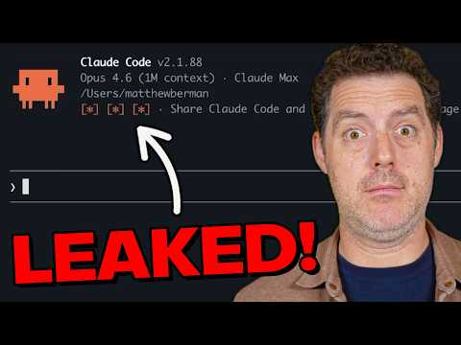 Claude Code was just leaked… (WOAH) (9:20)
- 6:28–7:36 — DeepAgents’ file-system substrate. Harrison Chase explains the pluggable file backend idea cleanly: agents think in files even when the actual storage is a DB or remote sandbox [2].
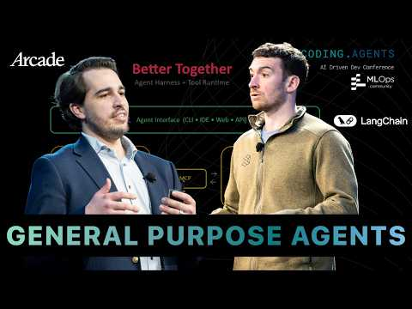 How to Make a Coding Agent a General Purpose Agent - Harrison Chase (6:28)
- 19:10–20:38 — A hardware founder uses Claude Code to build AWS telemetry. Sam D’Amico’s segment is worth the time because it is not an AI-tool demo guy; it is a practitioner using Sonnet + Claude Code + Cursor to ship infrastructure he had never built before [25].
 The Stove Guy: Sam D’Amico Shows New AI Cooking Features on America’s Most Powerful Stove at Impulse (19:10)

📊 PROJECTS & REPOS
- Beads — 20k stars, 5 months old. Yegge says it remains the durable substrate of the MEOW stack, with work decomposed into version-controlled, SQL-queryable orchestration steps via Dolt [14].
- Gas Town — 13k stars, 3 months old. Community signal: 1,000+ contributors, 4k+ PRs, 2,300+ merged, 15k commits, and nearly 2,000 users in the Gas Town Hall Discord [14].
- Gas City — went alpha last week, with general availability planned later in April. It is a ground-up rewrite and near-superset of Gas Town, with Gas Town itself becoming a declarative pack inside a broader orchestrator-builder [14].
- Claw v2026.3.31-beta.1 — small but relevant release if you track open coding-agent infrastructure: reliability and security improvements plus a new task system for subagents and crons [4].
- CodexBar v0.20.0-beta.1 — experimental multi-account support for Codex; small feature, real usefulness if you juggle multiple accounts or org contexts [5].
Editorial take: the durable edge right now is boring infrastructure around the model — files, tests, traces, permissions, review bots, and artifact UIs — not another clever prompt [2, 3, 13, 15].

Sources
- Claude Code was just leaked… (WOAH)
- How to Make a Coding Agent a General Purpose Agent - Harrison Chase
- Google DeepMind’s Vision for Agent-First Development | Kevin Hou and Varun Mohan on Antigravity
- 𝕏 post by @steipete
- 𝕏 post by @steipete
- 𝕏 post by @_catwu
- 𝕏 post by @_catwu
- 𝕏 post by @Alchemy
- 𝕏 post by @romainhuet
- 𝕏 post by @NielsRogge
- 𝕏 post by @embirico
- Slop artificiale? Spesso è solo umana
- 𝕏 post by @LangChain
- Vibe Maintainer
- 𝕏 post by @ScottWu46
- 𝕏 post by @swyx
- 𝕏 post by @AhmadNassri
- 𝕏 post by @swyx
- 𝕏 post by @PredragGruevski
- 𝕏 post by @romainhuet
- 𝕏 post by @kentcdodds
- 𝕏 post by @kentcdodds
- 𝕏 post by @kentcdodds
- 𝕏 post by @kentcdodds
- The Stove Guy: Sam D’Amico Shows New AI Cooking Features on America’s Most Powerful Stove at Impulse

