Codebase Q&A First, Then Let the Agent Edit
Coding Agents Alpha Tracker
2026-06-29

Codebase Q&A First, Then Let the Agent Edit
By Coding Agents Alpha Tracker • June 29, 2026
Boris Cherny shares a production-tested Claude Code playbook: start with repo Q&A, pin context in CLAUDE.md, and force plan/verification loops before edits. Also: Claude Code’s GitHub app and Hermes’ self-healing, routed-agent stack.

🔥 TOP SIGNAL
Boris Cherny’s strongest production lesson from inside Anthropic: use the coding agent as a codebase interrogator first and an editor second [1]. He says new technical hires start with code Q&A, then gate edits with before you write code, make a plan and run it by me; this is now part of an onboarding flow that he says went from 2-3 weeks to 2-3 days, and roughly 80% of Anthropic’s technical staff use Claude Code daily [1]. Jon Udell’s companion point, surfaced by Simon Willison, is the timeless framing: agentic development should stay our loop, with agents invited into a transparent human-led process rather than treated as a black box [2].

⚡ TRY THIS
- Start with repo Q&A, not codegen (Boris Cherny). Open Claude Code and ask questions like how is this class instantiated?, why does this function have 15 arguments? look through git history, or what did I ship this week?. Cherny says this is the default onboarding move at Anthropic; Claude explores the repo and git history without indexing, keeps code local, and does not train on your code [1].
- Force plan → verify → iterate. Use Cherny’s exact opener: before you write code, make a plan and run it by me [1]. Then give the agent a way to check itself—unit tests, Puppeteer screenshots, or iOS emulator screenshots—and let it run 2-3 feedback rounds; for UI work, you can also drag in a mock image and have Claude implement against it [1]. If it’s clearly on track, Shift+Tab moves Claude Code into auto-accept edits mode, and commit push pr will usually handle branch, commit, push, and PR creation [1].
- Externalize durable context into CLAUDE.md. Put a short CLAUDE.md at the repo root and check it into git for the team; fill it with common bash/MCP commands, style guide rules, architectural decisions, and core files [1]. Add nested CLAUDE.md files for subdirectories, keep them short so they do not waste context, and use # in-session when you want Claude to remember a new rule and fold it into the file [1].
- Use the agent like a UNIX utility in ops and CI. Cherny’s claude -p pattern: pass a prompt, allowed tools, and JSON or streaming JSON output, then pipe in things like git status, Sentry CLI output, or GCP logs [1]. For parallel work, run multiple sessions via tmux or SSH and isolate them with git worktrees instead of one giant session [1].

📡 WHAT SHIPPED
- Claude Code GitHub app. Anthropic announced a GitHub app that lets you mention Claude directly on any GitHub issue or PR; Cherny also says Claude Code is already used daily by roughly 80% of Anthropic’s technical staff, including researchers, which is a stronger adoption signal than most launch posts [1].
- Hermes is pushing a more modular agent stack. In Matthew Berman’s tutorial, Hermes shows built-in coding skills plus three patterns worth stealing: self-healing when a skill hits an unseen error, siloed agent profiles instead of one bloated assistant, and per-task model routing for vision, compression, and web extraction [3]. In the demo, a Manim skill turned make a cool video explaining how exponentials work into a 58-second animated MP4 [3].

🎬 GO DEEPER
- 4:05-7:16 — Boris Cherny’s Claude Code walkthrough on codebase Q&A. Best clip if you’re still using coding agents mainly for edits: Cherny shows the exact class-usage, git-history, and weekly-ship prompts that made this the first-day workflow for Anthropic onboarding [1].
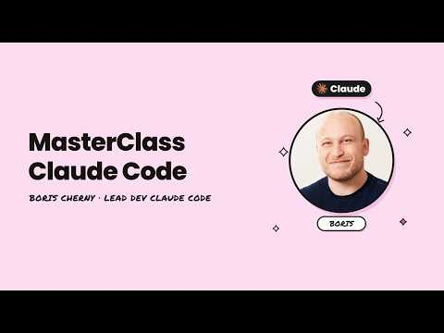 MasterClass du créateur de Claude Code : Boris Cherny (4:05)
- 12:25-13:59 — Cherny on CLAUDE.md. Strong reminder that context engineering does not need to be fancy: short repo-level instructions, nested directory-level context, and team-shared conventions beat re-explaining the same codebase every session [1].
MasterClass du créateur de Claude Code : Boris Cherny (12:24)
- 21:08-23:07 — Cherny on claude -p for CI and incident response. Worth watching if you want the agent outside the chat UI: JSON output, shell piping, and log triage make the CLI feel like a programmable UNIX tool [1].
MasterClass du créateur de Claude Code : Boris Cherny (21:08)
Editorial take: the highest-signal agent workflows still look human-owned—ask better questions, pin context to files, require a plan, and give the model a way to prove its work [1, 2].

Sources
- MasterClass du créateur de Claude Code : Boris Cherny
- Quoting Jon Udell
- “The best thing since OpenClaw” (Hermes Tutorial)

