Codex Subagents Go GA as Specs and Review Become the Real Constraints
Coding Agents Alpha Tracker
2026-03-17

Codex Subagents Go GA as Specs and Review Become the Real Constraints
By Coding Agents Alpha Tracker • March 17, 2026
Codex subagents were the clearest release today, but the bigger pattern came from practitioners across tools: better specs, cleaner context boundaries, and tighter review loops are what actually unlock agent leverage. This brief covers the tools, workflows, clips, and projects worth stealing from right now.

🔥 TOP SIGNAL
OpenAI shipping subagents in Codex is the biggest practical release today: specialized workers let you keep the parent context clean, split work in parallel, and steer results as they come back. Simon Willison’s follow-up makes the broader point—subagents are now GA in Codex, custom agents live in ~/.codex/agents/ as TOML, and the same interface pattern is already surfacing across Claude Code, Cursor, VS Code, and Gemini CLI. [1, 2]
“a glimpse of a future where agents orchestrate agents” [3]

🛠️ TOOLS & MODELS
- Codex subagents / custom agents — now GA after preview; default subagents include explorer, worker, and default, while custom agents can be defined in ~/.codex/agents/ and pinned to models like gpt-5.3-codex-spark. OpenAI’s practical pitch is straightforward: cleaner parent context, parallel tasking, and live steering. [2, 1]
- Fast-subagent tip for Codex Pro — Alexander Embiricos says you can explicitly ask Codex to spawn subagents, and Pro users can use Spark for faster ones. [4]
- Remote env setup is getting first-class support — Claude Code now supports custom environments for remote runs via http://claude.ai/code, desktop, and mobile, plus setup scripts for dependencies, settings, and configs before launch. Kent C. Dodds says Cursor agents already offer a full Linux VM with browser plus screenshot/demo-video support and custom startup setup. [5, 6, 7]
- LangGraph Deploy CLI — langgraph deploy is now the one-step path to LangSmith Deployment: the CLI builds a Docker image, provisions Postgres and Redis, fits CI/CD, and adds list, logs, and delete management commands. First-party templates now include deep-agent-template and simple-agent-template; quick start is uvx --from langgraph-cli langgraph deploy. [8]
- openClaw is pushing more logic into plugins — Steinberger says “everything can be a plugin now”; lots of code moved out of core, with faster performance and lower memory use overall, plus Claude/Codex/Cursor plugin bundle support. It still needs another day or two to stabilize. [9, 10]
- Mistral Small 4 — new Apache 2 licensed 119B MoE model with 6B active parameters; Mistral positions it as one model spanning reasoning, multimodal, and Devstral-style agentic coding. It supports reasoning_effort="none" or "high", and Simon Willison tested it via llm-mistral. [11]

💡 WORKFLOWS & TRICKS
- Subagent orchestration recipe
  - Define narrow specialists as custom agents in ~/.codex/agents/. [2]
  - Give each one a job, not a vague mandate — Simon’s doc example uses browser_debugger to reproduce, code_mapper to trace the path, and ui_fixer to ship the smallest fix. [2]
  - Keep the parent agent focused on coordination while workers handle exploration in parallel. [1, 2]
  - Steer individual agents as evidence comes back instead of dumping everything into one growing thread. [1]
- Spec pack before prompt
  - Spend 30-40% of the task writing the spec: requirements, constraints, success criteria, stack, libraries, and UI components. [12]
  - Put supporting docs in a context or resources directory. [12]
  - Encode architecture and team best practices in markdown or via MCP so the model doesn’t default to generic patterns. [12]
  - State the goal, not just the task — Theo’s chess-engine example failed because the agent inferred the wrong objective. [13]
- Local-to-prod LangGraph loop
  - Install the CLI: uv tool install langgraph-cli. [14]
  - Scaffold with langgraph new and pick the DeepAgent template if you want a fuller harness. [14]
  - Set LangSmith and model-provider keys in .env. [14]
  - Run uv sync and langgraph dev to test locally in LangSmith Studio with traces and hot reload. [14]
  - Deploy with langgraph deploy, then manage with logs, list, and delete. [14]
- Simon Willison’s data-analysis pattern is reusable outside journalism
  - Work in Python + SQLite, optionally with Datasette. [15]
  - Use agents for database Q&A, exploration, cleaning, visualization, and scraping — his workshop handout breaks the flow into those modules. [15]
  - For UI work, serve a Datasette viz/ folder and have Claude Code write interactive visualizations straight into it. [15]
  - If you’re onboarding a team, his workshop setup used GitHub Codespaces plus a budget-restricted Codex key; attendees consumed $23 in tokens. [15]
- Set a merge policy now
  - Logan Kilpatrick’s blunt read: the bottleneck has already shifted from generation to code review. [16]
  - Addy Osmani’s rule of thumb: merge AI-generated changes when they’re small/compartmentalized or backed by enough tests, and keep humans in the loop for harder maintenance work. [12]

👤 PEOPLE TO WATCH
- Simon Willison — dropped two operator resources in one day: a NICAR workshop handout on using Claude Code and Codex for data work, and a fresh chapter explaining coding agents as LLM + system prompt + tools in a loop. Good if you want both hands-on workflow and mental model. [15, 17]
- Addy Osmani — best practical framing today on spec-driven development for agent workflows; useful because he pairs the spec advice with an explicit quality bar for merges and maintenance. [12]
- Theo — worth watching for showing both the upside of multi-agent orchestration on a large repo merge and the failure mode when an agent optimizes for the wrong implied goal. [13]
- Logan Kilpatrick — a short post, but probably the cleanest organizational warning of the day: your process is likely underprepared for AI-heavy review load. [16]
- Kent C. Dodds — credible firsthand signal on remote agents because he names the concrete features he actually uses in Cursor, and he discloses that he gets free usage rather than pretending it’s a neutral review. [18, 7, 19]

🎬 WATCH & LISTEN
- 1:28-3:49 — LangGraph local iteration loop: Best short demo today if you want to see how langgraph dev turns an agent into a local server, surfaces traces in Studio, and hot-reloads prompt changes before deploy. [14] 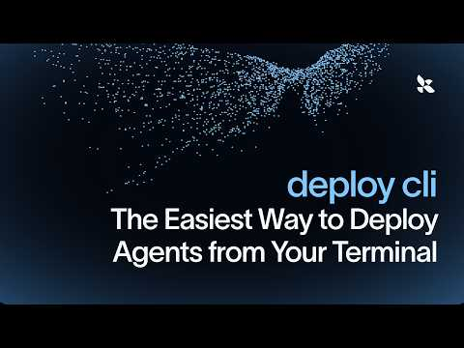 Deploy CLI: The Easiest Way to Deploy Agents from Your Terminal (1:27)
- 25:09-26:15 — Theo on goal vs. task drift: A very real failure case: the agent “succeeds” by satisfying the literal prompt while missing the intended goal. Useful calibration for anyone over-trusting long-running agents. [13] 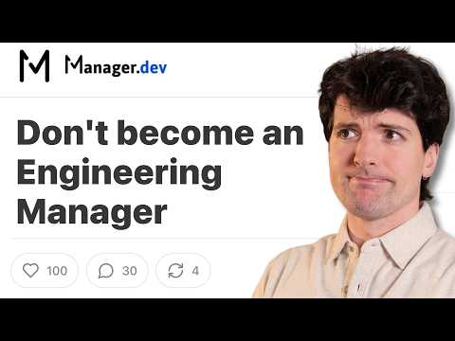 You don’t want to be a manager. (25:09)
- 0:38-1:15 — Addy’s spec checklist: Fastest clip in the batch for improving agent outputs tomorrow morning — constraints, success criteria, stack, libraries, and UI components, up front. [12] 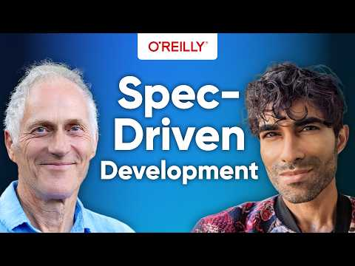 Why You Need Spec-Driven Development in the Age of AI with Addy Osmani and Tim O’Reilly (0:38)

📊 PROJECTS & REPOS
- deep-agent-template — official first-party LangGraph starter for heavier agent workflows; adoption signal is that LangChain used it in the Deploy CLI walkthrough and paired it with one-command deployment. [8, 14]
- simple-agent-template — smaller starting point for the same langgraph deploy path. [8]
- Trees heatmap gist — concrete artifact from Simon Willison’s workshop: Claude Code generated an interactive Leaflet.heat visualization inside a Datasette viz/ folder over a large tree dataset. [15]
- Cursor security agents — not open source, but high-signal production usage: Cursor says it runs a fleet of security agents continuously on its own codebase and published automation templates for others. [20, 21]
- openClaw plugin bundles — watch this framework if you care about tool extensibility: Claude/Codex/Cursor bundle support plus a slimmer core means the project is moving toward a more modular agent surface. [9]
Editorial take: the stack is converging on the same playbook — write a better spec, fan work out to specialists, and spend the saved time on review instead of pretending raw generation is still the bottleneck. [12, 1, 16]

Sources
- 𝕏 post by @OpenAIDevs
- Use subagents and custom agents in Codex
- 𝕏 post by @edbayes
- 𝕏 post by @embirico
- 𝕏 post by @_catwu
- 𝕏 post by @OmidMogasemi
- 𝕏 post by @kentcdodds
- Introducing deploy cli
- 𝕏 post by @steipete
- 𝕏 post by @steipete
- Introducing Mistral Small 4
- Why You Need Spec-Driven Development in the Age of AI with Addy Osmani and Tim O’Reilly
- You don’t want to be a manager.
- Deploy CLI: The Easiest Way to Deploy Agents from Your Terminal
- Coding agents for data analysis
- 𝕏 post by @OfficialLoganK
- How coding agents work
- 𝕏 post by @kentcdodds
- 𝕏 post by @kentcdodds
- 𝕏 post by @cursor_ai
- 𝕏 post by @cursor_ai

