Coding-Agent Loops Need Contracts, Not Just Prompts
Coding Agents Alpha Tracker
2026-07-14

Coding-Agent Loops Need Contracts, Not Just Prompts
By Coding Agents Alpha Tracker • July 14, 2026
Today’s strongest practical pattern is the durable coding-agent loop: a clear contract, persistent state, cost-aware triggers, and verification that returns feedback to the original agent. Also included: Codex containment tips, new agent-team and collaboration features, and two implementation walkthroughs worth watching.

🔥 TOP SIGNAL
Build agent loops as durable operating systems, not repeated prompts. Jason Zhou’s team uses a single Markdown document to hold a loop’s goal, autonomy boundaries, SOP, durable state, and append-only run log; after a month automating much of SuperDesign, they report that some loops worked and some did not. [1, 2] Pair that contract with the right trigger: their cost-conscious “combo” pattern checks a data source with a script first, then wakes the agent only when there is real work. [1]

⚡ TRY THIS
- Put every recurring agent task behind a LOOP.md. Define: (1) a finish line, (2) what the agent may ship or merge alone versus what must escalate, (3) a repeatable SOP, (4) a compact current-state section for hypotheses/backlog/follow-ups, and (5) an append-only log. For scheduled work, run a cheap script first; if it finds no changes, exit without invoking the model. Jason Zhou’s team uses this structure for loops such as daily documentation-drift checks and automated React issue cleanup. [1]
- Return review findings to the author-agent, then require evidence. Peter Steinberger’s PR/commit skill invokes an available review CLI, but sends the findings back to the original coding session—the one that understands the task’s constraints—rather than asking a fresh reviewer to blindly patch them. Have that session record accepted or rejected review decisions in the PR description, and define repository invariants in agent.md so reviewers do not “fix” intentional behavior. For UI or setup-sensitive changes, give the verifier a fresh-machine box with screenshots and click capability. [3]
- Contain Codex before it contains your rate limit. Theo’s current baseline is High reasoning, with Fast mode and Ultra turned off; he characterizes Ultra as an instruction to use more subagents rather than a reasoning level. [4, 5] Add this guardrail to global agents.md:
Only use subagents if the user explicitly requests them [4]
Then control autonomy in the task prompt: require a plan and feedback checkpoint, or let the agent build, test, open a PR, handle the first review round, and stop there. Theo’s point: explicit stop conditions are a cleaner control surface than repeatedly changing the harness. [4]

📡 WHAT SHIPPED
- Antigravity Agent Teams: run /teamwork-preview to create specialized subagents that coordinate in the background to plan, build, and verify complex engineering work in parallel. [6]
- Claude Code Artifacts: artifacts now support public sharing, multiplayer editing, and creation with Claude Tag. [7]
- Loopany platform: SuperDesign open-sourced its internal loop-management tool, which centralizes contracts, state, logs, triggers, and periodic “evolve” runs. Its templates include documentation maintenance, React Doctor, and tech-debt cleanup. Repo [2, 1]
- Deep Agents Code on NVIDIA NemoClaw: LangChain says a single command deploys Deep Agents Code as a governed blueprint using Nemotron 3 Ultra, while retaining control of source, model, and audit trail. Details [8]
- Field signal, not a benchmark: Simon Willison’s sqlite-utils 4.0rc2 was “mostly written by Claude Fable” for about $149.25. [9]

🎬 GO DEEPER
- 5:05–7:21 — Peter Steinberger on context-aware auto-review. Watch the implementation detail that matters: run a separate review, but feed the result back to the agent that authored the change so it can judge feedback against the real constraints.
 [한영자막] OpenClaw 창시자 Peter Steinberger가 AI 에이전트를 굴리는 방법 (5:05)
- 7:56–9:34 — Jason Zhou on the three-role loop. A concise production pattern: an orchestrator plans, isolated worktree executors run in parallel, and a verifier attaches test evidence for a human to inspect.
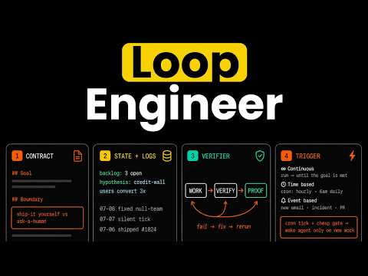 What I learnt after running loops for 1 month??? (7:56)
- Study the Loopany repo. Its useful contribution is not another agent wrapper—it makes the contract, trigger, state, logs, and iterative improvement cycle first-class artifacts. Open the repo [2, 1]
Editorial take: agent autonomy is earned through explicit boundaries, durable state, and verifiable evidence—not by indiscriminately adding more agents. [1]

Sources
- What I learnt after running loops for 1 month???
- 𝕏 post by @jasonzhou1993
- [한영자막] OpenClaw 창시자 Peter Steinberger가 AI 에이전트를 굴리는 방법
- This is absolute chaos…
- I can’t believe they released this
- 𝕏 post by @antigravity
- 𝕏 post by @ClaudeDevs
- 𝕏 post by @LangChain
- datasette code-frequency chart on GitHub

