Coding Agents Are Adding Gates Before and After the Code
Coding Agents Alpha Tracker
2026-08-13

Coding Agents Are Adding Gates Before and After the Code
By Coding Agents Alpha Tracker • August 13, 2026
Addy Osmani’s quality-gate thesis and Ref’s planning-first launch point to a more disciplined control plane for agent-written software, while Grok 4.6 and new observability tooling push cost and operations forward.

🔥 TOP SIGNAL
Agent output is becoming a verification problem, not a review problem. Addy Osmani argues that ordinary code review cannot keep up with agent-generated volume, so quality checks need to move into the harness, environment, and operating system: constraints, tests, and production-boundary gates decide whether a proposal is safe, correct, scoped, and useful, while humans concentrate on intent, taste, and architecture. [1]
Ref’s open-beta launch is the pre-code counterpart: a shared space for deciding what agents should build before code exists. Its sharpest warning is that letting agents make critical system and product decisions makes teams lose ownership. [2]

⚡ TRY THIS
- Put a human decision gate before the first tool call, then automated gates after it. Before granting repository write access, require a human-owned record of the goal, non-goals, acceptance criteria, and architectural choices the agent may not change. Then wire in unit, property, and acceptance tests; mutation testing; complexity and line-length checks; architecture lint; security policies; and CI deploy blocks. Pull a human in when those guardrails break—not for every routine diff. [2, 1]
- Treat the first 40 lines as the agent’s contract. DHH’s field observation is that agents often skim head -40 and start acting. Kent C. Dodds adds a prompt anti-pattern: negative instructions can plant the very idea they were meant to prevent—“Do NOT add a carousel.” Put scope, non-negotiables, and acceptance checks at the top, and express constraints as positive outcomes instead. Treat the 40-line heuristic as something to test in your harness, not a law of model behavior. [3, 4]
- Put model routing and spend control in the harness, not in developer discipline. LangChain’s governance walkthrough recommends a minute-level rate limit plus daily, weekly, and monthly caps, with the daily limit set well below the monthly ceiling and enforcement applied per user, API key, and organization. Block the next call before it leaves when a cap is reached, then fall back to another model; route retrieval and summaries to cheaper models and reserve frontier models for difficult reasoning, validating the trade with evals. Vtrivedy10’s complementary rule is model–harness–task fit: mine production behavior into evals rather than assuming one universal model or harness. [5, 6]
- Promote repeated prompts to durable, inspectable agents. A practical Managed Deep Agents skeleton is: uv tool install managed-deep-agents; mda init <agent>; keep the invariant role in Instructions.md; put specialized workflows in a trigger-described Skill.md; set memory.py to scope="agent"; run uv sync && mda dev to inspect model decisions, tool inputs/outputs, and memory writes; then mda deploy and connect Slack or a cron schedule. The tutorial’s structure is explicitly reusable for engineering updates, security research, and incident summaries. [7]

📡 WHAT SHIPPED
- Grok 4.6. SpaceXAI says 4.6 is a significant improvement over 4.5 at the same price; Michael Truell describes better performance on difficult tasks and knowledge work with low cost and high speed. DHH’s firsthand Fast test reports $4 in/$12 out, roughly one-quarter the price of other Fast modes, and a simple Omarchy PR with “No notes!” McKay Wrigley calls its intelligence per dollar “crazy good” while still putting Fable 5 clearly ahead. Treat this as practitioner cost/performance evidence, not a benchmark. [8, 9, 10, 11]
- Ref entered open beta. The product is a shared planning space for deciding what agents build before code is written; the company says it raised $4M and frames its target failure mode as “Velocity Sickness”: too many PRs, burnout, teams moving in different directions, and critical decisions being made by agents. [2]
- LangSmith tightened the observability/control plane. Rebuilt dashboards can place KPIs beside trends, compare metrics with different units, break traces down by model or user, add notes, and arrange views freely. Its AWS BYOC deployment keeps agent traces and runtime data inside the customer’s AWS boundary while LangChain manages provisioning, upgrades, scaling, and support. [12, 13]
- Omarchy Quattro reached release candidate. DHH says the first RC is out for testing, with a final release planned for Friday if testing goes well. Quattro’s crash watcher can offer an agent-assisted diagnosis with a tracing skill and a verified upstream report, and the diagnosing agent is configurable under Setup > Defaults > Agent. The native Codex Linux app is planned for Omarchy’s package repository, while Omarchy agents use an out-of-band mise path with a terminal mup update command. [14, 15, 16, 17, 18]

🎬 GO DEEPER
- LangChain — “Build a social media agent with Managed Deep Agents.” Study the durable-agent pattern rather than the social-post use case: always-loaded instructions, trigger-loaded skills, cross-thread memory, Slack delivery, weekday scheduling, and local trace inspection before deployment. The presenter explicitly maps the same structure to engineering updates, security research, and incident summaries. [7] 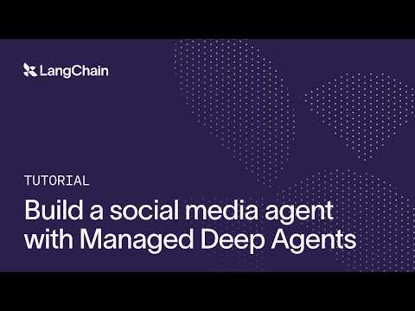 Build a social media agent with Managed Deep Agents (4:13)
- LangChain — “Building Governed Agents.” Jump to the operational checklist on runaway loops: minute-level rate limits, layered spend caps, pre-call blocking, and fallback models. It is vendor-specific guidance, but a compact way to pressure-test the controls around a coding-agent deployment. [5] 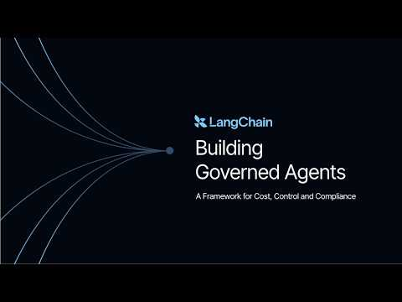 Building Governed Agents: A Framework for Cost, Control and Compliance (49:47)
Editorial take: The high-alpha move is to own the control plane: decide scope before delegation, apply back-pressure throughout the loop, and make model, cost, state, and trace choices explicit instead of treating the chat session as the product. [2, 1, 5, 7]

Sources
- 𝕏 article by @addyosmani
- 𝕏 post by @reactiverobot
- 𝕏 post by @dhh
- 𝕏 post by @kentcdodds
- Building Governed Agents: A Framework for Cost, Control and Compliance
- 𝕏 post by @Vtrivedy10
- Build a social media agent with Managed Deep Agents
- 𝕏 post by @SpaceXAI
- 𝕏 post by @mntruell
- 𝕏 post by @dhh
- 𝕏 post by @mckaywrigley
- 𝕏 post by @LangChain
- 𝕏 post by @LangChain
- 𝕏 post by @dhh
- 𝕏 post by @dhh
- 𝕏 post by @dhh
- 𝕏 post by @dhh
- 𝕏 post by @dhh

