Coding Agents Are Becoming Managed Loops
Coding Agents Alpha Tracker
2026-08-15

Coding Agents Are Becoming Managed Loops
By Coding Agents Alpha Tracker • August 15, 2026
Addy Osmani’s loop-engineering playbook, faster agent execution, and new handoff, context, and cost-control primitives point to the same shift: the unit of leverage is now the supervised system around the model.

🔥 TOP SIGNAL
Stop treating the coding agent as a single conversation. Addy Osmani’s loop-engineering practice is a supervised fleet: 5–10 agents a day, usually about five concurrently; he fully delegates only bounded tasks with explicit stopping conditions, and watches work touching authentication, security, or finance closely. He explicitly uses one sub-agent to draft and a separate one to verify. [1]
The important caveat is operational: /goal’s evaluator checks whether hard rules appear in the transcript, not whether the implementation is good. Automate execution; keep taste and judgment as a human gate. [1]

⚡ TRY THIS
- Turn a recurring queue into a loop → goal pipeline. Start with Osmani’s concrete pattern:
- /loop every 24h "Check GitHub for issues labeled 'bug'. If one exists, use /goal to implement a fix until all local tests pass and push the branch."
- Use deterministic finish lines—test counts, scores, or explicit thresholds—rather than “make it good.” For unattended recurring work such as bug reports, triage, migrations, and dependency upgrades, route routine work to smaller, faster models and reserve the strongest model for judgment calls. [1]
- Install a verifier, not just a better prompt. For UI changes, make the agent start the dev server, interact with the change, capture before/after screenshots, require zero new console errors or warnings, run a Chrome DevTools MCP performance trace and Core Web Vitals audit, and restart the checklist from step one after any failure. Keep the verifier separate from the implementer. [1]
- Fork context before it sprawls; make evidence part of the PR contract. Kent C. Dodds says he routinely tells one agent to spin up a new agent conversation so the original does not get sidetracked, with the necessary context transferred. Peter Steinberger’s OpenClaw team shares agent sessions as URLs and added an AGENTS.md instruction requiring videos on PRs that change UI state. Replicate the pattern: hand off branches of work to fresh sessions, share the session URL, and require a visual artifact for UI-state changes. [2, 3, 4]

📡 WHAT SHIPPED
- Cursor officially joined SpaceXAI. Cursor says its acquisition closed and that it will work on Grok Build, Grok Bot, Grok API, Cursor, and more. [5] Matthew Berman, after using GrokBot for about a week, reports a deliberately simpler agent surface: every thread is an individual agent, plugins connect Slack, Google Docs, and email, and agents can converse while preserving their histories. [6]
- GPT-5.6 Sol Ultrafast entered preview. OpenAI says the mode runs at up to 14× the speed and is initially available through the API to a select customer group. [7] Berman’s firsthand test cut a financial-terminal dashboard from 12:20 to 1:50; he expects to reduce his usual 10-agent parallelism to two or three because context switching becomes less valuable, while tool calls and CPU—not model thinking—become the bottleneck. [6]
- OpenWiki turned repository documentation into an agent-maintained context layer. The open-source project’s design uses self-contained fragments, predictable headings, context-window-conscious formatting, and OKF metadata for filtering and retrieval. [8, 9] openwiki init configures the keys, model, and repo instructions, then writes or modifies AGENTS.md/CLAUDE.md and a daily GitHub Action; updates inspect git history, skip unchanged repos, and open a PR with refreshed docs. [9] It is MIT-licensed, available through npm, and supports roughly 10–15 providers. Early DeepSuite results were 7–8 successful tasks out of 20 without the wiki versus 9–10 with it, alongside fewer tool calls and lower token consumption; the presenter calls the results early. [9]
- LangSmith’s LLM Gateway put spend control in front of the model call. The walkthrough shows one endpoint and provider-agnostic routing, with rate and spend limits enforced before requests leave the organization; integration requires changing the base URL and API key rather than request/response handling. [10] When a cap is reached, the gateway returns a catchable policy error and the organization is not charged, while the usage view records model, key, tokens, and cost. [10]
- Omarchy Quattro released. DHH announced the release and says Quattro uses agents as bug reporters to produce fewer but materially better reports—an interesting intake loop for open-source maintainers, though the post supplies no benchmark. [11, 12]
- Claude provenance is moving into code-adjacent output. Anthropic says future Claude models will watermark generated text for EU AI Act compliance; it claims the mark is reader-indistinguishable, adds no hidden characters or tokens, and carries no identifying information. [13] Its explanation says exact code tokens generally leave little room for watermarking, but arbitrary choices such as comments can be marked; supported PNG, JPG, and SVG files receive signed C2PA metadata, with a detection API planned. [13]
- Open-weight routing widened. Berman reports DeepSeek v4 Pro at 87.9 on Terminal Bench, just behind the top Sol/Fable results, with cache-miss input priced at $0.66 per million tokens and cache-hit input at $0.02; he places GLM 5.3 at 66.9 on deepsui and Meta’s 30B Muse Glimmer at 51 on Terminal Bench for on-device use. Treat this as a practitioner snapshot, not a universal leaderboard. [6]

🎬 GO DEEPER
- Matthew Berman — “AI News: ChatGPT Ultrafast, Grok 4.6, 3 New Open-Source Models, and more!” — Watch the Ultrafast/Cerebras segment for the 1:50 versus 12:20 comparison and the shift from “run more agents” to “remove the context-switching tax.” [6]  AI News: ChatGPT Ultrafast, Grok 4.6, 3 New Open-Source Models, and more! (0:55)
- Building Docs for Agents, Not Humans: Inside OpenWiki — The useful section is the implementation loop: generate structured fragments from repo history, update them on a schedule, and merge the resulting PR; the early evals are promising but appropriately modest. [9] 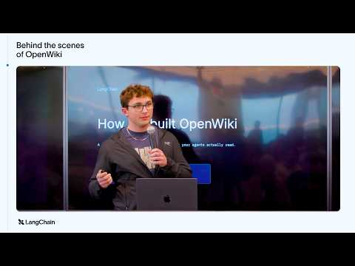 Building Docs for Agents, Not Humans: Inside OpenWiki (11:41)
- Keep model costs in check with LangSmith LLM Gateway — A compact design reference for centralizing keys, blocking over-budget calls before billing, and keeping a live per-team audit trail without rewriting each agent integration. [10] 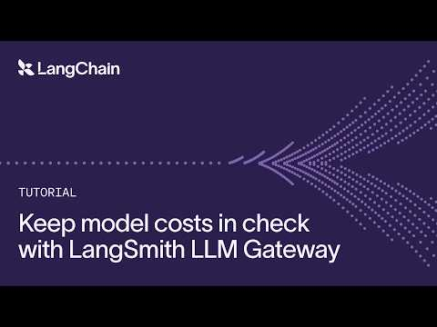 Keep model costs in check with LangSmith LLM Gateway (2:04)
Editorial take: The durable coding-agent advantage is no longer a clever prompt or a single frontier model; it is a supervised loop with measurable completion, an independent verifier, and context that can be handed off cleanly. [1]

Sources
- Practical Loop Engineering
- 𝕏 post by @kentcdodds
- 𝕏 post by @steipete
- 𝕏 post by @steipete
- 𝕏 post by @cursor_ai
- AI News: ChatGPT Ultrafast, Grok 4.6, 3 New Open-Source Models, and more!
- 𝕏 post by @OpenAI
- 𝕏 post by @LangChain
- Building Docs for Agents, Not Humans: Inside OpenWiki
- Keep model costs in check with LangSmith LLM Gateway
- 𝕏 post by @dhh
- 𝕏 post by @dhh
- How Claude’s text watermarking works

