Coding Agents Are Moving Into Continuous Maintenance
Coding Agents Alpha Tracker
2026-08-14

Coding Agents Are Moving Into Continuous Maintenance
By Coding Agents Alpha Tracker • August 14, 2026
Field-tested patterns for turning coding agents into maintenance queues, aligning scope before code, and routing model work with measurable gates.

🔥 TOP SIGNAL
The highest-alpha workflow today is an agent maintenance queue, not another chat-to-PR demo. Boris Cherny says Claude Tag runs from a Slack channel with daily routines across iOS, Android, Desktop, web, CLI, and Agent SDK: a simulator crash fuzzer, duplicate-abstraction unifier, dead-code remover, and “abstraction police.” [1] Over a few weeks, those routines opened 388 PRs; 180 were merged after Claude Code Review plus human review, and failures were fed back into routine tuning. [1]

⚡ TRY THIS
- Front-load alignment, but batch the human I/O. swyx modified /align-me to ask questions in batches rather than round-by-round, looking 2–10 steps ahead; he says it works “INCREDIBLY” for design exploration. [2] Theo says Matt Pocock’s grill-me skill helps align agents with his intent; in one long session, question 27 exposed the real goal and cut scope by about 90%. [3, 4] Run a batched pre-build interview, then hand the resulting scope to the coding agent. Review the alignment artifact first: Theo says the output can be slop enough to override his unslop skill. [5]
- Make subagents a fallback, not the default path. Unifi models a subagent as an explicit function call carrying a prompt, model, and reasoning budget; its main agent maps code over rows and waterfalls through cheaper APIs first, invoking the subagent only after those options are exhausted. The economic reason is concrete: 1,000 calls at one cent each costs $10 against a $20 base plan. [6] Build the interface with an explicit model and budget, try deterministic or cheaper routes first, and escalate only on failure.
- Add a real planning pass before expensive execution. Connor Heggie says a robust first step moved the needle: pause, brainstorm solution paths and pitfalls, ask clarifying questions, and scout high-recall versus high-precision trajectories before running the full task. [6] Pair that with trace review: Unifi says its 90–95% cost reduction came partly from reducing mass subagents, removing contradictions between system and skill prompts, and eliminating tool calls whose results were not used. [6]

📡 WHAT SHIPPED
- Agents on Rails benchmark. The first report ran 8 models against 21 atomic Rails tasks, with three runs per task covering a bug report, security finding, and feature request. Claude Opus 5 led at 92% solved (58/63); Kimi delivered almost the same accuracy for a little over half the cost. GPT-5.6 Luna was cheapest and fastest at 73% solved, $0.90 for all 63 runs, and a 3.3-minute median; GPT-5.6 Sol was the best combined result at 84%, $0.52, and 5 minutes per run. Treat this as a Rails-specific routing snapshot, not a universal leaderboard. [7]
- DeepSeek Harness v0.1 entered Developer Preview under the MIT license. Built on Cordis, it treats models, tools, skills, sessions, sandboxes, filesystems, loops, orchestration, and UI as replaceable plugins; the deepseek-ai/deepseek-harness repo is open. [8] A separate post by @eliebakouch claims roughly 20% of the harness’s commits and PRs come from Codex worktrees—an interesting adoption signal to verify, not a benchmark. [9]
- Cursor Builds now prepare ready-to-use development environments continuously in the background, with Cursor saying cloud agents start 3× faster and builds add no extra cost. Failed builds never go live; agents continue from the last successful build while the new one is debugged. [10, 11] Cursor says Faire, Headway, and Descript have seen starts fall from minutes to seconds and are increasingly trusting cloud agents with end-to-end tasks. [12]
- Grok 4.6 got a useful plan-following test. DHH gave Grok 4.6 Fable’s existing Rust-rewrite plan; with “a couple of nudges,” it repeated the work in 1 hour 24 minutes using 8.6M tokens at about $55—roughly one-tenth of Fable’s implementation cost. [13] The important caveat is that Grok did not plan the project from scratch, so this is evidence about execution and cost, not autonomous end-to-end planning. [14]
- Gemini 3.7 Flash is available in the API, AI Studio, Antigravity, and more; Google’s announcement says it is 50% cheaper than 3.6 Flash through year-end and gained intelligence in roughly three weeks. [15] Google DeepMind claims gains in debugging and issue resolution, web layouts with fewer prompts, and real-world business workflows. [16] Those are vendor claims; the Rails report above is the more useful independent comparison signal for coding-agent routing.
- AgentCookie is a small open-source fix for a recurring cloud-agent failure mode: it syncs Chrome cookies from a Mac to Grok Bot in the cloud using Tailscale so the agent does not get logged out. Repo: github.com/mvanhorn/agentcookie. [17]

🎬 GO DEEPER
- Harrison Chase — “When to Build Your Own Agent Harness”. Start with a general harness for fast time-to-value, then customize as the task moves out of the model’s training distribution; keep model-native tools for subtasks such as file editing. [18] The eval section is the useful implementation detail: Harbor packages a Dockerfile-defined sandbox, golden solution, tests, and instruction.md, while experiments track accuracy, latency, and tokens. [18] 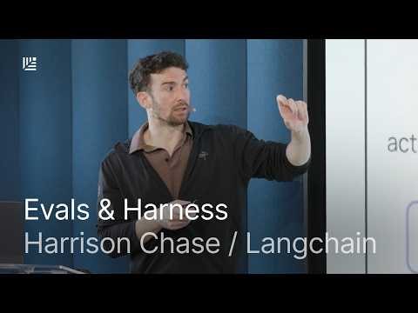 When to Build Your Own Agent Harness | Harrison Chase, LangChain (10:17)
- Connor Heggie — “How Unify cut its AI agent costs 95% in two weeks”. Watch the cost-control segment for the move from mass subagents to a smarter main agent, trace-bucketed prompt optimization, contradictory-instruction cleanup, unused-tool-call reduction, and the upfront planning pass. [6] 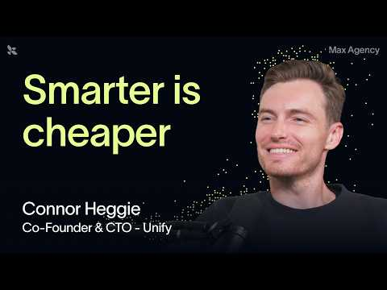 How Unify cut its AI agent costs 95% in two weeks (60:07)
- Study DeepSeek Harness for plugin boundaries. Its v0.1 design makes the harness—not just the model—the interchangeable unit: swap models, tools, sessions, sandboxes, filesystems, loops, orchestration, and UI independently. [8]
Editorial take: The durable edge is the control loop: narrow routines produce reviewable PRs, planning and cheap-first routing suppress waste, and harness-level evals decide what can safely run unattended. [1, 6, 18]

Sources
- 𝕏 post by @bcherny
- 𝕏 post by @swyx
- 𝕏 post by @theo
- 𝕏 post by @theo
- 𝕏 post by @theo
- How Unify cut its AI agent costs 95% in two weeks
- 𝕏 post by @rails
- 𝕏 post by @deepseek_ai
- 𝕏 post by @eliebakouch
- 𝕏 post by @cursor_ai
- 𝕏 post by @cursor_ai
- 𝕏 post by @cursor_ai
- 𝕏 post by @dhh
- 𝕏 post by @dhh
- 𝕏 post by @OfficialLoganK
- 𝕏 post by @GoogleDeepMind
- 𝕏 post by @mvanhorn
- When to Build Your Own Agent Harness | Harrison Chase, LangChain

