Coding Agents Are Shipping the Harness
Coding Agents Alpha Tracker
2026-09-16

Coding Agents Are Shipping the Harness
By Coding Agents Alpha Tracker • September 16, 2026
The strongest coding-agent signal is harness-level: project-isolated execution, scheduled thread fleets, deterministic verification, and hard spend limits are turning autonomy into an engineered workflow rather than a chat-session gamble.

🔥 TOP SIGNAL
Agent autonomy is becoming a harness problem, not just a model problem. Antigravity’s new permissions system runs commands automatically inside an environment isolated to the project, with network access disabled by default, on macOS and Linux. [1] Kent C. Dodds supplies the failure mode that makes the boundary non-negotiable—an agent that misreads an .env file can delete a production volume—while Brent Traut shows the next step up the stack: Codex threads can reference, message, monitor, and schedule one another as a fleet. [2, 3]

⚡ TRY THIS
- Put autonomous runs inside a project-only boundary. Use Antigravity’s new sandbox behavior as the minimum shape for unattended work: automatic commands, strict project isolation, and no network by default. Then test destructive paths in a disposable project before exposing anything valuable; Dodds’s .env/production-volume example is exactly the kind of failure a harness must contain. [1, 2]
- Turn Codex into a thread fleet. From a coordinator thread, @-mention or drag in another thread, ask threads to message or monitor peers, and add schedules for recurring work. That is Brent Traut’s concrete recipe; a useful starting decomposition is discovery → implementation → review, with each thread owning one bounded job. [3]
- Make “done” a deterministic harness event. Harrison Chase’s pattern is: when the agent thinks it is finished, run an explicit goal check; if it fails, send the run back to the beginning. For coding tasks that install arbitrary dependencies or start servers, use a full sandbox; a virtual filesystem is the lighter option when the task only needs file access. [4] Theo’s stronger version is to give the model the problem rather than a prescribed solution—I don't know how I want to solve this. Propose some solutions—then require computer-use validation, repository review bots, and a subagent pass before it returns. [5]
- Install a hard kill switch before unattended execution. ThePrimeTime’s Gemini 3.8 Flash test in Cursor spent 40 minutes rereading the same file, consuming 330 million tokens and $118 on a simple bug. He warns that an unattended eight-hour run could become a $1,000-plus bill, so enforce maximum runtime, spend/token budgets, and a no-progress detector in the runner rather than relying on the model to stop itself. [6]

📡 WHAT SHIPPED
- Antigravity permissions and sandbox rollout. Commands can run without constant approval inside a project-isolated environment with network access off by default; the rollout covers macOS and Linux. [1]
- Managed Deep Agents can now be MCP servers. LangChain says a deployed agent can expose research, analysis, and other capabilities to coding assistants and other agents through the built-in /mcp endpoint—deploy once, reuse across compatible MCP clients. Endpoint documentation [7]
- LangSmith Engine is getting task-specific models. Baseten says LangChain is fine-tuning open-weight models on agent traces for jobs such as reading a connected GitHub repository, diagnosing an issue, and drafting a prompt or code change for a pull request; narrower jobs can use smaller models such as Qwen to classify trace failures and severity. Baseten Loops supports supervised fine-tuning, reinforcement learning, and long-context workloads, with checkpoints evaluated during training and deployed directly to inference. This is a partnership announcement, not an independent performance benchmark. [8]
- Kody can package a full-stack Remix app inside dynamic workers. Kent C. Dodds links package-app-kit and says the packaged app can do anything his Kody account can do—an unusually direct path from agent workflow to personal software, with account permissions as the blast radius. [9]
- Lyft’s self-serve agent platform is an adoption signal. LangChain says PMs and operations staff define runtime configuration and prompts, engineers review them, and a meta-agent dynamically registers subagents; the reported production cycle fell from six months to one or two weeks, while resolution rate rose 16% after LangGraph and LangSmith adoption. [10, 11]
- Gemini 3.8 Live and Live Extended Thinking launched. Simon Willison pointed GPT-6 Astra Extra High at the documentation and had it build a dependency-free browser tester with model/voice selection, an optional system prompt, interruption, a direct WebSocket connection, and Web Audio capture/playback. The implementation is a compact example of turning API docs into a working agent-facing interface. [12]

🎬 GO DEEPER
- Theo — “How I Code Without Typing”: verify, review, then merge. The valuable section is not the voice-input demo; it is the operating loop of computer-use validation, AI review bots, subagent review, and eventually autonomous merges. Theo reports more than 100 Astra merges and at least 50 Fable merges, with two regressions across roughly 150 fully autonomous PRs; treat that as a firsthand project anecdote, not a benchmark. [5] 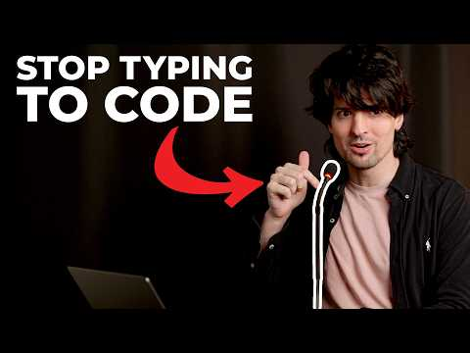 How I Code Without Typing (24:14)
- Harrison Chase on LangChain’s infrastructure bet: choose the harness by task. Chase connects deterministic goal checks, full sandboxes versus virtual filesystems, and separation of the agent “brain” from tool execution so requests can be inspected for PII, prompt injection, and other hazards. [4] 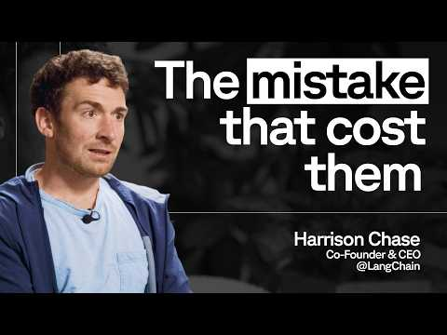 LangChain CEO Harrison Chase on the infrastructure bet he got wrong (16:32)
- Study package-app-kit for the boundary between a packaged application, dynamic workers, and an account-scoped agent runtime. [9]
Editorial take: The durable coding-agent loop is becoming sandbox → orchestrate → verify → budget, with model capability useful only inside those boundaries. [1, 3, 5, 6]

Sources
- 𝕏 post by @antigravity
- 𝕏 post by @kentcdodds
- 𝕏 post by @btraut
- LangChain CEO Harrison Chase on the infrastructure bet he got wrong
- How I Code Without Typing
- How are they Losing so Bad
- 𝕏 post by @LangChain
- 𝕏 article by @baseten
- 𝕏 post by @kentcdodds
- 𝕏 post by @LangChain
- How Lyft Increased Its Agent Resolution Rate by 16% with LangSmith and LangGraph
- Gemini Live audio

