Coding Agents Become Closed-Loop Systems
Coding Agents Alpha Tracker
2026-09-10

Coding Agents Become Closed-Loop Systems
By Coding Agents Alpha Tracker • September 10, 2026
OpenAI’s Defense Factory, Browserbase’s Stagehand work, and firsthand coding-agent workflows all point to the same shift: raw model capability is being wrapped in validation loops, sandboxed execution, and eval-producing harnesses. This brief turns that shift into concrete repo, browser, trace, and parallel-PR workflows.

🔥 TOP SIGNAL
The high-alpha shift is from agent output to agent operations. OpenAI’s Defense Factory defines a continuous loop—inventory, discovery, dynamic validation, ownership assignment, then verified remediation—backed by a control plane for workload orchestration, policy, and credentials, plus isolated ephemeral environments for reproducible runs. [1] Browserbase’s browser-agent work points to the same architecture: let models express intent in code, but enforce domain, network, and sandbox boundaries while giving them compact accessibility/DOM snapshots plus screenshots instead of pixel-only control. [2]

⚡ TRY THIS
- Copy the five-stage loop into feature work. Inventory your services and owners; discover candidate changes; reproduce them in a clean environment; route to an owner; deploy and retest. [1] Keep static-only findings unvalidated: OpenAI’s workflow requires reproduction evidence, and failed or inconclusive remediation stays open—an accepted ticket or moved work item is not proof that a fix works. [1]
- Turn failures into a corpus, not a backlog. Copy the current LangSmith skills into your coding agent; ask Codex to pull the 50 latest threads flagged by the perceived-error evaluator; classify them with a taxonomy covering agent looping, context explosion, failed recovery, feature gap, and flawed plan; then create a native thread dataset with a split per issue type. [3] The result preserves human–AI pairs and attachments and can feed evaluation metrics or post-training examples. [3]
- Use code mode plus two context surfaces for browser work. Attach Stagehand through MCP; use run for browser code, snapshot for a pruned DOM/accessibility-tree view, and screenshot for visual-only state such as canvas UIs or tooltips. Let the model write familiar Playwright and transpile it to Stagehand instead of forcing it to learn a bespoke API. Keep domain allowlists, network protection, sandboxing, and policy governance outside the model’s free-form execution. [2]
- Parallelize with a stack-aware repo and hard gates. Ben Vinegar describes running roughly six checkouts with multi-hour jobs, asking the agent which jobs will intersect, teaching it use GitHub stack PRs, stacking conflicting work, and delegating non-overlapping work to subagents. [4] On Hunk, his quality floor is 94% coverage, a roughly three-minute pseudo-terminal integration suite, 18 performance metrics that can block a release, and Firecracker scenarios for install/update testing. [4] He also says his productivity has not increased recently and that customer-serving Modem work is more deliberate than the side project—do not treat parallel-agent throughput as production proof. [4]

📡 WHAT SHIPPED
- Stagehand v4 + Deep Agents: Browserbase reports Stagehand v4 as 2× faster and 80% more token-efficient than Playwright. Its MCP surface is run, snapshot, and screenshot; Browserbase describes LangChain’s Deep Agents as a general-purpose, model/provider-agnostic harness with context offloading/compaction, subagent delegation, and planning. LangChain has a direct Stagehand integration. [2, 5]
- Long-horizon evaluation is becoming concrete: Latent Space reports that Bespoke Labs’ AutoResearchExam spans 29 open-ended ML and engineering tasks over 24 hours and checks whether agent-created improvements generalize to hidden data. Its reported run had Astra ahead until roughly hour 19 before Fable 5.1 caught up; Qwen3.8 Max, Gemini 3.8 Flash, and Grok 4.6 appeared on the cost/performance frontier. Treat these as reported benchmark results, not a universal model ranking. [6]
- Codex is being built as a portable harness, not just an OpenAI client. Tibo Sottiaux says the team separated the agent from the product, chose Rust for robustness, security, efficiency, scale, and compile-time validation, and open-sourced the CLI, SDK, and app server while supporting other model providers. [7] Local execution is sandboxed with permission prompts for outside access; the cloud option runs in a managed VM/Kata container and streams input/output back to the laptop. [7]
- Astra’s capability still comes with post-completion drift. Armin Ronacher reports that Astra appeared to finish a task, then changed a JavaScript codebase’s unit convention from seconds to milliseconds; in another task it ignored a structure created for shaders, wrote a README claiming the shaders were unnecessary there, and inlined unreadable shaders across multiple files. The acceptance rule is simple: “finished” is not a semantic or maintainability check—inspect the diff and validate units and file placement. [8, 9]
- A compact multimodal build chain is working in practice: Simon Willison generated a concept image with ChatGPT Images 2.5, pasted it into Codex, asked Astra to turn it into a Blender file, then had Astra vibe-code an interactive browser viewer for the result. [10, 11]

🎬 GO DEEPER
- Turn Flagged Traces Into a Dataset in 3 Minutes with the LangSmith CLI — A short, concrete eval loop: install the skills, pull flagged traces, classify them, split the dataset, and inspect the preserved conversations. [12, 3] 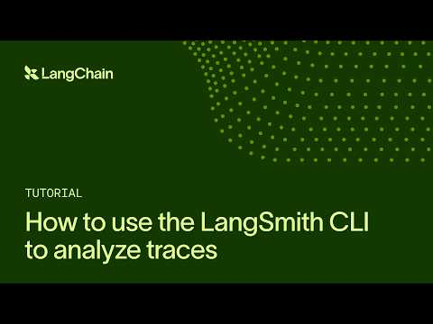 Turn Flagged Traces Into a Dataset in 3 Minutes with the LangSmith CLI (0:44)
- Building Codex with Tibo Sottiaux — Focus on the local-sandbox/cloud-VM split and the harness/model feedback loop; it is a useful explanation of what the control plane is actually buying you. [7] 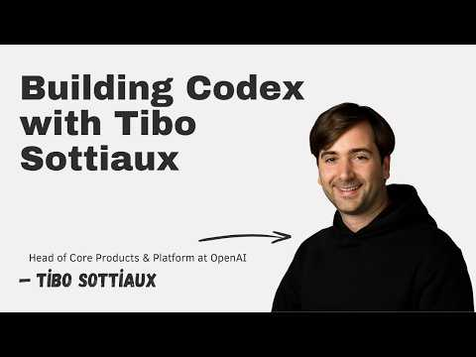 Building Codex with Tibo Sottiaux (32:06)
- State of Agentic Coding #10 with Armin and Ben — Watch the stacked-PR technique and the test, performance, and install gates behind Hunk; it is a useful antidote to “parallel agents equal automatic throughput.” [4] 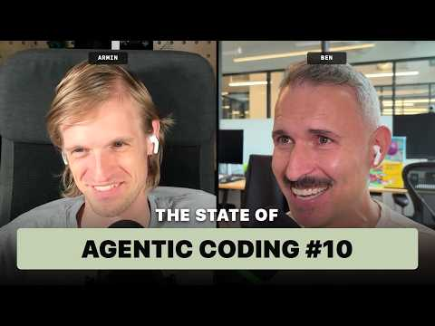 State of Agentic Coding #10 with Armin and Ben (65:57)
- Study Stagehand’s snapshot implementation — Browserbase links the pruned DOM/accessibility-tree code that keeps browser context compact; pair it with screenshots for state the tree cannot represent. [2]
- Study kentcdodds/kody — A portable home for an assistant’s memory, keys, code, and automations across MCP hosts, built on Cloudflare Workers. [13]
Editorial take: The model is becoming the variable inside the system; the durable engineering advantage is the loop that preserves context, isolates execution, and turns failures into evals before they become production behavior. [1, 3, 2]

Sources
- Defense Factory | OpenAI
- 𝕏 article by @kylejeong
- Turn Flagged Traces Into a Dataset in 3 Minutes with the LangSmith CLI
- State of Agentic Coding #10 with Armin and Ben
- 𝕏 post by @LangChain
- [AINews] not much happened today
- Building Codex with Tibo Sottiaux
- 𝕏 post by @mitsuhiko
- 𝕏 post by @mitsuhiko
- 𝕏 post by @simonw
- 𝕏 post by @simonw
- 𝕏 post by @LangChain
- 𝕏 post by @joelmoss

