Competing Against Luck, Steppenwolf, and an AI Influence Report
Recommended Reading from Tech Founders
2026-07-01

Competing Against Luck, Steppenwolf, and an AI Influence Report
By Recommended Reading from Tech Founders • July 1, 2026
Three organic recommendations cleared the filter today. Kevin Systrom provided the strongest signal with a concrete product framework from Clay Christensen, while Martin Casado and Marc Andreessen pointed readers toward a classic novel worth rereading and a policy report on AI influence campaigns.

Highest-signal pick
The clearest recommendation today was Kevin Systrom’s mention of Competing Against Luck. It stood out because he attached a specific framework to it—jobs to be done—and tied that framework to Instagram’s product thinking, including its core value of visual life-sharing and features like Stories [1].

Competing Against Luck
- Content type: Book
- Author/creator: Clay Christensen
- Link/URL: Not provided in the source notes
- Recommendation context: YouTube interview
- Who recommended it: Kevin Systrom
- Key takeaway: Systrom highlighted the book’s jobs to be done theory as a way to understand why users “hire” products, and said he applied that thinking to Instagram’s value proposition and feature design [1]
- Why it matters: This was the most actionable recommendation in the batch because it came with both a reusable framework and a concrete founder example of how that framework shaped product decisions [1] 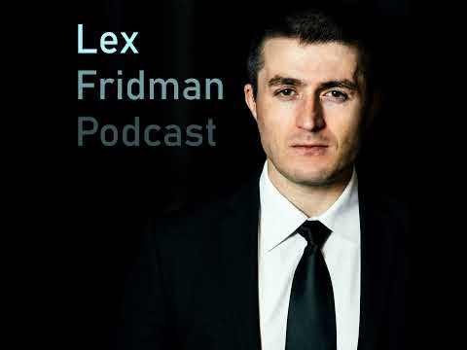 #243 – Kevin Systrom: Instagram (93:17)

Two more worth saving

Steppenwolf
- Content type: Book
- Author/creator: Hesse
- Link/URL: Not provided in the source notes
- Recommendation context: X post
- Who recommended it: Martin Casado
- Key takeaway: Casado said rereading the book decades later made it feel like an entirely different work, because age changes the reader’s perspective [2]
- Why it matters: The value here is not a business framework but a reading practice: some books appear to reward rereading at a different stage of life [2]
“The perspective of age changes everything.” [2]

Linked report on foreign influence campaigns against American AI
- Content type: Report / article
- Author/creator: Not specified in the source notes
- Link/URL: btcpolicy.org article
- Recommendation context: X post
- Who recommended it: Marc Andreessen
- Key takeaway: Andreessen gave a direct endorsement of the linked report, telling readers simply to read it [3, 4]
- Why it matters: It was the only recommendation in this batch focused on AI policy and influence operations rather than product thinking or literature [3, 4]

Pattern
No repeat titles surfaced in this batch. The mix was still useful: one founder-endorsed product framework, one literary reread that gains meaning with age, and one policy report on AI influence campaigns [1, 2, 3, 4].

Sources
- #243 – Kevin Systrom: Instagram
- 𝕏 post by @martin_casado
- 𝕏 post by @pmarca
- 𝕏 post by @SamLyman33

