Context and Verification Are the New Coding-Agent Bottlenecks
Coding Agents Alpha Tracker
2026-07-18

Context and Verification Are the New Coding-Agent Bottlenecks
By Coding Agents Alpha Tracker • July 18, 2026
Today’s most practical pattern is to design coding agents as resumable, verifiable loops: keep state outside the prompt, reset context before it degrades, and make commits pass deterministic gates. Also covered: Kimi K3 field tests, GPT-5.6 production comparisons, Grok Build open-sourcing, and agent-secret infrastructure.

🔥 TOP SIGNAL
Long-running agents are becoming useful enough that context and verification—not raw model capability—are the practical bottlenecks. Theo’s Kimi K3 migration ran for more than three hours and completed 122 tasks from a short prompt before hitting its context limit; RALPH creator Geoffrey Huntley’s countermeasure is deliberately simple: preserve state in the filesystem, recycle the context window, and restart rather than letting an agent flail. [1, 2]

⚡ TRY THIS
- Run a resettable loop, not one giant chat. Put the desired end state in a prompt, keep progress and artifacts in files, then run a simple while true loop that re-reads those files each iteration. Huntley recommends treating roughly 100k tokens as the comfortable zone for hard work; if the model starts applying hacks or misidentifying stale tests, stop and begin a fresh context. [2]
- Make the agent earn its commit. Encode architecture and domain constraints in pre-commit hooks, including rules such as which boundaries may not depend on each other. Pair that feedback with static checks, linters, and semantic verification; Huntley’s point is that agents do not mind the friction, so the loop can be prevented from closing until requirements pass. [2]
- Use vision as an explicit UI feedback loop. Give the agent a reference screenshot, then require a repeatable cycle: launch the app, capture a screenshot, inspect it, edit, and re-check. Theo watched Kimi K3 follow this pattern; when browser behavior consumed a one-time authentication token, one clear steering instruction let it continue refining and report/clean up its mistake. [1]
- Quarantine computer-use agents in VMs. If an agent can drive a browser and desktop UI, run it in a VM so it cannot steal focus from your working machine. Peter Steinberger uses this with Codex while it handles GitHub interactions. [3]

📡 WHAT SHIPPED
- Kimi K3 in agent harnesses: Theo used the open-weight model through OpenCode and T3 Code for long migrations, phase-specific subagent workflows, security-audit discovery plus 25 verification agents, and screenshot-backed UI work. Caveat: the subscription setup he tested did not expose the full advertised context capacity and hit rate limits quickly under heavy use; Armin Ronacher separately warns that current maximum-thinking restrictions make K3 a poor fit for some basic tasks. [1, 4]
- GPT-5.6 field reports are mixed by task, not benchmark. DHH says GPT-5.6 Sol fixed an icon-alignment issue in 4m45s after GPT-5.5, Opus 4.8, and Gemini failed on that case. For code review, Steinberger reports 5.6 Terra high made his clawsweeper bot about 40% faster with negligible quality loss versus its prior setup, while Terra high outperformed Sol low for his own review use case—an explicit reminder to evaluate on your workload. [5, 6, 7]
- Grok Build is now Apache 2.0 open source. After backlash over directory uploads, xAI released its Rust-based coding-agent CLI; Simon Willison found 844,530 lines of Rust, visible system/subagent prompts, ports of Codex and OpenCode-style tools, and disabled remnants of GCS-upload code. Study it as a large agent harness, but the privacy incident is part of the operational context. Repository [8]
- Treg: Jason Zhou announced an open-source, self-hostable skill and secret registry that bundles skills with a CLI/endpoint while injecting authentication server-side, so agents do not hold keys; it also logs calls per agent and user. Repository [9, 10]
- Deep Agents: LangChain’s harness packages planning, subagents, filesystem-backed context, sandboxes, and automatic compaction around 80% of the context window for long-running work. Its useful abstraction is progressive disclosure: offload large tool outputs and load files or skills only when needed. [11]

🎬 GO DEEPER
- 12:25–13:35 — Kimi K3’s 122-task migration run. Watch the practical long-horizon test: a short prompt, a real codebase migration, then an abrupt context ceiling. It is a useful demonstration of both capability and the need for resumable state.
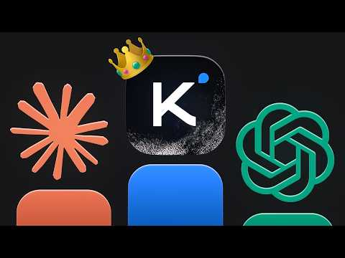 Kimi K3 is the best model ever made (sometimes) (12:25)
- 6:30–10:07 — Use the filesystem as your context layer. The Deep Agents walkthrough explains why large tool outputs should live outside the active prompt, and how an agent can fetch them on demand rather than repeatedly summarizing away detail.
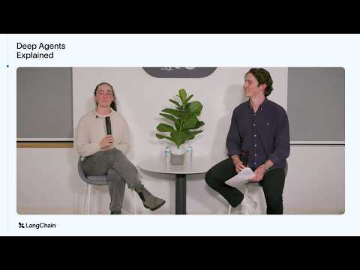 Deep Agents Explained (6:29)
- 45:11–45:31 — RALPH reduced to its primitive. Huntley’s short explanation of the while true + cat pattern is worth watching before building a more elaborate orchestration framework.
 The Great Loops Debate — Dex Horthy, Geoff Huntley, Ian Livingstone, Greg Pstrucha, @insecure-agents (45:13)
- Repository to study: Grok Build. Its exposed prompt templates and implementations of familiar coding-agent tools make it a concrete codebase for examining how a large terminal-agent harness is assembled. Open the repo [8]
Editorial take: the high-leverage upgrade is a resumable loop with hard verification gates—model improvements matter, but unattended context drift still decides whether long runs produce usable code. [2, 1]

Sources
- Kimi K3 is the best model ever made (sometimes)
- The Great Loops Debate — Dex Horthy, Geoff Huntley, Ian Livingstone, Greg Pstrucha, @insecure-agents
- 𝕏 post by @steipete
- 𝕏 post by @mitsuhiko
- 𝕏 post by @dhh
- 𝕏 post by @steipete
- 𝕏 post by @steipete
- Kimi K3, and what we can still learn from the pelican benchmark
- 𝕏 post by @jasonzhou1993
- 𝕏 post by @jasonzhou1993
- Deep Agents Explained

