Context Discipline Beats Tool Sprawl for Coding Agents
Coding Agents Alpha Tracker
2026-06-27

Context Discipline Beats Tool Sprawl for Coding Agents
By Coding Agents Alpha Tracker • June 27, 2026
monday.com’s Sidekick rebuild and Geoffrey Huntley’s RALPH loop point to the same lesson: coding agents get better when you reduce always-on context and expose tools more selectively. Also in today’s brief: Codex session rituals, LangSmith spend controls, T3’s browser-first remote setup, and fresh model signals from Theo and Simon Willison.

🔥 TOP SIGNAL
monday.com’s Sidekick rebuild is the clearest lesson today: one agent with 200+ tools created context pollution, confused the model, and pushed up cost, so the team moved to one orchestrator on a Deep Agent backbone with layered tool discovery, sub-agents, middleware, and a sandboxed write-code tool [1].
Geoffrey Huntley is arguing for the same principle from the opposite end: larger context windows often make agents worse, so his RALPH loop keeps the model deliberately forgetful—pick the most important item from a backlog, work it, reset context, repeat [2]. Theo’s repeated complaints about Gemini getting stuck in bad loops, reading the wrong files, and misusing tools are a reminder that agent quality is still heavily harness-dependent, not just model-dependent [3].

⚡ TRY THIS
- Shrink the active tool surface before adding more agents. Omri Bruchim’s monday.com pattern: keep a small base set for the 50-60% case, inject only screen/entity-specific tools, and keep the long tail in a deferred catalog with short descriptions that the agent loads only when needed. Put middleware in front for context injection, tool-name repair, model selection, and retries/resource scaling; monday.com says those self-healing paths hit a 94% recovery rate [1].
- Use code execution as the universal fallback tool. Instead of shipping a separate sum/filter/search/etc. tool for every edge case, let the agent write and run Python in a sandbox. monday.com says this replaced hundreds of tools and enabled composite tasks like combining mapping APIs to search for London office locations under commute constraints [1].
- Run a forgetful backlog loop. Huntley’s RALPH recipe: hand the model a task list, rough specs, and the current codebase; tell it to choose the most important next item; let it finish that slice; then reissue a fresh goal with fresh backing context instead of keeping one giant chat alive. For language ports, first reduce the old codebase into PM-style specs plus a test lookup table, then generate the target implementation from that distilled artifact [2].
- Make planning and completion explicit. Huntley uses voice-first prompting to tell the agent which libraries/components to study first, and withholds build permission until he says move [2]. Pietro Schirano adds text-expansion rituals in Codex: spawn to launch multiple agents, agent to inject a persistent goal-completion instruction, and a closing regression sweep asking for bugs, regressions, and edge cases [4].

📡 WHAT SHIPPED
- LangSmith LLM Gateway — before broader ship, LangChain rolled it out internally for real-time spend visibility and budgets at the org, workspace, user, and API-key level. If coding-agent adoption inside your team is running into surprise bills, this is the clearest cost-control pattern in today’s sources. Blog [5]
- T3 Code’s current wedge is remote dev, not Codex. Theo says npx t3@nightly serve works over Tailscale, that he now does 90% of his coding from the browser, and that the demo machine was set up the same day [6, 7, 8].
- Gemini still looks weak on long-horizon agent work, per Theo. His firsthand issues: dumb reasoning loops, wrong-file reads, weak tool use, and worse coherence as tasks run longer. He also says Cursor had to heavily reshape prompts to make Google models use tools correctly, though /thinking traces are at least somewhat better than before [3].
- Frontend prompt behavior may be shifting. Simon Willison says he used to add don't use React to most frontend prompts; now most models don’t default there, and a fresh-project test returned vanilla HTML+JS. He isn’t sure whether that’s changed model preference or better awareness of existing project context [9, 10].
- Training signal to watch: Theo argues that real human/LLM interaction histories plus before/after code changes matter more for agent RL than raw codebase size, which helps explain how a smaller player like Cursor could improve quickly [3].

🎬 GO DEEPER
- 11:52-14:14 — Huntley explains RALPH. Best timeless clip today if you’re building your own loop: it’s about memory management, not vibes, and the example makes the case for deliberate forgetting [2].
 Hot-takes at a fireside chat during AI:Engineer Miami (11:51)
- 12:24-13:32 — monday.com on why a write-code tool beats hundreds of micro-tools. The London-office example makes the payoff obvious: code execution is a general-purpose escape hatch, not just a fancy calculator [1].
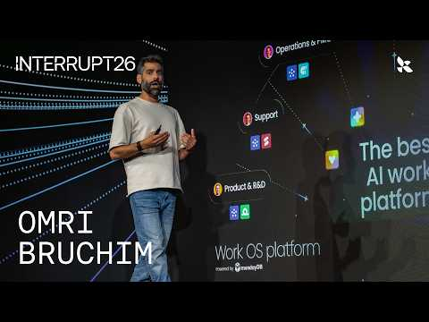 How Monday.com Built Sidekick on Deep Agents | Interrupt 2026 (12:24)
- 10:22-11:19 — Theo audits Gemini reasoning traces. Good watch before you pick a default coding-agent model: the traces are more coherent than before, but he still catches low-focus planning and nonsense [3].
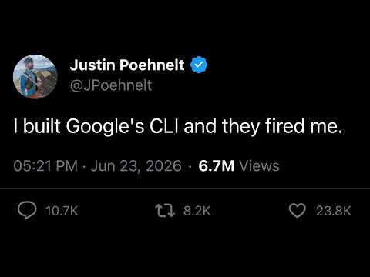 Dear Google, we need to talk. (10:22)
- 26:17-28:54 — Huntley’s voice-first planning workflow. Useful prompt-engineering clip if your agent thrashes during implementation: assign reading context first, talk through the plan, then unlock build mode with move [2].
Hot-takes at a fireside chat during AI:Engineer Miami (26:17)
Editorial take: the highest-alpha work right now is not adding more agent autonomy—it’s deciding what the agent sees, when it sees it, and when the loop should reset. [1, 2, 3]

Sources
- How Monday.com Built Sidekick on Deep Agents | Interrupt 2026
- Hot-takes at a fireside chat during AI:Engineer Miami
- Dear Google, we need to talk.
- Builders Unscripted: Ep. 4 - Pietro Schirano
- 𝕏 post by @LangChain
- 𝕏 post by @theo
- 𝕏 post by @theo
- 𝕏 post by @theo
- 𝕏 post by @simonw
- 𝕏 post by @simonw

