Cursor’s Mixed-Autonomy Playbook, OpenClaw’s Rise, and Safer Agent Eval Loops
Coding Agents Alpha Tracker
2026-07-07

Cursor’s Mixed-Autonomy Playbook, OpenClaw’s Rise, and Safer Agent Eval Loops
By Coding Agents Alpha Tracker • July 7, 2026
Practitioners are getting more selective about where autonomy belongs: frontier models for ambiguous planning, smaller models and sandboxes for mechanical execution. Today’s brief covers Cursor’s production playbook, OpenClaw’s rise, Harbor/LangSmith eval setup, and the current routing debate from working developers.

🔥 TOP SIGNAL
The most useful pattern today: route by loop, not by model brand. Cursor says Sonnet is currently the net-best model for coding intent, but its production stack still splits work between frontier models for planning and custom small models for Apply diffs and Tab autocomplete [1]. Matthew Berman’s manual spec handoff shows why this pays—planning with Fable and coding with a cheaper model cut his sample build from $9.50 to $3.02—while antirez warns the split only works when the task is well-bounded; once implementation details force replanning, the smart planner + weak implementer pattern breaks down [2, 3]. Cursor’s other blunt point is the same: agents shine on well-specified fixes, but most programming still wants instant iteration loops [1].

⚡ TRY THIS
- Add a background verification loop before human review. Cursor’s shadow workspace is a hidden editor instance where the agent can change code, get linter/type/go-to-definition feedback, and iterate without touching the visible files [1]. Replicable pattern: 1) give the agent a separate workspace, 2) let it iterate against compiler/LSP feedback, 3) only then review the diff. Cursor says this is best for well-specified fixes, not vague exploratory work [1].
- Prioritize context instead of stuffing it. Cursor’s Preempt renders prompts declaratively, with the current cursor line as highest priority and surrounding lines decaying from there [1]. Cursor also auto-suggests likely related files while you write the prompt [1]. Practical rule: include current line/file first, then likely cross-file dependencies, then the wider repo [1].
- Stand up a real agent eval lane. Harbor expects a dataset folder where each task contains instruction.md, an environment/ image, a deterministic test/ verifier, and task.toml resource limits [4]. Install with pip install harbor langsmith, export your model key plus LangSmith key, then run:
harbor run --dataset <path> --agent <path> -E langsmith --plugin langsmith --dataset-name <name>
[4]
Every run gets its own micro-VM, and LangSmith shows reward score, pass/fail, traces, tokens, and cost [4].
- Make the agent inspect itself before you step in. Peter Steinberger says he repeatedly uses self-introspection prompts like what tools do you see?, can you call the tool yourself?, what error do you see?, and read the source code, figure out what's the problem [5]. For longer runs, his bigger rule is just as useful: agents start fresh and never see the whole project, so give them a few targeted file pointers; after the merge, ask what can we refactor? [5].

📡 WHAT SHIPPED
- OpenClaw — open-source autonomous AI agent with system-level access and messaging integrations across Telegram, WhatsApp, Signal, and iMessage; supports Claude Opus 4.6 and GPT 5.3 Codex [5]. The project reportedly grew from a one-hour WhatsApp ↔ Claude Code prototype into a repo with 175k+ GitHub stars [5].
- Hy3 — TencentHunyuan’s 295B MoE release, Apache 2.0, positioned for agentic use cases with reliability and anti-hallucination gains. Useful links: free API, weights, research [6, 7].
- Cursor’s public model snapshot — Sonnet is the team’s current net-best coding model; R1 is stronger on hard reasoning and LeetCode-style tasks but weaker on rough intent; production uses frontier models for planning plus custom models for Apply and Tab [1].
- Harbor + LangSmith — open-source eval framework plus sandbox/observability stack for agents that read/write files or execute scripts; each run gets its own isolated micro-VM and deterministic verifier [4].
- antirez’s solo-dev routing take — reserve Fable for design docs, analysis, and hard blockers; prefer GPT-5.5 or Opus 4.6 Thinking Max over Opus 4.8 for regular work, and treat tokens as scarce rather than defaulting to the best model every time [3].

🎬 GO DEEPER
- 53:09-55:43 — Cursor on Preempt prompt rendering. Best clip if you care about context packing: JSX-like prompt components, explicit priorities, and a renderer that keeps the cursor line first instead of blindly stuffing tokens [1].
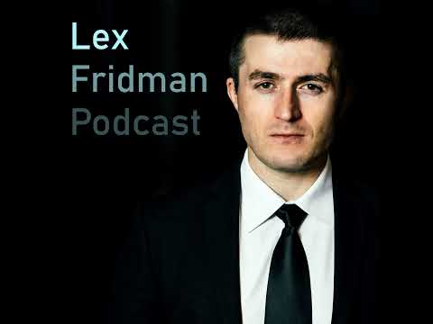 #447 – Cursor Team: Future of Programming with AI (53:09)
- 7:35-8:52 — Harbor + LangSmith on what to inspect after a run. Quick walkthrough of reward score, pass/fail, traces, tokens, and cost after sandboxed runs finish [4].
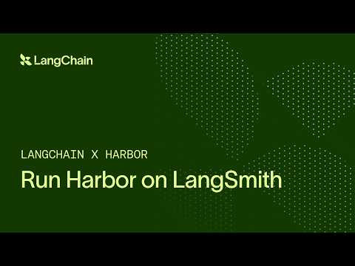 Building a Production Agent Eval Pipeline: Harbor + LangSmith + OpenAI SDK (7:35)
- 1:16:28-1:17:18 — OpenClaw on context empathy. Peter’s point is simple: agents always start fresh, so a few file pointers and constraints beat making them rediscover your whole codebase [5].
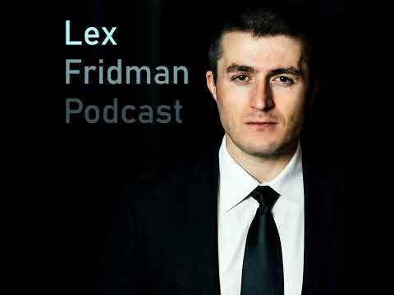 #491 – OpenClaw: The Viral AI Agent that Broke the Internet – Peter Steinberger (76:28)
- OpenClaw codebase — worth studying for messaging-native agent loops, no reply behavior in group chats, markdown/vector memory, and self-introspection debugging prompts [5].
- Hy3 weights — worth testing if you care about open-weight agents; Tencent’s pitch is agentic reliability plus anti-hallucination at 295B MoE [6, 7].
Editorial take: the alpha is in tighter loops—frontier models for ambiguous thinking, smaller models or isolated sandboxes for mechanical execution, and real feedback signals before you trust autonomy. [1, 4, 3]

Sources
- #447 – Cursor Team: Future of Programming with AI
- Cut your AI cost IN HALF (EASY)
- Se gli LLM fossero esoscheletri
- Building a Production Agent Eval Pipeline: Harbor + LangSmith + OpenAI SDK
- #491 – OpenClaw: The Viral AI Agent that Broke the Internet – Peter Steinberger
- 𝕏 post by @TencentHunyuan
- 𝕏 post by @ShunyuYao12

