Dan Loeb’s Four-Book Framework for Special Situations, Capital Allocation, Quality, and Focus
Recommended Reading from Tech Founders
2026-05-29

Dan Loeb’s Four-Book Framework for Special Situations, Capital Allocation, Quality, and Focus
By Recommended Reading from Tech Founders • May 29, 2026
Dan Loeb’s latest book recommendations form a tight learning stack across event-driven investing, capital allocation, quality businesses, and focus. The standout was Joel Greenblatt’s You Can Be a Stock Market Genius, which Loeb said remains the best still-relevant book in the category.

A compact reading stack from Dan Loeb
In this source interview, Dan Loeb named four books that map across special situations, capital allocation, long-term quality, and focus under information overload [1].

Most compelling recommendation

You Can Be a Stock Market Genius
- Content type: Book
- Author/creator: Joel Greenblatt
- Link/URL: not provided in source
- Who recommended it: Dan Loeb
- Key takeaway: Loeb called it the best still-relevant book on event-driven investing and special situations, and said it shaped how he thought about spin-offs, demutualizations, privatizations, and post-reorg equities [1]
- Why it matters: This was the strongest endorsement in the set. Loeb said many investors in that world still use it as a framework [1]
“The best book, which I think is still relevant today, would be Joel Greenblatt’s book, the classic You Can Be a Stock Market Genius.” [1] 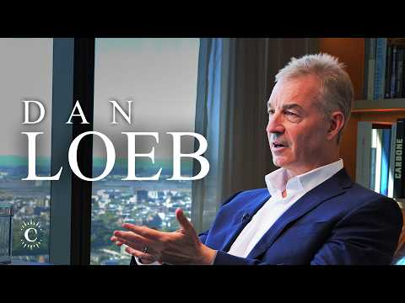 30 Years of Finding Alpha | Dan Loeb (6:38)

Three adjacent books worth saving

The Outsiders
- Content type: Book
- Author/creator: not specified in source
- Link/URL: not provided in source
- Who recommended it: Dan Loeb
- Key takeaway: Loeb highlighted it as an influential book on capital allocation, focused on managers who pair capital allocation with strong operations, including examples such as Danaher and TransDigm [1]
- Why it matters: It shows that Loeb’s reading extends beyond situations and securities to the operating decisions of exceptional managers [1]

Quality Investing
- Content type: Book
- Author/creator: Cunningham
- Link/URL: not provided in source
- Who recommended it: Dan Loeb
- Key takeaway: Loeb called it the most eye-opening book on owning high-quality businesses with strong moats and returns on capital for the long term [1]
- Why it matters: In this set, it complements event-driven and capital-allocation thinking with a long-term quality lens [1]

Essentialism
- Content type: Book
- Author/creator: not specified in source
- Link/URL: not provided in source
- Who recommended it: Dan Loeb
- Key takeaway: Loeb referenced it as a way to focus on what matters most while trying to ingest large amounts of information [1]
- Why it matters: It is the only non-investing title in the group, making it the clearest signal that attention management matters alongside analytical skill [1]

Why this set stands out
These recommendations came from Loeb describing books he found influential or useful in conversation. If you save one first, the clearest choice is You Can Be a Stock Market Genius because he paired conviction with specific application: he called it the best book in the area, said it remains relevant, and tied it directly to the framework he used for special situations [1].

Sources
- 30 Years of Finding Alpha | Dan Loeb

