Data-Center Buildout Thesis Leads Today's Resource Picks
Recommended Reading from Tech Founders
2026-07-06

Data-Center Buildout Thesis Leads Today’s Resource Picks
By Recommended Reading from Tech Founders • July 6, 2026
The clearest signal today was an FT article, shared by Packy McCormick and reinforced by Garry Tan, arguing that data centers finance a broader industrial buildout. Other organic picks included Tim Ferriss on Retro Codex, Elon Musk on the Declaration of Independence, and Tobi Lütke’s direct share of an academic paper.

Most compelling recommendation
The clearest signal today was an FT article by @joshzoff, first shared by Packy McCormick and then explicitly reinforced by Garry Tan. It stood out because both the recommendation and the reason for it were specific: the piece argues that data centers should be understood as a way to finance a much broader industrial buildout, not just as standalone compute projects. [1, 2]

Title not specified in source notes (FT article by @joshzoff)
- Content type: Article [1]
- Author/creator: @joshzoff [1]
- Link/URL: Resource URL not provided in source notes; discussion via Packy McCormick’s post and Garry Tan’s follow-up [1, 2]
- Who recommended it: Packy McCormick, with a follow-on endorsement from Garry Tan. [1, 2]
- Key takeaway: Packy said the piece argues the US cannot treat data centers the way it treated rare earths, and that data centers can finance the development of other advanced technologies. Garry Tan sharpened that point by calling a data center “a financing vehicle” for power generation, the grid, chips, and construction. [1, 2]
- Why it matters: This was the strongest recommendation today because it combined repeated endorsement with a concrete explanation of why the resource matters. [1, 2]
“A data center isn’t just compute
It’s a financing vehicle that pulls power generation, grid, chips, and construction along with it. One buildout drags a dozen adjacent industries forward.” [2]

Other organic recommendations

Retro Codex
- Content type: Website [3]
- Author/creator: Not specified in source notes [3]
- Link/URL: Website URL not provided in source notes; explanation via Tim Ferriss’s YouTube episode [3]
- Who recommended it: Tim Ferriss. [3]
- Key takeaway: Ferriss called it a “really, really cool website” that lets users look up their high-school graduation year and see things they learned in school that have since been disproven. He gave examples including myths about lightning, bulls reacting to red, and goldfish having three-second memories. [3]
- Why it matters: It gives readers a concrete way to inspect how once-taught claims later changed. [3] 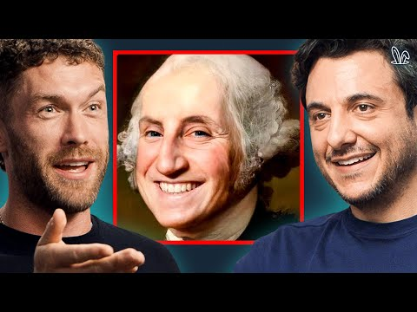 Everything You Learned In School Is A Lie (0:00)

Declaration of Independence
- Content type: Historical document/paper [4]
- Author/creator: Not specified in source notes [4]
- Link/URL: Resource URL not provided in source notes; recommendation via Elon Musk’s X post [4]
- Who recommended it: Elon Musk. [4]
- Key takeaway: Musk said he read it aloud “with heartfelt conviction” and described it as “a work not just of genius, but also of a purity of soul that resonates to this very day.” [4]
- Why it matters: The recommendation’s value was in the strength of the endorsement: Musk framed the text as something that still “resonates to this very day.” [4]
“It is a work not just of genius, but also of a purity of soul that resonates to this very day.” [4]

Title not specified in source notes
- Content type: Academic paper [5]
- Author/creator: Not specified in source notes [5]
- Link/URL: https://academic.oup.com/evolut/advance-article/doi/10.1093/evolut/qpag111/8706652 [5]
- Who recommended it: Tobi Lütke. [5]
- Key takeaway: Lütke described it simply as a “Really interesting read.” [5]
- Why it matters: The context is thin, but it is still a direct pointer to a specific research paper rather than secondary commentary. [5]

Pattern
Today’s list was unusually mixed by format: one infrastructure article, one website, one historical document, and one academic paper. The strongest entries were the ones where the recommender explained why the resource mattered, with the data-center article leading on that front and Retro Codex close behind. [1, 2, 3]

Sources
- 𝕏 post by @packyM
- 𝕏 post by @garrytan
- Everything You Learned In School Is A Lie
- 𝕏 post by @elonmusk
- 𝕏 post by @tobi

