Deterministic Agent Pipelines Move From Prompting to Production
Coding Agents Alpha Tracker
2026-07-25

Deterministic Agent Pipelines Move From Prompting to Production
By Coding Agents Alpha Tracker • July 25, 2026
Today’s strongest signal is the rise of production coding-agent architectures that make planning, validation, permissions, and deployment explicit. Practical workflows cover executable task schemas, Sentry-driven repair loops, graph-to-code specs, and credential injection.

🔥 TOP SIGNAL
The production-agent moat is shifting from clever prompting to deterministic execution architecture. Bridgewater’s Pocket Analyst turns an investment plan into schema-defined Python tasks, then uses static analysis, a DAG, and mandatory parallel validation—yielding identical code across two agents in 95% of test-suite runs. [1] Anthropic’s internal Claude Tag offers a complementary adoption signal: it now lands 65% of product-engineering PRs for the Claude Code team. [2]

⚡ TRY THIS
- Make the plan an executable contract, not a to-do list. Before codegen, have your planner produce tasks with: function name, calculation description, expected output schema, and semantic constraints. Generate each task independently; statically derive dependencies; then force validation for every DAG layer in ordinary orchestration code. This is Bridgewater’s “natural-language Python project” pattern, designed so agents working from the same task produce semantically equivalent output. [1]
- Close the Sentry → fix → deploy loop, but gate it by risk. Kent C. Dodds’ setup is: (1) expose a Kody webhook, (2) send Sentry errors to it, (3) have Kody launch a Cursor cloud agent to investigate and patch, and (4) auto-merge, deploy, and verify only low-risk fixes. He prefers this route for its customization and broader service access. [3, 4]
- Use a hand-drawn graph as an agent spec. Draw the workflow in any tool—or on paper—then give Codex this prompt: “write a code mode script that implements this workflow, run it with .” Peter Steinberger shared the technique as a practical way to turn visual process logic into executable code. [5, 6]
- Keep secrets out of the agent runtime. For tools such as Datadog, use credential injection: an identity/credential system inserts the credential only when the request is made, so the agent can use it without being able to access it. Anthropic describes this pattern for remote environments. [2]

📡 WHAT SHIPPED
- Claude Opus 5 in Cursor: Cursor says Opus 5 matches Fable 5 on CursorBench at default effort (66.7 vs. 66.5) at half the price, and supports Zero Data Retention. Cursor’s comparison page is here. [7, 8]
- T3 Code: Theo reports 76 PRs merged since Monday. Notable agent-facing changes: Auto mode for Claude Code and Codex approvals, shared t3.json project config, Opus 5 support, Claude Code skills in the composer picker, 1M-context Claude defaults, and worktrees branching from latest origin/main. [9]
- Kody v2026.07.23: agents can browse by domain instead of guessing from ranked search hits; broad queries return a compact overview, then follow-ups scope to a domain. The release is here. Kent C. Dodds separately reported creating and merging 55 PRs in a day using Cursor, Kody, Grok 4.5, GPT 5.6 Sol, and Claude Fable 5. [10, 11, 12]
- Codex Real Time Voice: Riley Brown’s initial test shows a Start New Voice Chat entry point, voice-directed parallel chats, and remote control from ChatGPT voice on an iPhone to tasks running on a Mac. The live voice environment does not permit silent sends or consequential changes without explicit authorization. [13]
- Regression watch: Theo reports that a Claude Code Auto Mode classifier change blocks his HTML-file upload attempts through an “HTML plan skill.” Treat permission classifiers as part of the workflow surface area and regression-test them alongside model changes. [14]

🎬 GO DEEPER
- 20:20–21:06 — Bridgewater’s plan → typed task architecture. Watch how the Pocket Analyst team maps each task to a Python/Pandas function with an expected schema, making parallel generation and deterministic evaluation feasible. 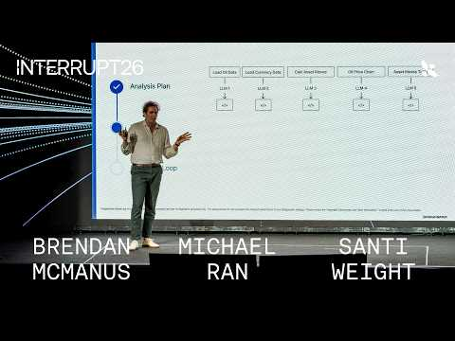 How Bridgewater Built Pat, The AI Pocket Analyst Tool | Interrupt 26 (20:20)
- 22:11–22:44 — Forced validation through a DAG. Bridgewater explains why its agents do not orchestrate each other: regular Python enforces the validation handoffs, so agents cannot skip them. How Bridgewater Built Pat, The AI Pocket Analyst Tool | Interrupt 26 (22:10)
- 11:11–11:35 — Context management via filesystems. Traversal argues that summaries plus grep-style drill-down give agents a practical way to explore detail beyond finite context windows. 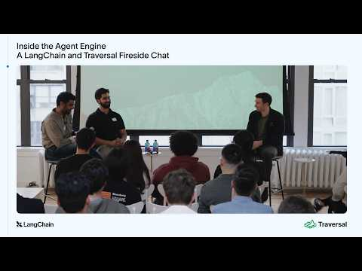 Inside the Agent Engine: A LangChain and Traversal Fireside Chat (11:50)
Editorial take: the durable pattern is to turn agent work into a constrained pipeline—explicit intermediate contracts, enforced validation, scoped permissions, and risk-gated deployment—not a long free-form prompt. [1, 3, 2]

Sources
- How Bridgewater Built Pat, The AI Pocket Analyst Tool | Interrupt 26
- OpenAI’s accidental cyberattack against Hugging Face is science fiction that happened
- 𝕏 post by @kentcdodds
- 𝕏 post by @kentcdodds
- 𝕏 post by @alex_frantic
- 𝕏 post by @steipete
- 𝕏 post by @cursor_ai
- 𝕏 post by @cursor_ai
- 𝕏 post by @theo
- 𝕏 post by @kodykoala
- 𝕏 post by @kentcdodds
- 𝕏 post by @kentcdodds
- OpenAI just released Codex Voice (It’s basically Jarvis)
- 𝕏 post by @theo

