Elorian’s $55M Seed and the Expanding Infrastructure for Agents and Physical AI
VC Tech Radar
2026-07-17

Elorian’s $55M Seed and the Expanding Infrastructure for Agents and Physical AI
By VC Tech Radar • July 17, 2026
New seed financings highlight visual reasoning, agent execution infrastructure, and healthcare deployment. The broader signal is a move toward open-weight model competition, physical AI, experimentally grounded scientific systems, and more controlled operational use of agents.

Funding & Deals
- Elorian raised a $55M seed round at a $300M valuation. The company is pursuing specialized multimodal models for visual understanding and reasoning, with an eventual goal of visual AGI. Its investor group includes Menlo Ventures, Nvidia, and Jeff Dean. [1, 2] The 13-person team plans to grow 2–3x over the next six months and aims to release a public API after pursuing frontier visual-reasoning benchmarks later this year. [1]
- Runta raised a $20M seed led by a16z. It is building an execution layer intended to constrain agents while they run, with security and policy controls for local or cloud deployment. The founding team’s background includes leading Cloudflare’s edge proxy and Kong’s core proxy; Martin Casado is joining the board. [3, 4]
- Bunkerhill Health raised $55M for a hospital AI platform. The company says its single interface will help health systems deploy AI across dozens of use cases. [5]
- Menlo Ventures and Anthropic launched the $100M Anthology Fund to invest in early-stage AI startups and provide participating companies access to Anthropic credits. [6]

Emerging Teams
- Elorian pairs substantial model-building pedigree with a narrowly defined technical wedge. Its founder spent more than a decade at Google DeepMind, worked on Gemini from its inception, and authored a 2015 paper later cited by OpenAI in relation to ChatGPT. [1, 2] Elorian’s stated focus is on failures in advanced visual tasks such as counting objects, tracing wires, and locating items in images—rather than general multimodal capability. [1]
- Lila Sciences is building a data-generation thesis around autonomous labs. CTO Andy Beam and CSO Rafa Gómez-Bombarelli are developing AI-guided robotic labs across biology, chemistry, drug discovery, and materials science. Lila reports producing more than 10 trillion experimentally validated scientific-reasoning tokens in a single automated facility. [7] Its team reports a gas-sorption measurement redesign that is roughly 2,500x faster and model-suggested platinum-group-free electrocatalysts that became its best performers. [7]
- Bunkerhill Health’s origin and go-to-market offer useful healthcare-AI signals. CEO Nish Khandwala’s work began with a Stanford research project and was shaped by his father’s heart attack; the company landed Cleveland Clinic as its first customer through a cold email. [5]
- Appnigma is a small but relevant vertical-AI watchlist company. Its cofounder spent 3.5 years on Salesforce’s AppExchange security-review team, reviewing more than 300 ISV submissions. The company says it generates native Salesforce managed packages from natural-language instructions, and that Pylon, Warmly, and Avoma shipped to AppExchange in days rather than quarters. These are founder-reported customer outcomes. [8]

AI & Tech Breakthroughs
- Kimi K3 is a notable open-weights model release to track. Moonshot AI describes it as a 2.8T-parameter, 1M-context, natively multimodal model designed for long-horizon agentic coding; it reports up to 6.3x faster decoding in million-token contexts through Kimi Delta Attention and roughly 25% higher training efficiency through Attention Residuals. [9] The company says weights will be released by July 27. [9] On Frontend Code Arena, Kimi K3 reached first place with 1,679 points, leading six of seven domains after a 17-place jump from Kimi K2.6. [10]
- AMI Labs is pursuing physical-AI world models through JEPA. Yann LeCun described JEPA as learning abstract representations of a signal and making predictions in that representation space, rather than predicting every signal detail. [11] Existing V-JEPA models reportedly understand video, identify impossible events, and transfer to downstream tasks with minimal fine-tuning. [11] Proposed applications include robot action planning, drone trajectory planning, and industrial-process control. [11]
- Sunday Robotics reports a generalization and reliability result for home robotics. Its ACT-2 Preview claims that a single fine-tuning example can teach a new behavior that generalizes, and reports a 99% zero-shot success rate in real, unseen homes. This is a company-reported result that warrants independent diligence. [12]
- Agent infrastructure is becoming a distinct systems layer. Perplexity launched SPACE, a secure sandbox platform for agentic AI; NVIDIA reports early tests showing up to 1.9x faster sandbox starts on Vera CPUs. [13] Runta similarly argues that VMs and containers are not the right long-term execution substrate for agents. [14]

Market Signals
- Open-weight competition is broadening beyond a single vendor ecosystem. Marc Andreessen argues that well-funded teams in the U.S. and abroad are producing near-SOTA open-weight models, particularly for coding and agentic use. [15] His accompanying view is that organizations are increasingly prioritizing control of data and token costs, even if that means giving up some frontier-model access. [15]
- AI and B2B venture capital remains sharply concentrated geographically. SaaStr reports that the Bay Area receives 51.5% of AI venture dollars and 53.2% of B2B dollars, while the top two metros together capture 72% of B2B funding. [16] The implication for competitive Seed–Series B financings is not that location is mandatory, but that proximity to specialized investors can still matter. [16]
- Vertical applications may remain resilient against foundation-model substitution. Spellbook reported losing less than 1% of deals to Claude in Q2, challenging the claim that foundation models will absorb every software category. This is a company-reported sales metric rather than an industry-wide measure. [17]
- Operational agent deployments are moving toward controlled automation, not fully hands-off systems. Mintlify, which a16z says grew 10x in a year, routes actionable support tickets through coding agents and automated PR review, while retaining engineers for final review, testing, and merge decisions. [18, 19] Its hiring framework asks whether a problem can be solved by automation or process change before adding headcount. [20]

Worth Your Time
- Elorian’s TechCrunch interview — the most direct source on its visual-reasoning thesis, Nvidia relationship, and public-API roadmap. [1] 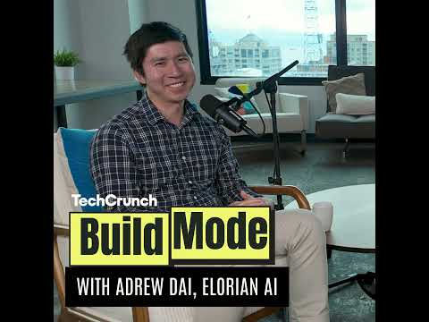 How Elorian AI pulled off a $300M pre-seed valuation with Andrew Dai (4:32)
- Yann LeCun’s AMI Labs fireside — useful for evaluating the technical case for abstract-prediction world models and their potential role in physical AI. [11] 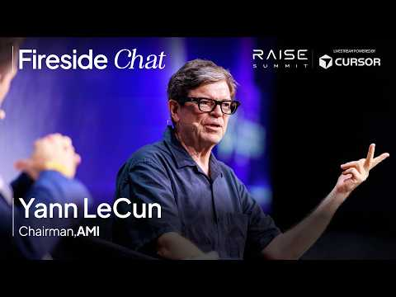 Fireside Chat with Yann LeCun, Executive Chairman of AMI Labs | RAISE Summit 2026 (10:07)
- Latent.Space’s Lila Sciences conversation — a substantive look at automated labs as a mechanism for generating experimentally verified training data, including the tradeoff between fast iteration and large multiplexed screens. [7]
- A16z’s Mintlify agent-systems thread — concrete workflow detail on support remediation, knowledge retrieval, sales briefs, and the human controls retained around automated coding. [19, 21, 22]

Sources
- The founder that left Google and secured a $300M pre-seed valuation in months l Build Mode
- How Elorian AI pulled off a $300M pre-seed valuation with Andrew Dai
- 𝕏 post by @guanlan
- 𝕏 post by @a16z
- 𝕏 post by @ycombinator
- SCOOP: Menlo Ventures Sees IRR of 40%+ on Recent Funds After Doubling Down on Anthropic
- 🔬 The Lab of the Future Should Feel Like a Data Center — Andy Beam & Rafa Gómez-Bombarelli, Lila Sciences
- r/SaaS post by u/AppX_Unmanaged
- 𝕏 post by @Kimi_Moonshot
- 𝕏 post by @arena
- Fireside Chat with Yann LeCun, Executive Chairman of AMI Labs | RAISE Summit 2026
- 𝕏 post by @tonyzzhao
- 𝕏 post by @NVIDIAAIInfra
- 𝕏 post by @martin_casado
- 𝕏 post by @sriramk
- The Bay Area Now Takes 51% of Every AI Venture Dollar. And 53% of Every B2B Dollar.
- 𝕏 post by @scottastevenson
- 𝕏 post by @a16z
- 𝕏 post by @a16z
- 𝕏 post by @a16z
- 𝕏 post by @a16z
- 𝕏 post by @a16z

