Empathy Books, Organic Design, and an Enterprise AI Memo
Recommended Reading from Tech Founders
2026-06-30

Empathy Books, Organic Design, and an Enterprise AI Memo
By Recommended Reading from Tech Founders • June 30, 2026
Today’s authentic recommendations clustered around two durable founder inputs—psychology and architecture—and one current operator read on enterprise AI. Satya Nadella, Ivan Zhao, and Keith Rabois each pointed to resources they framed as genuinely useful, not promotional.

What stood out
The strongest organic recommendations today were not product demos or hot takes. They were resources leaders said shaped how they think about empathy, culture, and organizational design, plus one dense enterprise AI memo Keith Rabois flagged for careful reading [1, 2, 3].

Most compelling recommendation

Nonviolent Communication
- Content type: Book recommendation [1]
- Author/creator: Not specified in the source notes
- Link/URL: Not provided in the source notes
- Who recommended it: Satya Nadella [1]
- Key takeaway: Nadella tied it to empathy, understanding where another person is coming from, and avoiding reactive communication [1]
- Why it matters: He described it as influential for his own leadership and said the idea applies to corporate culture as well as personal development [1]
“non-violent communications … developing a sense of empathy understanding where the other person is coming from not having your amygdala always triggered … it’s a great read” [1] 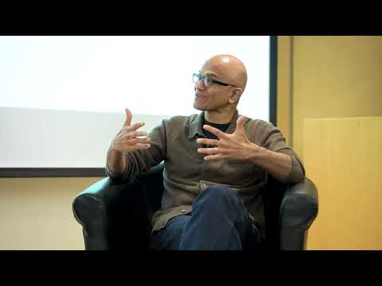 Stanford CS153 Frontier Systems | Building the Frontier Ecosystem (37:33)
Satya paired this with Carol Dweck’s work on growth mindset, making the broader signal clear: he sees both as practical tools for countering fixed mindsets and improving behavior inside organizations [1].

Also worth saving

Carol Dweck’s work on growth mindset
- Content type: Work / reading recommendation; specific title was not named in the source [1]
- Author/creator: Carol Dweck [1]
- Link/URL: Not provided in the source notes
- Who recommended it: Satya Nadella [1]
- Key takeaway: Nadella grouped it with Nonviolent Communication as an influential practice with relevance beyond child psychology and into corporate culture [1]
- Why it matters: It was part of the same leadership toolkit Nadella said influenced him [1]

The Timeless Way of Building
- Content type: Book [2]
- Author/creator: Christopher Alexander [2]
- Link/URL: Not provided in the source notes
- Who recommended it: Ivan Zhao [2]
- Key takeaway: Zhao said Alexander’s central idea is that buildings should evolve rather than be rigidly designed, and he translates that into thinking about product and company design [2]
- Why it matters: Zhao said he was reading it for the second time and uses it as inspiration for building organizations and culture in an organic way [2]

Christopher Alexander’s “pattern library” volume
- Content type: Book [2]
- Author/creator: Christopher Alexander [2]
- Link/URL: Not provided in the source notes
- Who recommended it: Ivan Zhao [2]
- Key takeaway: Zhao connected its architectural patterns to “the culture that matters” inside a company [2]
- Why it matters: Zhao explicitly applies Alexander’s ideas to how organizations should develop instead of being overdesigned from scratch [2]
“buildings should be evolved rather than designed” [2]

MEMORY IS THE MOAT
- Content type: X post / interview summary [4]
- Author/creator: gokulr [3]
- Link/URL: X post [3]
- Who recommended it: Keith Rabois [3]
- Key takeaway: The summary argues that enterprise AI advantage comes from context and memory, not just the model, and that most companies still need to redesign workflows around AI rather than bolt it onto old ones [4]
- Why it matters: Rabois called it “Worth reading carefully,” and the piece compresses a broad operator view on enterprise AI depth, false-positive risk, token economics, and security urgency [3, 4]

Why these matter together
A clear pattern runs through the strongest recommendations. Satya Nadella and Ivan Zhao both pointed outside software—to psychology and architecture—for frameworks on how people and organizations should behave [1, 2]. Keith Rabois’s pick is more current and tactical, but it serves the same purpose: a dense resource that helps operators think more clearly about what actually creates advantage in enterprise AI [3, 4].

Sources
- Stanford CS153 Frontier Systems | Building the Frontier Ecosystem
- Notion CEOが選んだ“ジャズモード”な経営・プロダクト開発・AIネイティブ組織の動かし方
- 𝕏 post by @rabois
- 𝕏 post by @gokulr

