Encode Team Knowledge Before You Scale Coding Agents
Coding Agents Alpha Tracker
2026-07-16

Encode Team Knowledge Before You Scale Coding Agents
By Coding Agents Alpha Tracker • July 16, 2026
The practical shift is from isolated coding assistants to systems that retain team knowledge, automate recurring checks, and earn autonomy through scoped evaluation. Also: Slack-native agent workflows, Anthropic prompting lessons, and a Codex safety reminder.

🔥 TOP SIGNAL
The coding-agent multiplier is organizational knowledge encoded as infrastructure. Boris Cherny’s practical prescription is to turn team conventions into CLAUDE.md, REVIEW.md, skills, docs, comments, and memories so agents can operate without fresh prompting; recurring failures should become lint, CI, or routines rather than repeated agent work. [1] Anthropic’s internal Claude Tag is the operational version of that idea: it reports landing 65% of product-engineering PRs while retaining channel-level memory and proactively handling work. [2]

⚡ TRY THIS
- Make “zero-context contribution” a repo requirement. Document architectural rules, preferred frameworks, review expectations, and task-specific procedures in CLAUDE.md, REVIEW.md, skills, code comments, and docs. When a PR is rejected for an architectural or framework mismatch, treat it as missing automation and encode the rule for the next agent or contributor. [1]
- Promote recurring fixes into deterministic checks. When an agent encounters the same defect twice, have it create a lint rule, CI step, or routine instead of fixing another instance. This cuts repeat token spend and turns a class of busywork into a durable check. [1]
- Delegate code review by proven scope, not by optimism. Start with human review everywhere; only remove it for specific file sets once evals show agent review catches the issues you care about. Keep code owners on critical areas, and after an incident, add the causing PR to the eval set so the reviewer is tested against that failure going forward. [2]
- Use agents to accelerate diagnosis, not to declare victory. For a GPU/rendering regression, ask the model to generate a browser-console script that toggles suspected CSS features, then isolate the cause manually. Theo used this to find that animate-pulse, blur, and a grain background layer drove an approximately 85% GPU-utilization reduction; the agents had tools but focused on irrelevant code. [3]

📡 WHAT SHIPPED
- Claude Tag in Slack: Anthropic says its new collaboration-layer agent is multiplayer, proactive, and remembers channel preferences. A team can have it monitor bug reports, open fix PRs, and tag the engineer who last touched the affected area; Anthropic positions Claude Code for complex interactive work and Tag for background/proactive work. [2]
- LangSmith Fleet Slack upgrade: Any Fleet agent can now be added to Slack in one click, given a custom identity, used in channels or threads, handed files, and paused for approvals while retaining work context. Read the announcement. [4]
- Prompting field note from Anthropic: For Fable and Opus 4.8, Anthropic says it cut system-prompt tokens by about 80% by removing over-constraining examples and “do not” rules in favor of more context and fewer hard constraints. It now maintains different prompts by model; older models retain the fuller prompt. [2]
- LangSmith Engine design lesson: Automatically opening a PR for every issue created too much noise; the team switched to an inbox that clusters problems and preserves their history. If your agent finds many small issues, aggregate and prioritize before creating work for humans. [5]
- Safety watch — GPT-5.6/Codex: Tibo reports a handful of unexpected file-deletion cases, most often with full access, no sandboxing or auto-review, and an attempted $HOME override for a temporary directory. Mitigations cited include a revised developer message, safer-permission guidance, and additional harness safeguards. [6]

🎬 GO DEEPER
- 6:51–8:59 — Claude Tag’s proactive Slack workflow. Watch Cat Wu explain the useful operational split: collaborative, persistent background work in Slack versus complex, interactive work in Claude Code. 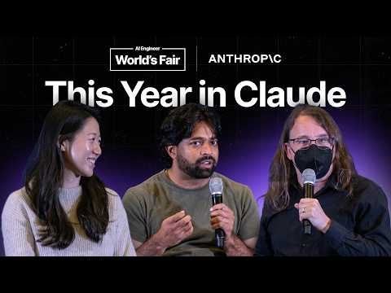 Simon Willison in conversation with Cat Wu & Thariq Shihipar, Anthropic (6:51)
- 15:46–17:16 — How to earn agent-only review. The key detail is the gradual handoff: establish performance on narrowly scoped files, retain owners for core systems, and feed incident-causing PRs back into the eval suite. Simon Willison in conversation with Cat Wu & Thariq Shihipar, Anthropic (15:46)
- 21:36–23:01 — Why fewer prompt rules can work better. Anthropic’s team describes dropping examples and hard prohibitions for newer models, then tailoring prompts per model rather than treating one system prompt as universal. Simon Willison in conversation with Cat Wu & Thariq Shihipar, Anthropic (21:21)
Editorial take: the durable advantage is not merely agent autonomy—it is a codebase that stores its knowledge, routes work with low noise, and converts every failure into a better guardrail. [1, 5]

Sources
- 𝕏 post by @bcherny
- Simon Willison in conversation with Cat Wu & Thariq Shihipar, Anthropic
- 𝕏 post by @theo
- 𝕏 post by @LangChain
- 𝕏 post by @LangChain
- 𝕏 post by @thsottiaux

