Extreme Ownership Leads a Founder Reading List on Accountability, Policy, and AI Safety
Recommended Reading from Tech Founders
2026-03-31

Extreme Ownership Leads a Founder Reading List on Accountability, Policy, and AI Safety
By Recommended Reading from Tech Founders • March 31, 2026
Marc Andreessen’s recommendation of Jocko Willink’s Extreme Ownership stands out because he ties it to a clear operating framework rather than offering generic praise. Other authentic picks include the Draghi Report, Tony Fadell’s Apple II history article, and Sam Altman’s nod to a Boaz Barak AI safety post.

Most compelling recommendation: Extreme Ownership
Marc Andreessen’s endorsement of Extreme Ownership is the clearest signal in today’s set because he explains exactly what he took from the book and how he uses it. He says the idea of assuming fault first helps him focus on self-improvement, relieve stress, drain resentment, and lean on intrinsic rather than extrinsic motivation; he also says he fell in love with the book when it came out and wanted to share it with founders [1]
- Content type: Book
- Author/creator: Jocko Willink [1]
- Link/URL: Not provided in the source material
- Who recommended it: Marc Andreessen [1]
- Key takeaway: Treat “extreme ownership” as an operating rule: if something goes wrong, start by assuming it is your fault, then improve what you can control [1]
- Why it matters: This stands out because the recommendation comes with a concrete framework, not just praise. Andreessen ties it to a repeatable psychology he says is useful precisely when external rewards are not enough [1]
“Life just gets a lot simpler if you just assume everything is your own fault.” [1] 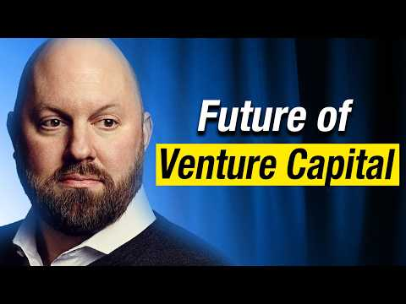 Marc Andreessen: Will a16z Go Public & Why Labour Displacement with AI is Wrong? (14:29)

Other clearly organic picks
A pattern in today’s set: the highest-signal recommendations came with explicit operating rules, while the lighter picks still help readers track what prominent tech leaders found worth sharing.

Draghi Report
- Content type: Report
- Author/creator: Mario Draghi [1]
- Link/URL: Not provided in the source material
- Who recommended it: Marc Andreessen [1]
- Key takeaway: Andreessen says readers should “just read that report” because “everything’s in there,” and frames it as a set of prescriptions for building stronger tech ecosystems in Europe [1]
- Why it matters: He presents it as an execution playbook rather than a diagnosis alone; the gap, in his telling, is implementation [1]

Apple II Forever!
- Content type: Article
- Author/creator: The Verge [2, 3]
- Link/URL: https://www.theverge.com/tech/900677/apple-ii-personal-computer [2]
- Who recommended it: Tony Fadell [3]
- Key takeaway: Fadell says the Apple II was his first computer; he saved up by caddying while his grandfather matched his earnings, then read MacWorld and other computer magazines while dreaming of joining the Macintosh team [3]
- Why it matters: The recommendation is anchored in a formative personal story about how early computing shaped a future hardware builder’s ambitions [3]

the state of AI safety in four fake graphs
- Content type: Blog post
- Author/creator: Boaz Barak [4]
- Link/URL: Announcement post — https://x.com/boazbaraktcs/status/2038606572046172443 [5]
- Who recommended it: Sam Altman [5]
- Key takeaway: Altman called it “a very good post” [5]
- Why it matters: The source material does not include a fuller summary of the post’s thesis, but the endorsement itself is a strong signal for readers tracking what prominent tech leaders are flagging in AI safety discussions [5, 4]

Sources
- Marc Andreessen: Will a16z Go Public & Why Labour Displacement with AI is Wrong?
- 𝕏 post by @verge
- 𝕏 post by @tfadell
- 𝕏 post by @boazbaraktcs
- 𝕏 post by @sama

