Fake Legibility, Dynamic Interfaces, and First-Principles Tools
Recommended Reading from Tech Founders
2026-05-03

Fake Legibility, Dynamic Interfaces, and First-Principles Tools
By Recommended Reading from Tech Founders • May 3, 2026
Four organic recommendations from Notion’s Head of Product all point to the same discipline: work from reality, not simplified abstractions. The standout is Seeing Like a State, followed by picks on interactive prototyping, computing fundamentals, and tools that preserve human autonomy.

What stood out
Max Schwing’s recommendations all push toward the same habit: work from reality, not from simplified representations that hide what matters. He applied that lens to executive reporting, chat-interface design, computing fundamentals, and the design of tools themselves [1].

Start here

Seeing Like a State
- Content type: Book
- Author/creator: James C. Scott
- Link/URL: No direct book URL was provided; source context: Why cultivating agency matters more than cultivating skills in the AI era | Max Schoening (Notion)
- Who recommended it: Max Schwing
- Key takeaway: He recommends it especially to executives building systems, as a warning against creating reporting structures that give leaders legibility while neglecting the reality of how teams actually work [1].
- Why it matters: This was the most compelling recommendation in today’s set because Schwing turned the book into a concrete management test: if a system looks clean from the top but fails to reflect what is happening on the ground, that clarity may be false [1].
“executives love creating fake legibility for themselves because we don’t like noise as humans… we want the signal but there’s often less signal in it than one might think” [1] 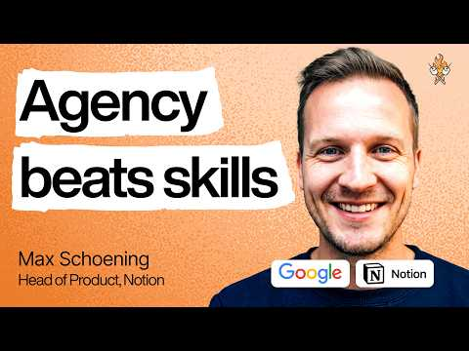 Why cultivating agency matters more than cultivating skills in the AI era | Max Schoening (Notion) (80:30)

Three more worth saving

Stop Drawing Dead Fish
- Content type: Talk/video
- Author/creator: Brett Victor
- Link/URL: No direct resource URL was provided; source context: Why cultivating agency matters more than cultivating skills in the AI era | Max Schoening (Notion)
- Who recommended it: Max Schwing
- Key takeaway: Schwing praised it while discussing chat interfaces at Notion, using it to argue that static Figma screens are inadequate for dynamic conversational products and that teams should prototype those interactions in interactive code [1].
- Why it matters: It is the clearest product-design recommendation in the set: if the product is dynamic, the design process needs to capture that dynamism rather than freeze it into still images [1].

Code: The Hidden Language of Computer Hardware and Software
- Content type: Book
- Author/creator: Charles Petzold
- Link/URL: No direct book URL was provided; source context: Why cultivating agency matters more than cultivating skills in the AI era | Max Schoening (Notion)
- Who recommended it: Max Schwing
- Key takeaway: He recommends it as a way to learn how computers actually work, noting that many professional programmers still lack that grounding and that the book does not introduce code until much later in the text [1].
- Why it matters: It stands out as a fundamentals pick for readers who want a first-principles understanding of computing without needing to start from syntax [1].

Tools for Conviviality
- Content type: Book
- Author/creator: Ivan Illich
- Link/URL: No direct book URL was provided; source context: Why cultivating agency matters more than cultivating skills in the AI era | Max Schoening (Notion)
- Who recommended it: Max Schwing
- Key takeaway: Schwing described it as a contrast between tools that let people exercise ingenuity and autonomy and industrial-scale tools that can become destructive to human autonomy [1].
- Why it matters: It offers a clean framework for evaluating whether a technology expands human agency or strips it away [1].

Bottom line
If you save one item, save Seeing Like a State for the clearest warning in today’s set: neat visibility is not the same thing as understanding [1]. If you are building AI or chat products, pair it with Stop Drawing Dead Fish for a more concrete design principle about prototyping live interaction as live interaction [1].

Sources
- Why cultivating agency matters more than cultivating skills in the AI era | Max Schoening (Notion)

