Ferriss's "10,000 True Fans" Endorsement Leads Today's Learning Picks
Recommended Reading from Tech Founders
2026-07-10

Ferriss’s “10,000 True Fans” Endorsement Leads Today’s Learning Picks
By Recommended Reading from Tech Founders • July 10, 2026
Tim Ferriss delivered the strongest explicit recommendation in the set with Kevin Kelly’s “10,000 True Fans,” then tied Seneca’s “Letters from a Stoic” to his own approach to loss and conviction. Alexandr Wang added a current SemiAnalysis read on Meta’s superintelligence progress.

Most compelling recommendation
Tim Ferriss supplied the clearest high-conviction pick in today’s notes: Kevin Kelly’s 10,000 True Fans. He said it is the one marketing article he would keep if forced to choose just one, noted that it is free, and pointed readers to kk.org. Kelly was identified as the founding editor of Wired. [1]
- Title: 10,000 True Fans
- Content type: Article
- Author/creator: Kevin Kelly
- Link/URL: kk.org [1]
- Who recommended it: Tim Ferriss
- Key takeaway: Ferriss framed it as the single article on marketing he would keep above all others. [1]
- Why it matters: He did not just mention the piece; he ranked it above essentially every other marketing article. [1]
“If you could only read one article about marketing for the rest of your life, that would be one.” [1] 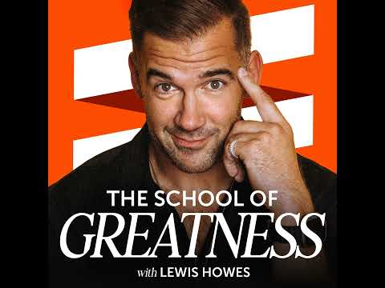 3 Tim Ferriss on Meta Learning and Living the Good Life (38:16)

A philosophy text Ferriss tied to behavior
Ferriss also singled out Seneca’s Letters from a Stoic when explaining how he learned not to fear loss and why he is comfortable expressing his opinions. [1]
- Title: Letters from a Stoic
- Content type: Book
- Author/creator: Seneca
- Link/URL: Exact book URL was not provided in the source notes
- Who recommended it: Tim Ferriss
- Key takeaway: Ferriss said Stoic philosophy, with a focus on Seneca and Letters from a Stoic, taught him to stay attached only to things that cannot be taken away. [1]
- Why it matters: He tied the book to concrete behavior: how he handles loss and how openly he speaks. [1]
“I am comfortable expressing my opinion because I have learned to be attached to only those things that cannot be taken away.” [1]

One current AI analysis signal
Alexandr Wang organically amplified SemiAnalysis’s The Future of Meta Superintelligence: A 1 Year Progress Update and linked directly to it. The post he surfaced describes a set of claims around an RL environment startup, an aggressive compute ramp, 2000km+ scale-across, and advice for Google DeepMind. [2]
- Title: The Future of Meta Superintelligence: A 1 Year Progress Update
- Content type: Article
- Author/creator: SemiAnalysis
- Link/URL: https://semianalysis.substack.com/p/the-future-of-meta-superintelligence [2]
- Who recommended it: Alexandr Wang
- Key takeaway: Wang did not add a detailed thesis of his own; his post functioned as a strong endorsement of the piece and its author. [3]
- Why it matters: For readers tracking Meta’s AI compute ramp, the article bundles several concrete claims into one read. [2]
“compute daddy @dylan522p has spoken” [3]

What stands out
This was a small but clean set of organic recommendations. The strongest signals were highly specific: Ferriss attached one resource to marketing judgment and another to his own operating philosophy, while Wang pointed readers to a current Meta-focused AI analysis rather than a generic reading-list item. [1, 3, 2]

Sources
- 3 Tim Ferriss on Meta Learning and Living the Good Life
- 𝕏 post by @SemiAnalysis_
- 𝕏 post by @alexandr_wang

