GPT-5.5 Moves Deeper Into Enterprise as TRINITY, Sonic, and Sovereign AI Advance
AI News Digest
2026-04-26

GPT-5.5 Moves Deeper Into Enterprise as TRINITY, Sonic, and Sovereign AI Advance
By AI News Digest • April 26, 2026
A governed Databricks rollout gives GPT-5.5 a new enterprise foothold, Sakana AI shows a tiny coordinator can outperform individual frontier models, and NVIDIA’s Sonic points to lighter robot control. The digest also covers new financing and policy commitments behind the Cohere-Alef Alpha sovereign AI alliance, plus Yoshua Bengio’s warning on guardrails.

Agents and deployment

GPT-5.5 reaches a governed enterprise stack
OpenAI’s GPT-5.5 is now available on Databricks, with Codex coding workflows and model inference governed through Unity AI Gateway [1]. Databricks says customers can use it to power coding agents, build custom agents grounded in enterprise data, ask business questions over enterprise data with Genie, and automate document intelligence pipelines with Lakeflow Spark Declarative Pipelines [1]. Greg Brockman separately framed the move simply as GPT-5.5 for the enterprise [2].
Why it matters: This is another sign that frontier models are being integrated into managed enterprise systems with governance and data controls, not just exposed through standalone chat or APIs [1].

Sakana AI’s TRINITY shows how far orchestration can go
Sakana AI published TRINITY, a system that uses a lightweight coordinator with fewer than 20K learnable parameters, optimized with a derivative-free evolutionary algorithm, to assign Thinker, Worker, and Verifier roles across a pool of frontier LLMs at test time [3]. In Sakana’s experiments, TRINITY set a new state of the art on LiveCodeBench at 86.2% pass@1 and transferred zero-shot to four unseen tasks, where the evolved coordinator outperformed every individual model in its pool on average, including GPT-5, Gemini 2.5-Pro, and Claude-4-Sonnet [3].
Why it matters: The notable move here is not a larger base model, but a tiny controller that composes existing frontier models without changing their weights [3]. Sakana says this research is part of the core engine behind its Fugu product [3, 4].

Embodied AI

NVIDIA’s Sonic puts multimodal robot control on a phone
Sonic, a teleoperated robot controller from NVIDIA’s humanoid robots lab, translates human video motions, voice commands, text, and music into robot joint positions with a 42 million parameter network that can run on smartphones [5]. The system was trained on 100 million unlabeled human motion frames and uses a motion generator, human encoder, quantizer for universal tokens, and decoder for motor commands; a root trajectory spring model dampens abrupt commands so the robot settles smoothly without oscillation [5].
Why it matters: The combination of whole-body control, expressive movement, lightweight inference, and open-sourced models points to a more deployable class of robot control systems [5].
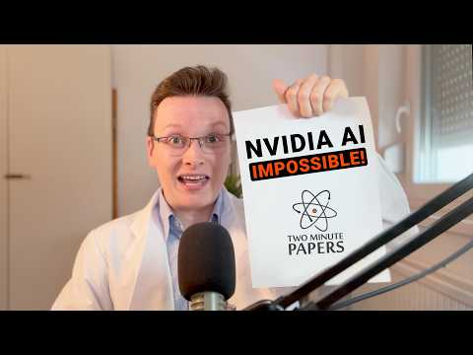 NVIDIA’s New AI Broke My Brain (0:48)

Sovereignty and guardrails

The Cohere-Alef Alpha alliance now has concrete financing and state backing
The Canada-Germany partnership between Cohere and Alef Alpha is being framed as an independent sovereign AI platform anchored in Canada and Germany, combining Cohere’s global scale with Alef Alpha’s European R&D for secure enterprise AI in regulated sectors [6]. Schwarz Group says it is committing €500 million in financing and will offer sovereign cloud infrastructure through StackIT, while the governments described data control, IP protection, transparency, and public-procurement support as part of the arrangement [6]. German officials also described Germany becoming Cohere’s second global headquarters [6].
Why it matters: This makes the sovereign AI push more concrete: not just rhetoric, but capital, infrastructure, and procurement alignment [6].

Bengio’s reminder: capability growth is outrunning governance
“AI is advancing faster than our ability to manage it. We still have the opportunity to build the societal and technical guardrails we need to keep people, institutions, and democracies safe — we shouldn’t let it pass us by.” [7]
Nando de Freitas said he fully agrees [8]. Why it matters: Even as product and research momentum accelerates, leading researchers are still describing governance as an immediate gap rather than a future one [7].

Sources
- 𝕏 post by @databricks
- 𝕏 post by @gdb
- 𝕏 post by @SakanaAILabs
- 𝕏 post by @hardmaru
- NVIDIA’s New AI Broke My Brain
- Deutsch-Kanadische KI-Partnerschaft | Karsten Wildberger (CDU) & Co. | BPK 24. April 2026
- 𝕏 post by @Yoshua_Bengio
- 𝕏 post by @NandoDF

