GPT-6 Astra Raises the Ceiling—and the Operating Burden—for Coding Agents
Coding Agents Alpha Tracker
2026-09-04

GPT-6 Astra Raises the Ceiling—and the Operating Burden—for Coding Agents
By Coding Agents Alpha Tracker • September 4, 2026
Early Astra stress tests point to long-running, multi-agent engineering runs; the practical controls are bounded concurrency, model handoffs, structured tools, and proof-bearing PRs.

🔥 TOP SIGNAL
The highest-alpha signal is a workflow change, not a leaderboard win. After burning over 20B tokens, Latent Space reports that GPT-6 Astra can choose and train models, label data, keep pipelines saturated, instrument and read logs, deploy and debug systems, and fan out, command, and evaluate subagents while maintaining coherence across billions of tokens in a single thread. [1] Their observed rate was 33 tokens/sec at $50/M tokens, or roughly $6/hour, but they also warn that parallelizing Astra burns well above that headline rate. The unit of work is moving from a single code-generation prompt to a monitored engineering run; concurrency, budgets, and proof are now first-class controls. [1, 2]

⚡ TRY THIS
- Bound the fleet before scaling it. Start with individually tuned subagents, cap concurrency, and let a supervisor monitor runs and start/stop waves—the pattern Latent Space used. Add a per-wave token/cost ceiling and stop condition; the team says one such run cost about $100 over two days. [1]
- Make feature delivery role-specialized and proof-bearing. In Cursor’s Grok Bot demo, a tech lead assigned a lodging feature to backend Bobby and frontend Fay; QA Quincy ran localhost end-to-end checks and recorded both UI and network-inspector evidence, while the agents messaged each other to unblock dependencies. Start with a lead prompt such as Work with our engineering team to build [feature], let the backend agent publish the contract before frontend work begins, and require video/network evidence in every PR. [2]
- Use cross-model handoffs as a ship gate. Theo’s comparison is unusually concrete: Astra’s code is roughly Fable 5-tier, while Fable 5.1 is the unexpected “fine to merge” model; Fable found Astra’s AGY implementation, polished it, and shipped it. Use Astra for broad implementation and computer use, then send the diff to Fable 5.1 for merge review and polish. [3, 4]
- Keep GUI use for what only GUI can do. Kent C. Dodds estimates computer use at 30–50× the cost of structured API interaction. Route routine file and service actions through MCP/API, reserving screen-driven work for missing interfaces; LangChain’s current MCP layer adds stateless deployment, cached tool discovery, and interrupt-based approval for destructive calls. [5, 6]

📡 WHAT SHIPPED
- GPT-6 Astra / OpenAI. The staged rollout starts with a limited set of organizations, then expands over the following days to ChatGPT Plus, Pro, Business, and Enterprise users, the OpenAI API, and AWS. The API identifier is gpt-6-astra; standard pricing is $10 per million input tokens / $50 per million output tokens, with Fast mode offering up to 2× speed at 2× the standard price. [7] OpenAI positions Astra as its best software-engineering model to date and reports 57.9% on Terminal-Bench 4.0 versus 55.8% for Fable 5.1, at roughly 63% lower estimated API cost per task. [7] Treat that as a model-plus-harness result: Simon Willison notes Astra’s 99.9% ARC-AGI 3 score used a Provider Adapter harness that preserved reasoning state and compacted long conversations, while the default harness scored 62.7%. [8] OpenAI also warns that its evaluation scores are maximum-effort research/API results and may differ from production ChatGPT; Theo’s live comparison already found Gemini 3.8 Flash ahead of Astra on DeepSWE, 73.8% to 73.3%. [7, 9]
- LangChain MCP integration (beta). MCP moved into the main langchain.mcp package, is built on FastMCP, negotiates old and new protocol versions per connection, and supports the stateless spec. Redeployments no longer kill live sessions; servers can advertise tool-list freshness, clients can cache catalogs, and elicitation pauses a run through a LangGraph interrupt. [6] Install with langchain[mcp]>=1.4.0; Python support is available now, with TypeScript next. A checkpointer is required when a paused run must wait for approval, including destructive tools. [6]
- Grok Bot for Enterprise. Available now and free for all Grok and Cursor enterprise customers for two weeks. [10] A company-side post describes deployment as “onboarding thousands of capable teammates”—an adoption claim, not an independent measurement. [11] The accompanying engineering workflow is the useful part: persistent role agents run on their own remote computers, can be taught reusable skills and routines, and can require permission before external side effects. [2]
- Basecamp drops per-user and per-agent pricing. The new project-based plans include the Basecamp CLI, with MCP planned; Studio starts at $59/month and includes unlimited users and agents. [12]

🎬 GO DEEPER
- Matthew Berman — “GPT-6 IS HERE!!! (ASTRA)” — ⏱️ ≈25:00–29:00. Watch the long-running /goal segment: a five-day Sim City-style browser build, followed by the exact optimization prompt, “Make sure you’re optimizing for the browser. Make sure you’re optimizing for frames per second.” Berman says the project was still unfinished after five days—the right warning to pair persistence with checkpoints and a definition of done. [13] 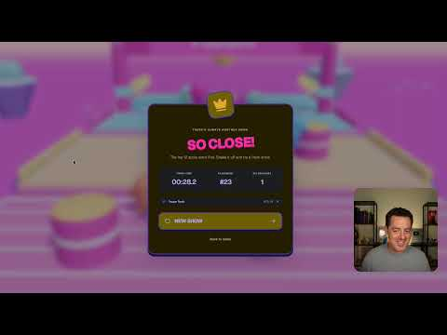 GPT-6 IS HERE!!! (ASTRA) (32:51)
- Cursor — “Refactoring Legacy Codebases” — ⏱️ ≈28:00–32:00. Follow the plan → Jira tickets → cloud agents → separate PRs → screenshots/video verification pipeline. The demo explicitly avoids one giant, unreviewable PR. [14] 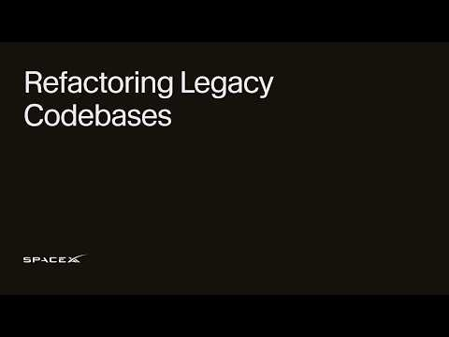 Refactoring Legacy Codebases (32:16)
- Study LangChain’s MCP docs. The implementation details worth stealing are stateless connections, TTL-aware tool catalogs, and checkpointer-backed human approval—not just “MCP support.” [6]
Editorial take: Astra raises the ceiling, but the durable coding-agent edge is operating the loop—bounded concurrency, cross-model verification, structured tools, and proof-bearing merges. [1, 3, 6, 14]

Sources
- GPT-6 Astra: an automated AI Engineer you can hire for <$6 an hour
- Meet Grok Bot: Your Team of AI Agents
- 𝕏 post by @theo
- 𝕏 post by @theo
- 𝕏 post by @kentcdodds
- 𝕏 article by @sydneyrunkle
- GPT-6 Astra: A new generation of intelligence | OpenAI
- GPT‑6 Astra
- 𝕏 post by @theo
- 𝕏 post by @bot
- 𝕏 post by @mntruell
- 𝕏 post by @jasonfried
- GPT-6 IS HERE!!! (ASTRA)
- Refactoring Legacy Codebases

