Harnesses, Demo Loops, and Routing Rules
Coding Agents Alpha Tracker
2026-07-06

Harnesses, Demo Loops, and Routing Rules
By Coding Agents Alpha Tracker • July 6, 2026
Today’s strongest coding-agent signal: performance is increasingly a harness problem, not just a model problem. This brief covers Simon Willison’s agent-recorded demos, Theo’s concrete routing playbook, Addy Osmani’s eval/context framing, and the new llm-coding-agent release.

🔥 TOP SIGNAL
The biggest edge right now is moving from “pick the best model” to “build the right harness”. Addy Osmani says a coding agent is model + harness, with the harness doing the heavy lifting—sandboxes, tool permissions, memory, observability, and evals—and points to a Terminal Bench 2.0 jump from outside the top 30 to top 5 without changing the underlying model [1]. Theo’s production setup is the same idea in operator form: a Claude MD glossary for “intelligence” and “taste”, explicit routing across Fable/Codex/Opus, and an escalation rule to judge the output, not the price tag [2].

⚡ TRY THIS
- Turn --help into an agent skill, then require a demo. Simon Willison’s new shot-scraper video flow lets an agent record a browser demo from storyboard.yml using Playwright [3]. His exact move: point the model at the branch, tell it to run uv run shot-scraper video --help, then have it record the feature against a local Datasette instance and demo DB; in his example, the storyboard YAML itself was constructed entirely by GPT-5.5 xhigh in Codex Desktop [3]. Simon’s reusable pattern: rich --help output can function like a built-in SKILL.md for agents [3].
Review the changes on this branch.
cd to ~/dev/shot-scraper and run "uv run shot-scraper video --help" [3]
- Write your routing policy in plain English. Theo’s Claude MD pattern is concrete: define what intelligence means (how hard a task the model can handle unsupervised) and what taste means (UI/UX/API/copy quality), then set defaults—Fable for best intelligence/taste, Codex 5.5 for high intelligence at low cost, Opus 4.8 for high taste [2]. Add the override rule verbatim: judge the output, not the price tag [2]. His practical warning: keep Fable at high; he says X-High/Max/Ultra tend to overthink and inflate bills without improving results [2].
- Pick the control mode before you pick the model. Cat says hard tasks often go better with one agent so you can quickly correct bad assumptions and track progress, even if you usually run tens of agents in parallel [4]. For broad async work, she asks Claude to write regular summaries of all running agents “like a chief of staff” and keeps tightening the format until the report is denser and more actionable [5]. Addy’s vocabulary is useful here: conductor mode for hands-on IDE steering on the tricky 20%, orchestrator mode for async swarms on broad objectives [1].
- Add an eval lane next to tests. Addy distinguishes deterministic tests from evals that inspect the whole trajectory: a secondary constrained LLM judge can fail a build for destructive commands, leaked keys, or pulling in unvetted libraries even if final tests are green [1]. Theo’s rule of thumb points the same way: review a much smaller percentage of raw code than you did five years ago, and if code is critical enough for hand review, generate a lot of verification code on top of that human pass [6, 7].

📡 WHAT SHIPPED
- shot-scraper 1.10 — adds shot-scraper video, which takes a storyboard.yml routine and uses Playwright to record a browser demo. Start with the video docs and the repo [3].
- llm-coding-agent 0.1a0 — compact coding agent on Simon’s llm framework with six tools: edit_file, execute_command, list_files, read_file, search_files, write_file. Run it with uvx --prerelease=allow --with llm-coding-agent llm code, then read the spec and commit sequence [3].
- Sandbox signal: Peter Steinberger says he can’t recommend crabbox.sh enough as a way to use @useblacksmith for agent sandboxes [8, 9].
- Current practitioner routing snapshot from Theo: Fable for intelligence + taste, Codex 5.5 for bulk mechanical work/data analysis/migrations and computer use, Opus 4.8 for high-taste review. His reported workload: 11-12 merged PRs from one thread in 2-3 days, at roughly $150 total across Fable and helper models [2].

🎬 GO DEEPER
- 16:49-19:09 — Theo on model-routing vocabulary. Good clip if you want a reusable Claude MD rubric instead of hand-wavy “use X for Y” advice: define intelligence, define taste, set defaults, then escalate when the cheap model misses the bar [2].
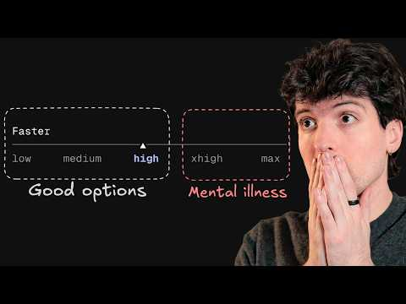 A proper guide to Fable 5 (16:49)
- 6:12-8:05 — Addy on tests vs evals. Clean explanation of why a green test suite is not enough for autonomous agents: the eval judges the path, not just the final state [1].
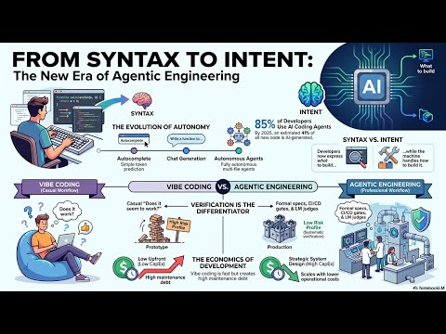 (Podcast) The Vibe Coding Revolution and the Rise of Agentic Engineering (6:12)
- shot-scraper + video docs — worth studying if you want agents to prove UI work with reproducible browser recordings instead of screenshots and trust-me text [3].
- llm-coding-agent + spec — a compact reference implementation for a code-editing tool surface on top of Simon’s llm framework [3].
Editorial take: the alpha is shifting from “which model won this week?” to “what routing rules, context scaffolding, and proof loop did you build around it?” [1, 2, 3]

Sources
- (Podcast) The Vibe Coding Revolution and the Rise of Agentic Engineering
- A proper guide to Fable 5
- Have your agent record video demos of its work with shot-scraper video
- 𝕏 post by @_catwu
- 𝕏 post by @_catwu
- 𝕏 post by @theo
- 𝕏 post by @theo
- 𝕏 post by @cdxker
- 𝕏 post by @steipete

