Hussein’s Essay Draws Repeat Endorsement; Evan Spiegel Shares a Three-Book Stack
Recommended Reading from Tech Founders
2026-04-27

Hussein’s Essay Draws Repeat Endorsement; Evan Spiegel Shares a Three-Book Stack
By Recommended Reading from Tech Founders • April 27, 2026
The strongest signal today was a Hussein Substack essay Patrick Collison said he keeps sending to people, with Marc Andreessen adding a co-sign. The rest of the list features Evan Spiegel’s books on innovation, Apple history, and shipping risk, plus recommendations from Patrick O’Shaughnessy and Collison.

What stood out
One essay had the clearest shared endorsement: Patrick Collison said he has been sending Hussein’s essay to many people, and Marc Andreessen added a brief co-sign [1, 2]. Beyond that, Evan Spiegel shared a compact three-book stack, Patrick O’Shaughnessy gave rare praise to Dwarkesh Patel’s podcast, and Collison pointed readers to a Robert Irwin interview on Arabic literature [3, 4, 5, 6].

Start here

The Post-Christian Condition and… [1]
- Content type: Essay / Substack post [1]
- Author/creator: Hussein [1]
- Link/URL: https://critiqueanddigest.substack.com/p/the-post-christian-condition-and [1]
- Who recommended it: Patrick Collison; Marc Andreessen added a brief co-sign [1, 2]
- Key takeaway: Collison said he has “recently been pointing many people to this essay” [1]
- Why it matters: It was the only item in today’s set with explicit reinforcement from a second recommender, giving it the clearest shared signal [1, 2]
“I’ve recently been pointing many people to this essay.” [1]

Evan Spiegel’s book stack
Spiegel’s recommendations covered three distinct use cases: a framework for innovation, a concentrated history of early Apple, and a book about shipping and geopolitical fragility [3].

Loonshots [3]
- Content type: Book [3]
- Author/creator: Safi Belell [3]
- Link/URL: Source context: Lenny’s Podcast interview with Evan Spiegel [3]
- Who recommended it: Evan Spiegel [3]
- Key takeaway: He called it the best “academic overview or summary” of the innovation process and said it is “really worth reading” [3]
- Why it matters: This stood out as the day’s clearest recommendation for a general model of how innovation works [3]

The First 50 Years of Apple [3]
- Content type: Book [3]
- Author/creator: David Pogue [3]
- Link/URL: Source context: Lenny’s Podcast interview with Evan Spiegel [3]
- Who recommended it: Evan Spiegel [3]
- Key takeaway: Spiegel recommended the first half in particular because it draws on interviews with roughly 150 early Apple team members, with “great stories” and “a lot of learnings” [3]
- Why it matters: It packages a large number of early-Apple stories and lessons into one recommendation [3]

The End of the World Is Just the Beginning [3]
- Content type: Book [3]
- Author/creator: Not specified in the source material
- Link/URL: Source context: Lenny’s Podcast interview with Evan Spiegel [3]
- Who recommended it: Evan Spiegel [3]
- Key takeaway: He said the book focuses on the vulnerability of global shipping and on a world where the US may struggle much more to secure global waterways [3]
- Why it matters: Spiegel framed it as especially relevant “for this particular moment” [3]
“The global economy is built on global shipping.” [3] 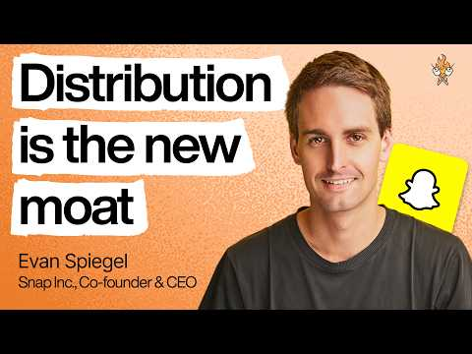 Snapchat CEO: Why distribution has become the most important moat | Evan Spiegel (66:18)

Two other recommendations worth saving

Dwarkesh Patel’s podcast [4]
- Content type: Podcast [4]
- Author/creator: Dwarkesh Patel [4]
- Link/URL: No direct podcast URL was included in the source material; Patrick O’Shaughnessy shared this related profile: https://www.nytimes.com/2026/04/26/business/dwarkesh-patel-podcast-ai.html?smid=nytcore-ios-share [4]
- Who recommended it: Patrick O’Shaughnessy [4]
- Key takeaway: He called it one of the few podcasts he listens to “virtually every episode,” expecting it to be “deep, unique, and impeccably well researched” [4]
- Why it matters: This was a high-conviction endorsement centered on consistency, not just one strong episode [4]
“One of the few podcasts I listen to virtually every episode, knowing it’ll be deep, unique, and impeccably well researched.” [4]

Interview with Robert Irwin on Arabic literature [5]
- Content type: Interview / article [5]
- Author/creator: Robert Irwin [5]
- Link/URL: https://fivebooks.com/best-books/classics-of-arabic-literature-robert-irwin/ [5]
- Who recommended it: Patrick Collison [5]
- Key takeaway: Collison said it touches on the issues he had been thinking about after asking which Arab or Middle Eastern novels are most humane, empathetic, or compassionate [5, 6]
- Why it matters: This was a recommendation tied to a concrete reading problem rather than a generic share [5, 6]

Bottom line
If you open one resource first, start with Hussein’s essay because it had the clearest multi-person endorsement. After that, Spiegel’s three-book stack is the most useful cluster: one book for innovation theory, one for company history, and one for geopolitical context [1, 2, 3].

Sources
- 𝕏 post by @patrickc
- 𝕏 post by @pmarca
- Snapchat CEO: Why distribution has become the most important moat | Evan Spiegel
- 𝕏 post by @patrick_oshag
- 𝕏 post by @patrickc
- 𝕏 post by @patrickc

