Karpathy Stops Typing Code as Orchestration Becomes the New IDE
Coding Agents Alpha Tracker
2026-03-21

Karpathy Stops Typing Code as Orchestration Becomes the New IDE
By Coding Agents Alpha Tracker • March 21, 2026
Karpathy’s near-100% delegation was the clearest workflow signal today, and multiple practitioners now agree the developer workspace is shifting from one editor window to orchestration surfaces built for parallel agents. Also inside: Cursor Composer 2’s disclosed training stack, honest Codex vs. Opus field notes, and the most copyable workflow patterns from people shipping with agents.

🔥 TOP SIGNAL
Andrej Karpathy says his day-to-day has already crossed from AI pair programming to operating a small fleet: he hasn’t typed code since December, now delegates non-interfering features to parallel agents, and thinks in “macro actions” over repos instead of line edits [1]. The bigger pattern is showing up from multiple angles: Addy Osmani argues the IDE is being de-centered into orchestration surfaces, and Theo says current editors break down because agentic work spans multiple projects, terminals, browsers, and worktrees at once [2, 3].

🛠️ TOOLS & MODELS
- Cursor Composer 2: built on Kimi k2.5, which Cursor says was the strongest base on its perplexity-based evals. Cursor then did continued pretraining plus a 4x high-compute RL scale-up on top, using Fireworks for RL and inference; Aman Sanger says only about 1/4 of final-model compute came from the base and full pretraining is planned later [4, 5, 6]. Cursor also says it missed crediting Kimi in the initial blog and will fix that next time [4].
- The control plane is becoming the product: Osmani’s current stack includes Conductor, Claude Code Web/Desktop, GitHub Copilot Agent, Jules, Vibe Kanban, and cmux; his framing is that the editor is still critical, but no longer the front door [2]. He also flags Claude Code’s new Swarm/agent-teams direction and notes that developer reaction to Cursor Glass was basically “this feels more like an agent orchestrator than an IDE” [7, 2].
- Task-level model notes, not universal benchmarks: Theo says Opus spent over an hour on a new feature and still got the implementation entirely wrong; Codex did the same feature correctly in 15 minutes [8, 9]. Karpathy, meanwhile, says Claude’s coding agent has a better teammate-like personality while Codex feels dry, but his latest gripe is broader than model choice: agents still bloat abstractions, copy-paste, and ignore AGENTS.md style instructions [1, 10].

💡 WORKFLOWS & TRICKS
- Run repo work in macro-actions, not prompt-by-prompt
  - Split work into non-interfering feature chunks.
  - Hand separate chunks to parallel agents across checked-out repos/workspaces.
  - Use other agents for planning and research in parallel.
  - Review output proportionally to how much you care about that path.
Karpathy points to Peter Steinberger’s setup with roughly 10 Codex agents as the visual form of this pattern; each high-effort task runs about 20 minutes, then you top them up and keep moving [1].
- Treat unused quota as lost throughput: Karpathy says if one tool/provider hits quota, switch to another; his default when agents fail is not “the capability isn’t there” but “bad instructions, memory, or tooling” [1].
- Set objective metrics and boundaries, then get out of the way: Karpathy’s AutoResearch loop improved a nanoGPT repo overnight by finding weight-decay/value-embedding and Adam-beta interactions he had missed; his Program.md is just a markdown attempt to describe how the autoresearcher should search [1].
- Design for async review: the stable loop across Osmani, Theo, and Copilot-style tooling is isolated workspaces/worktrees, task-state UIs, background execution, and attention routing so humans only re-enter when an agent actually needs them [2, 3].
“specify intent → delegate → observe → review diffs → merge” [2]
- Use model progress to change product process: @_catwu’s team now plans in short sprints, builds demos/evals instead of docs, revisits “too hard” features after each model release, and removes scaffolding once new models make it unnecessary. Also: keep agentic systems as simple as possible because failures compound with complexity [11, 12, 13, 14].
- Make self-checks cheap: Dreamer’s coding loop does plan → build → test → fix, and David Singleton says TypeScript works especially well because compile-time errors give the agent loop immediate feedback on mistakes [15, 16]. Theo’s Kernel demo shows the same philosophy on browser auth: one cloud-browser sign-in flow, including 2FA, can then be reused across agent instances for private GitHub access [3].

👤 PEOPLE TO WATCH
- Andrej Karpathy — still the highest-signal operator feed in public: near-total delegation on real repos, strong views on memory/personality, and zero sugarcoating when code quality is bad [1, 10].
- Addy Osmani — best current synthesis of the orchestration shift, because it’s grounded in the actual tools he uses daily instead of a generic future-of-IDEs take [2, 7].
- Theo — worth tracking for honest task-level comparisons and for pushing the “bigger IDE” framing from complaint into product experiments like T3 Code and Kernel demos [8, 9, 3].
- @_catwu — useful if your bottleneck is deciding what to ship in a world where model capability changes every release cycle [17, 11, 13].

🎬 WATCH & LISTEN
- 4:03-4:54 — Karpathy on 10-agent macro-actions. Best quick mental model for parallel feature delegation across multiple repos [1].
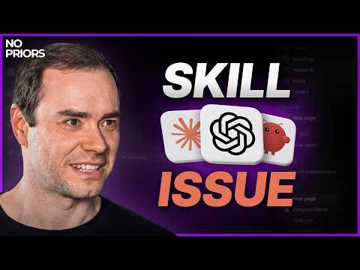 Andrej Karpathy on Code Agents, AutoResearch, and the Loopy Era of AI (4:03)
- 16:35-19:18 — Karpathy on AutoResearch. Watch this if you want the cleanest explanation of objective-metric loops and why the human becomes the bottleneck [1].
Andrej Karpathy on Code Agents, AutoResearch, and the Loopy Era of AI (16:34)
- 2:20-2:56 — Addy on orchestration as the skill to learn. Fast distillation of the move from one-agent chats to fleets, coordination, and context handoff [7].
 How to Beat AI FOMO and Stay Ahead in 2026 with Addy Osmani and Tim O’Reilly (2:20)
- 12:38-15:14 — Theo’s bigger-IDE thesis. Good segment if your workflow collapses the moment you run multiple agents across multiple projects [3].
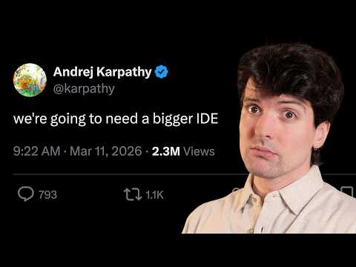 Everything needs to change (12:38)

📊 PROJECTS & REPOS
- OpenClaw / ClawHub — maintainer @magicseth says ClawHub now supports 1M weekly active users on Convex; Peter Steinberger says the next push is making plugins great. Notable adoption signal for an agent platform [18, 19].
- lat.md — early agent integration for keeping spec files synced with implementation. Armin Ronacher finds it interesting, but explicitly wants proof on larger codebases before getting excited [20].
- Arena + EVO Skill — Sentient’s new open competition for agent harnesses is using Office QA as its benchmark and aims to generate open feedback/data about where open harnesses still lag Claude Code. EVO Skill generates multiple candidate skills from eval feedback and keeps the best [21].
- Dreamer — not open source, but a project worth watching because its build loop is unusually explicit: Sidekick plans tools/data, builds, tests, exposes code/prompt internals, and exports via SDK/CLI. The platform also pays tool builders by usage and has a $10k prize for the best tool added by mid-April [15].
Editorial take: today’s real edge wasn’t a new chatbot tab — it was running more work in parallel, with cleaner isolation, explicit success metrics, and a higher skepticism level about agent-written code [1, 2, 10].

Sources
- Andrej Karpathy on Code Agents, AutoResearch, and the Loopy Era of AI
- Death of the IDE?
- Everything needs to change
- 𝕏 post by @amanrsanger
- 𝕏 post by @Kimi_Moonshot
- 𝕏 post by @leerob
- How to Beat AI FOMO and Stay Ahead in 2026 with Addy Osmani and Tim O’Reilly
- 𝕏 post by @theo
- 𝕏 post by @theo
- 𝕏 post by @karpathy
- 𝕏 post by @_catwu
- 𝕏 post by @_catwu
- 𝕏 post by @_catwu
- 𝕏 post by @_catwu
- Dreamer: the Personal Agent OS — David Singleton
- Dreamer: the Agent OS for Everyone — David Singleton
- 𝕏 post by @_catwu
- 𝕏 post by @magicseth
- 𝕏 post by @steipete
- 𝕏 post by @mitsuhiko
- The Future Live | 03.20.26 | Guests from MOTS Podcast, Microsoft, Eliza Labs, and Sentient!

