Karpathy’s *Daemon* Pick Leads Today’s Resource List, With Jack Backing the No Priors Episode
Recommended Reading from Tech Founders
2026-03-21

Karpathy’s Daemon Pick Leads Today’s Resource List, With Jack Backing the No Priors Episode
By Recommended Reading from Tech Founders • March 21, 2026
Today’s strongest organic recommendation is Andrej Karpathy’s mention of Daemon, which he uses as a model for humans functioning as AI actuators and sensors. A second signal comes from Jack Dorsey, who endorsed the broader No Priors episode featuring Karpathy.

Most compelling recommendation
Two organic recommendations surfaced today, both tied to the same No Priors conversation with Andrej Karpathy. The clearest one is Karpathy’s own book pick, because he explains the specific idea he found useful. A second signal comes from Jack Dorsey, who separately endorsed the episode itself [1, 2, 3].

Daemon
- Title: Daemon [1]
- Content type: Book [1]
- Author/creator: Not specified in the cited material
- Link/URL: None provided in the source material
- Who recommended it: Andrej Karpathy [1]
- Key takeaway: Karpathy says the book is inspiring because it imagines an intelligence that “puppeteers” humanity, with humans acting as both its actuators and its sensors [1]
- Why it matters: This is a concrete mental model for how AI systems and human labor could interlock, which makes the recommendation more useful than a generic reading-list mention [1]
“In Daemon, the intelligence ends up puppeteering almost a little bit like humanity in a certain sense. And so humans are kind of like its actuators, but humans are also its sensors.” [1] 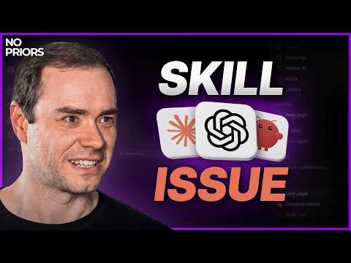 Andrej Karpathy on Code Agents, AutoResearch, and the Loopy Era of AI (59:37)

No Priors episode with Andrej Karpathy
- Title: No Priors episode with Andrej Karpathy [2]
- Content type: Podcast [2]
- Author/creator: No Priors [2]
- Link/URL: https://x.com/saranormous/status/2035080458304987603 [2, 3]
- Who recommended it: Jack Dorsey (@jack) [3]
- Key takeaway: Jack’s endorsement is concise—he calls the episode “excellent”—and the shared description says it covers the phase shift in engineering, AI psychosis, claws, AutoResearch, a SETI-at-Home-like movement in AI, the model landscape, and second-order effects [3, 2]
- Why it matters: The posted topic list and chapter outline indicate a broad AI discussion spanning capability limits, coding-agent mastery, job-market data, open versus closed models, robotics, and agentic education [2]

Why the book stands above the episode
Both items are useful, but Daemon is the higher-signal save because Karpathy attaches a specific framework to it. Jack’s recommendation is still worth keeping as the broader conversation that surfaces that framework and situates it alongside a wider AI agenda [1, 3, 2].

Sources
- Andrej Karpathy on Code Agents, AutoResearch, and the Loopy Era of AI
- 𝕏 post by @saranormous
- 𝕏 post by @jack

