LeCun’s World Models, Sygaldry’s Raise, and the Agent-Control Stack
VC Tech Radar
2026-04-15

LeCun’s World Models, Sygaldry’s Raise, and the Agent-Control Stack
By VC Tech Radar • April 15, 2026
Sygaldry’s $139M raise, Yann LeCun’s new world-model company, and a wave of agent security and orchestration startups defined this cycle. The broader signal is that AI value is shifting from base models toward context loops, deployment control, and compute financing.

1) Funding & Deals
- Sygaldry raised $139M. The company was founded by Chad Rigetti, alongside Idalia Friedson and Michael Keiser, and is targeting the AI data-center power problem with servers that combine quantum hardware and classical chips to run AI workloads faster than GPUs while reducing cost and energy use for larger models [1]. Fortune coverage [1]
- AMP is sketching a different financing model for frontier compute. Anj Midha said AMP has started securing about 1.3 gigawatts of compute infrastructure—roughly $40B of cloud spend over four years—financed with about 20% equity and the balance as debt. He describes AMP as a coordinating layer for compute capacity rather than a traditional cloud provider, which makes this notable as capital formation for AI infrastructure, not a standard venture round [2]

2) Emerging Teams
- amilabs is the highest-pedigree new AI company in the set. Yann LeCun said he left Meta around the turn of the year to start Advanced Machine Intelligence, focused on world models and JEPA. He also said the company is still doing research, open-sourcing, publishing, and hiring, with members of his former Meta team now working with him there [3]
- General Matter is a hard-tech team to watch if AI power demand keeps climbing. Scott Nolan—employee #35 at SpaceX, later at Founders Fund—has incubated General Matter to rebuild U.S. uranium enrichment capacity. The wedge is the enrichment bottleneck itself, starting with HALEU for advanced reactors and later LEU for the existing reactor fleet; Nolan explicitly connects the opportunity to behind-the-meter energy for data centers [4]
- Silmaril is one of the clearest security wedges in the YC batch. YC says the company is building the first self-healing prompt injection defense, claiming it catches 2x more attacks 10x faster than leading defenses and retrains continuously to protect agent stacks including Claude Code and OpenClaw [5]. Garry Tan called it the missing link for mission-critical workflows, and said the cofounders previously stopped billions of dollars in damages at Amazon and AWS [6]
- A second YC theme is the control plane around coding agents. Runtime is building harnesses, sandboxes, context, and visibility so teams can ship safely with any coding agent on any model or infra [7]. Arga Labs creates per-PR sandboxes with service twins and in-memory dependencies, then runs auto-generated E2E tests and routes failures back to an AI agent for autonomous fixes [8]. Workstreams is an open-source macOS IDE that runs parallel agents in isolated git worktrees to reduce merge-conflict and terminal chaos [9]

3) AI & Tech Breakthroughs
- LeCun’s JEPA/world-model thesis is the most consequential research view in the set. He argues world models should predict abstract representations rather than generate raw data, and recent JEPA-based systems can plan action sequences in simulated tasks [3]. In V-JEPA tests, impossible events caused prediction error to spike, which he describes as evidence that the system learned some physical common sense from observation alone [3]
“But as a path towards human level intelligence, LLMs are dead end.” [3]
- Tencent’s HYWorld 2.0 pushes world models toward usable 3D. The launch claim is an engine-ready system that generates editable 3D scenes from a single image, positioned as more useful than video-only generation, with an open-source release announced for Hugging Face [10, 11]
- Hugging Face is productizing GPU-kernel distribution. Kernels on the Hub are pre-compiled for exact GPU, PyTorch, and OS combinations, let multiple kernel versions coexist in one process, support torch.compile, and were shown at 1.7x-2.5x over PyTorch baselines [12]
- Agent orchestration is getting more asynchronous and multimodal. LangChain’s deepagents v0.5 adds async subagents that run background tasks on Agent Protocol servers without blocking the main agent, keep stateful threads for follow-ups, and now handle images, audio, video, and PDFs, with improved prompt caching on Claude models [13, 14]

4) Market Signals
- The best macro frame here: value is shifting to context loops, compute, capital, and culture. Anj Midha argues those are the four bottlenecks, with context feedback loops providing both capability gains and business advantage [2]. His example is Periodic Labs: LLMs propose new materials, robots synthesize them, x-ray diffraction validates the result, and the verification data is fed back into training; he said more compute is currently producing super-exponential gains in superconductor discovery with no visible saturation [2]. On compute, he argues the market is less an AI bubble than a GPU wastage bubble because supply is fragmented and non-fungible across clusters and chip generations [2]
- Enterprises are likely to add a new operating role: the AI agent deployer/manager. Aaron Levie says these people will identify high-leverage workflows, map structured and unstructured data flows, design human-agent interfaces, run evals after model or data changes, and track KPIs. He expects the role to sit inside functions rather than live as a single centralized team [15]
- Coding-agent economics are already blowing through budgets. Uber CTO Neppalli Naga said AI coding tools—particularly Claude Code—have already maxed out Uber’s 2026 AI budget [16]. Clement Delangue’s response was a direct plug for open-source and local models [17]
“I’m back to the drawing board, because the budget I thought I would need is blown away already,” Neppalli Naga said [16]
- The model market is fragmenting, not converging. Andrew Chen’s list includes coding-tuned vs. generalist, text-first vs. multimodal, uncensored vs. guardrailed, local vs. cloud, geopolitical alignment, political bias, personality types, and different response behaviors [18, 19]
- Policy risk remains under-modeled. a16z argues that states are driving AI governance in the U.S., but courts lack the evidence base needed for cost-benefit analysis of state AI legislation, which could become an important constraint on how quickly state-level rules stick [20]

5) Worth Your Time
- Yann LeCun, “Special Lecture on AI and World Models” — the best primary-source articulation of why he started amilabs and why he is betting on JEPA-based world models over LLM-first scaling [3] 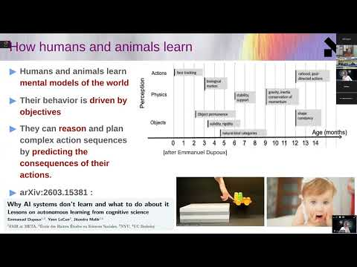 Yann LeCun: Special Lecture on AI and World Models (61:00)
- 20VC with Anj Midha — the best conversation in the set on context feedback loops, compute financing, and sovereign AI infrastructure [2] 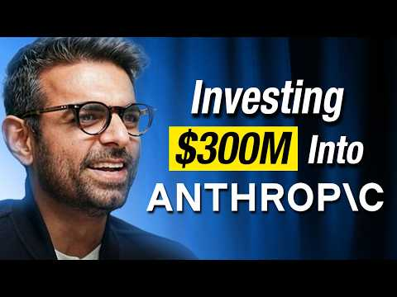 The Early Days of Anthropic & How 21 of 22 VCs Rejected It | The Four Bottlenecks in AI | Anj Midha (24:12)
- Invest Like the Best: Scott Nolan on General Matter — the clearest explanation here of why uranium enrichment, not reactor design, may be the near-term chokepoint for advanced nuclear deployment and AI-era power buildout [4] 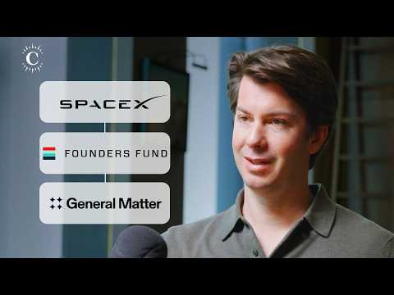 From SpaceX to Founders Fund to Solving America’s Nuclear Fuel Problem (54:08)
- Aaron Levie’s agent-deployer thread — useful operating memo on the new enterprise role around AI workflows, evals, and KPI ownership. Thread [15]
- a16z on the evidence gap in state AI regulation — useful policy reading if you underwrite enterprise AI companies selling across U.S. jurisdictions. Essay [20]

Sources
- 𝕏 post by @ycombinator
- The Early Days of Anthropic & How 21 of 22 VCs Rejected It | The Four Bottlenecks in AI | Anj Midha
- Yann LeCun: Special Lecture on AI and World Models
- From SpaceX to Founders Fund to Solving America’s Nuclear Fuel Problem
- 𝕏 post by @ycombinator
- 𝕏 post by @garrytan
- 𝕏 post by @ycombinator
- 𝕏 post by @ycombinator
- r/SideProject post by u/Lumpy-Sir9871
- 𝕏 post by @DylanTFWang
- 𝕏 post by @ClementDelangue
- 𝕏 post by @ClementDelangue
- 𝕏 post by @LangChain
- 𝕏 post by @hwchase17
- 𝕏 post by @levie
- 𝕏 post by @anissagardizy8
- 𝕏 post by @ClementDelangue
- 𝕏 post by @andrewchen
- 𝕏 post by @andrewchen
- 𝕏 post by @a16z

