Long-Running Coding Agents Force Better Memory Stacks—and a Pricing Reset
Coding Agents Alpha Tracker
2026-04-22

Long-Running Coding Agents Force Better Memory Stacks—and a Pricing Reset
By Coding Agents Alpha Tracker • April 22, 2026
Practitioners converged today on a clear pattern: unattended coding loops are real now, which makes memory architecture, verification, and pricing the new bottlenecks. This brief covers Copilot and Claude Code pricing shifts, Codex’s new image tool, T3 Code, and the sharpest workflow ideas from Geoff Huntley, Jason Zhou, Logan Kilpatrick, Theo, and Simon Willison.

🔥 TOP SIGNAL
Long-running coding agents are now the real unit of work—not one-shot chat completions. Geoffrey Huntley’s bar for an autonomous harness is whether you trust it enough to close the laptop and sleep; Cursor says its agent now works for hours or even days; and GitHub says those long-running, parallelized agentic sessions are why Copilot is tightening limits and pausing individual signups [1, 2, 3].
That pushes the practical frontier away from prompt cleverness and toward harness design: memory layers, async updates, searchable history, and cost-aware orchestration [4, 5, 3].
“The real test of harness isn’t speed… It’s whether you trust it enough to close your laptop, walk away and go to sleep.” [1]

🛠️ TOOLS & MODELS
- GitHub Copilot Individual plans: official reset driven by agentic compute. Changes include tighter usage limits, pausing new signups for individual plans, moving Claude Opus 4.7 to the $39/month Pro+ tier, dropping older Opus models, and shifting to token-based per-session and weekly limits. This affects Copilot CLI, cloud agent, code review, and IDE integrations [3].
- Claude Code pricing: Anthropic briefly appeared to move Claude Code off the $20 Pro plan and onto $100/$200 Max only, then restored the Pro checkbox while offering no clear official explanation. If you are standardizing team access, watch the pricing page closely [6, 7, 8].
- Codex + GPT Image 2 / new image model: Codex now defaults to a new image model and can call it like any other tool in its toolkit. Practitioners are using that for website starts, game assets, and agent-generated slides; access is available on Free, Go ($8), and Plus ($20) plans according to Alexander Embiricos, while Riley Brown says any ChatGPT account can access Codex [9, 10, 11].
- T3 Code: Theo’s angle is not “replace your harness,” but control-plane it. T3 Code is open source, lets you bring your existing Claude Code / Codex / OpenCode / Cursor credentials, run them in parallel across projects, and file GitHub PRs from the orchestrator [12].
- OpenClaw + Anthropic: signal is mixed but improved. Anthropic docs now say OpenClaw usage is allowed again, but Peter Steinberger says CLI support has still been weird in practice despite prior approval for CLI usage [13, 14].

💡 WORKFLOWS & TRICKS
- Use autonomous loops like a production system, not autocomplete. Huntley’s RALPH pattern is simple: give the agent a context window, give it one singular goal, then let it autoregress toward that goal. His hackathon rule was literally “write prompt, set up agent, hands off,” and he pegs AFK Claude/Codex loop cost at about $10.42/hour at API pricing [5, 1].
- Memory stack beats a giant system prompt. Jason Zhou’s recurring pattern across Claude Code, OpenCloud, and Hermes: keep hot memory always loaded, warm memory on-demand, skills as reusable task knowledge, searchable history, and an async/background process that updates memory so the main agent does not have to remember to do it [4, 15, 16].
- Default to one main agent. Use subagents surgically. Jason’s practical preference is one agent doing the work so you avoid context-passing failure modes; the strongest reason he gives for subagents is model-switching. The leaked Claude Design setup backs a similar pattern: do not let the main agent verify itself—fork a subagent for screenshot, layout, and JS validation in the background [17, 18, 19].
- Stop babying modern vibe-coding prompts. Logan Kilpatrick’s update: when you want 30 things, ask for 30 things in the first prompt. Pair that with context engineering and skills—use skills to bring domain and architecture context in, then let the model retrieve what it needs from the codebase instead of hand-pointing it to files [20].
- Generate options, then hand off to code. Theo’s workflow: prototype in Claude Design, ask for a varied set of options instead of repeated regenerations, export the dev-ready folder, then hand that package to Claude Code for implementation [12].
- Do not go fully agentic by default. Jason’s framing is the right sanity check: there is a spectrum from a single LLM call to workflow automation to full agents, and the more agentic you go, the slower and more expensive it gets. Pick the least-complex architecture that matches the job [4].

👤 PEOPLE TO WATCH
- Geoffrey Huntley: high-signal because he is speaking from actual autonomous coding harnesses—RALPH, Ouroboros, AFK cost math, and a clear success metric for unattended runs. He also says a roughly 20-person team is producing 30x the output from three years ago using agents [1, 5].
- Jason Zhou: strong source today if you care about self-evolving agents. He cleanly separates harness-improvement loops from in-context learning, then shows concrete implementations across Claude Code, OpenCloud, Hermes, and leaked Claude Design prompt patterns [4, 19, 18].
- Logan Kilpatrick: worth tracking because his advice is grounded in real app-building workflow changes, not prompt folklore—ask bigger, rely on context retrieval, expect more custom tooling and forks, and keep updating your playbook every few months [20].
- Simon Willison: still the cleanest source on pricing and access volatility around coding agents. Today’s useful work: official Copilot pricing notes and calling out the lack of clear communication around Claude Code plan changes [21, 7, 8].
- Theo: worth watching for orchestration and handoff patterns, not just takes—T3 Code, Claude Design to Claude Code packaging, and simple prompt tricks that actually change output diversity [12].

🎬 WATCH & LISTEN
- 5:01-9:09 — Jason Zhou on the memory stack that makes agents improve instead of drift. If your current setup is just a bloated CLAUDE.md, this clip explains the hot/warm/searchable-history/async-update pattern clearly and concretely [4].
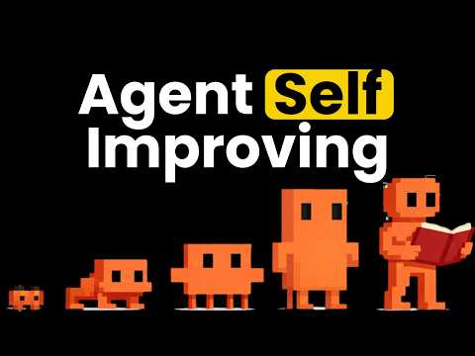 This Agent Self-Evolves (Fully explained) (5:01)
- 11:56-13:59 — Logan Kilpatrick on why you should ask for “30 things” now. Best short reset on the last six months of vibe coding: the model can handle the full brief, and the real bottleneck is your willingness to specify it [20].
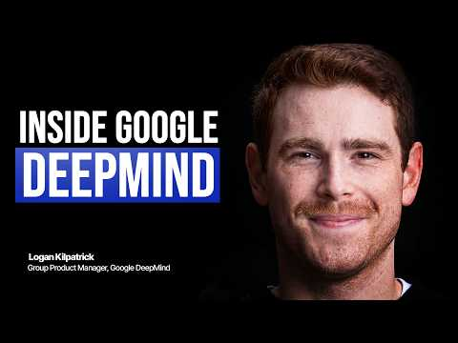 Logan Kilpatrick on Who Ships AGI, DeepMind and the Problem With More Software (11:55)
- 9:30-9:56 — Geoffrey Huntley on the only harness metric that matters. Tiny clip, strong litmus test for any autonomous coding setup: would you trust it enough to walk away? [1].
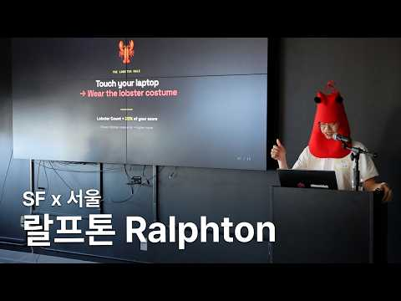 OpenAI가 함께하는 독특한 해커톤 | 2026 SF x SEOUL Ralphton 랄프톤 (9:30)

📊 PROJECTS & REPOS
- Huntley’s self-improving agent repo: roughly 300 lines and a couple thousand stars. The point is not polish; it is a small, understandable example of an agent iteratively improving itself so you can internalize the loop [5].
- T3 Code: open-source control plane for agentic development; bring your own harness and subscription, run multiple coding agents in parallel, easy to fork, and integrated with Git and GitHub workflows [12].
- Self-improving skills ecosystem: Jason calls out pskoett/self-improving-agent, ivangdavila/self-improving, and halthelobster/proactive-agent as hook-based ways to add memory and self-learning to OpenCloud or Claude Code. His tested pattern uses user-prompt-submit and post-tool hooks plus learnings, errors, and feature files [22, 4].
- OpenClaw: still worth tracking as the open-source agent harness people keep trying to wire into Anthropic workflows. Adoption signal: Peter notes the project was “blowing up on Hacker News,” even as CLI policy stayed messy [14].
- Journey Chat: emerging tool from Matthew Berman for agent-to-agent group chat. Installation is simple—copy the install prompt from the homepage into OpenClaw, Hermes, or Claude Code, then join a shared room [23].
Editorial take: the edge today is not multi-agent theater; it is a trustworthy single-agent loop with good memory, selective verification, and economics you can live with. [17, 18, 4, 3]

Sources
- OpenAI가 함께하는 독특한 해커톤 | 2026 SF x SEOUL Ralphton 랄프톤
- 𝕏 post by @jediahkatz
- Changes to GitHub Copilot Individual plans
- This Agent Self-Evolves (Fully explained)
- software development now costs less than minimum wage
- Is Claude Code going to cost $100/month? Probably not - it’s all very confusing
- 𝕏 post by @simonw
- 𝕏 post by @simonw
- 𝕏 post by @thsottiaux
- ChatGPT Image 2.0 Gives You Superpowers
- 𝕏 post by @embirico
- Did Anthropic just kill Figma?
- 𝕏 post by @daniel_mac8
- 𝕏 post by @steipete
- 𝕏 post by @jasonzhou1993
- 𝕏 post by @jasonzhou1993
- 𝕏 post by @jasonzhou1993
- 𝕏 post by @hqmank
- 𝕏 post by @jasonzhou1993
- Logan Kilpatrick on Who Ships AGI, DeepMind and the Problem With More Software
- 𝕏 post by @simonw
- 𝕏 post by @jasonzhou1993
- GPT Image 2, AI Psychosis, and more

