Low-Freedom Agent Pipelines and Loop Guardrails
Coding Agents Alpha Tracker
2026-06-28

Low-Freedom Agent Pipelines and Loop Guardrails
By Coding Agents Alpha Tracker • June 28, 2026
JamesOR’s Antigravity codelab gives a copyable migration harness for messy monoliths, while Geoffrey Huntley lays out the loop-hardening stack: fresh-context rounds, memory files, strict caps, and context engineering.

🔥 TOP SIGNAL
Today’s clearest practical convergence: both JamesOR’s Antigravity codelab and Geoffrey Huntley’s latest video argue that agent reliability comes from constrained loops, not better prompt poetry. JamesOR lays out a structured, open-source multi-agent workflow for migrating monolithic legacy code with low-freedom guardrails, Antigravity browser-subagent verification, and self-healing TDD pipelines [1]. Huntley makes the same case at the harness layer: restart with fresh context, keep memory on the filesystem, and put hard caps plus approval gates around every run [2].
“I don’t prompt anymore. My job is to write loops.” [2]

⚡ TRY THIS
- For legacy migrations, split the work before you scale the agents. JamesOR’s codelab starts with a structured multi-agent framework, then explicitly separates deterministic tasks from heuristic tasks. Wrap the flow in low-freedom guardrails, add Antigravity browser subagent verification, and close the loop with self-healing TDD so the pipeline can recover instead of silently drifting [1].
- Run fresh-context rounds, not one giant chat. Huntley’s RALPH pattern is simple: restart the agent each round with fresh context, use the filesystem as memory, and keep a memory file that the loop reads every turn so fixes stick without being re-explained [2].
- Add a real HUD before you trust autonomy. Huntley’s minimum controls are a cost cap and step cap on every run. Then layer least-privilege roles, sandboxing, human approval for anything that changes state, a verifier grounded in real data, circuit breakers, full tracing, and a default rule that instructions inside your data are hostile until proven otherwise [2].
- Treat context as a scarce resource. Huntley cites Anthropic’s finding that larger context windows can reduce accurate recall through “context rot,” so feed only what the model needs each turn instead of dumping the whole codebase into the window [2].

📡 WHAT SHIPPED
- Antigravity’s surface map is now explicit: 2.0, CLI, IDE, and SDK. Google also published a chooser post for when to use each surface blog post [3, 4].
- JamesOR’s Antigravity migration codelab is the most substantive workflow drop in today’s feed: a step-by-step, open-source multi-agent orchestration framework for poorly documented monoliths with tech debt, using low-freedom guardrails and browser-subagent verification thread [1].
- Antigravity 2.0 community demos are expanding beyond text chat. One shared demo shows multi-agent orchestration with voice-driven sub-agents demo [5].

🎬 GO DEEPER
- 1:42-1:58 — Huntley on the skill shift from prompts to loops. Short clip, but it cleanly reframes the whole category: the durable skill is loop design, not prompt ornamentation [2].
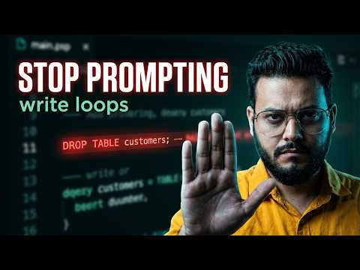 Stop Prompting Your AI Agents. Build Loops That Can’t Wreck You. (1:42)
- 4:11-4:38 — Huntley on context engineering. Worth watching if your agent gets worse as you add more docs: his hook is that bigger windows can create “context rot,” so good loops ration context turn by turn [2].
Stop Prompting Your AI Agents. Build Loops That Can’t Wreck You. (4:10)
- Study JamesOR’s codelab thread, not just the demo. The key pieces to copy are the deterministic-vs-heuristic split, low-freedom guardrails, browser-based verification, and closed-loop TDD recovery path thread [1].
- Study Huntley’s bounded-loop resource list. He specifically points to Matthew Berman’s 70 ready-made bounded loops, the Agent Loops list, Ralph, and a free checklist at qualixar.com as templates you can copy instead of inventing from scratch [2].
Editorial take: today’s practical edge is not “more agent”—it’s tighter loops, narrower freedom, and explicit verification at every handoff.

Sources
- 𝕏 post by @JamesOR
- Stop Prompting Your AI Agents. Build Loops That Can’t Wreck You.
- 𝕏 post by @antigravity
- 𝕏 post by @lukeschlangen
- 𝕏 post by @antigravity

